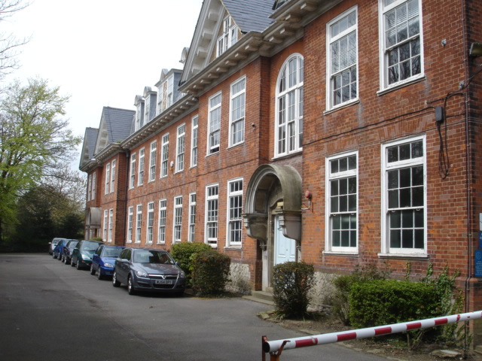

We are looking for people to join our friendly team of Exam Invigilators at The Folkestone School for Girls.

Your responsibilities would include helping students by: ***Salary £9.50/hour (uplift for room leads)***

***+ Holiday Allowance + Benefits***

* Being **available for exams in May/June** and others as required No prior experience of invigilating or working
* Monitoring students to ensure exam conditions are met in schools is required – **Full training will be given**
* Setting up and preparing resources for exam rooms
* Being literate in the use of email and text messaging
* Having experience of following rules and regulations or working to procedures

To find out more email [KWhawell@folkestonegirls.kent.sch.uk](mailto:KWhawell@folkestonegirls.kent.sch.uk)

**EXAM INVIGILATORS WANTED**