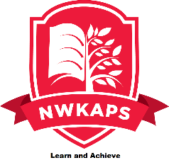 NWKAPS
JOB DESCRIPTION.

Job title: Y11 Transition Mentor

Grade: KR5
Location: NWKAPS – The Westcourt Centre, DA12

Role Purpose:

To support Year 11 students in their transition to Further Education, Employment or Work

Responsibilities:

- Working directly with Year 11 and 12 students to ensure they make a smooth transition into the next steps of their career. This might involve regular phone calls and / or visits. (Please note appropriate safeguarding measures should always be followed.)

- Liaising with providers (e.g. FE Colleges, apprenticeship providers) and families over key students and identifying appropriate support measures to keep them actively engaged in education or training.

- Supporting students who are not in employment, education or training in the autumn term to engage through, for example, regular contact, support events, skills workshops and career fairs.

- Proactively Identifying opportunities for students post-16 such as local apprenticeships, training providers and careers events.

- Organising visits to colleges, providers and events

- Organising skills events, workshops and career fairs

- Assisting in ensuring CEIAG (Careers Education, Information, Advice and Guidance) remains high profile within the Academy, including updating display information.

- Working closely with the staff member responsiblefor PDWB and other key staff for CEIAG to ensure there is a consistent approach across the Academy.

- Maintaining records of interventions, tracking destination data and producing reports.

        - 10. Writing CVs, applying for bursaries and various transition tasks.

Key Duties: J

- Upholding Academy expectations around conduct and safeguarding

- Attendance at relevant staff training

- Working with tutors, teachers and other staff in the Academy to ensure students are supported cohesively

Indicative knowledge, skills and experience: J

- Minimum of grade C or above GCSE in English and Maths

- Experience of working with children age 11-16

- Good communication and IT skills, a strong character, persistence, plenty of enthusiasm and the desire to help make a difference

- Knowledge and compliance with policies and procedures relevant to child protection and health and safety

