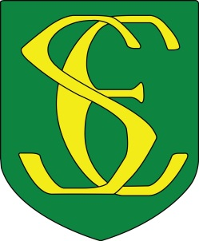
St Simon of England R.C Primary School

“We work, learn, play and pray together fulfilling God’s unique plan for every one of us.”

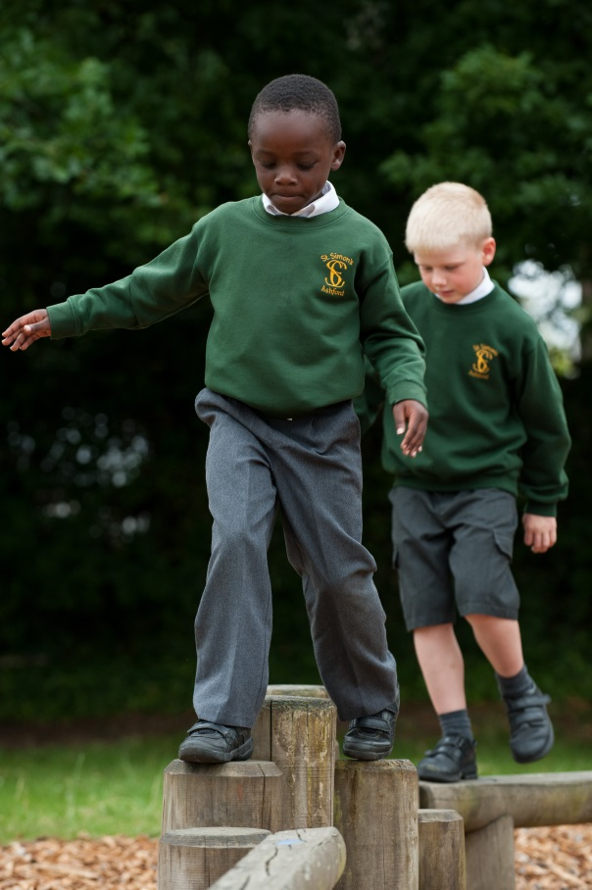
St Simon of England is a warm friendly School
with a family atmosphere and a strong sense
of community.
The children and their parents are very proud
to belong to the school and work together to
fulfil the school’s mission. Children are central
to all that we do, every child matters as an
image of God and a gift of love.

We are a Faith School
We are a church school which means that we
follow the teachings of Jesus putting our faith
into action by being fully inclusive showing
respect for all cultures, faiths and traditions.
Our faith and belief shapes everything we
do in school.
Contact:
Mr Peter McCabe Head teacher
St Simon of England R.C Primary School
Noakes Meadow
South Ashford
Kent
TN23 4RB
01233 623199
Peter.McCabe@st-simons-ashford.kcsp.org.uk

Our Achievements
The school is oversubscribed and is held in high esteem among the local community a school parents and carers would like to secure a place for their children.

Rated as “Good” in our last Ofsted Inspection
Rated as “Outstanding in our last Section 48 Inspection

Parents and Pupils
The children work hard and listen carefully in all lessons. They are keen and enthusiastic and love to share and talk about their learning. The children enjoy school and learning and help each other to do the same.
Parents work in partnership and fully engage in school activities supporting their children to achieve their full potential.
The school maintains excellent links with parents recognised by our achievement of a Leading Parents Partnership Award.

Governing Body
St Simon’s has a very effective and supportive Governing Body who are committed to the school. They help shape and share in the work fulfilling our mission and vision.

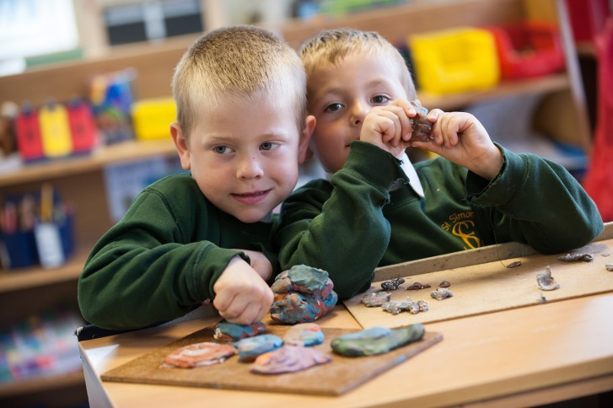
Investing in People
We believe strongly that we cannot achieve excellence without developing our staff so we have a strong commitment to continued professional development through our collaborative links. Our staff are our most valuable asset so we believe in developing them and training them so that they will become our future school leaders.

“Where every child matters as an image of God and a gift of love”
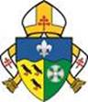
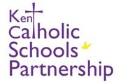
Collaboration
As a one form entry school we recognise the importance of collaborating with other schools so that teachers can support one another and share good practice.

St Simon’s benefits from being part of the Kent Catholic Schools Partnership which is a multi-academy trust which can draw upon the support of currently 24 schools, 19 Primary Schools and 5 Secondary Schools across the diocese of Southwark.

We are also active members of a strong local collaborative hub the Central Ashford Town Schools (CATS) which offer support and another avenue of networking among colleagues- schools supporting other schools.

‘
Our Curriculum
Our curriculum is constantly evolving and developing. We seek to deliver an exciting curriculum which is designed to inspire and engage not only the children but the whole school family.
We enrich our curriculum with themed days and weeks such as Science Week, Sports Week and Multicultural Week so be prepared to dress as a book or Bible character, step back into time and become a Victorian street urchin or a World War 2 evacuee.

The children take part in many educational workshops and offsite visits throughout the year.

In recognition of our enriched curriculum we have achieved: Music Mark, Arts Mark Gold, MFL Quality Mark and Bronze Active Mark for sport.

