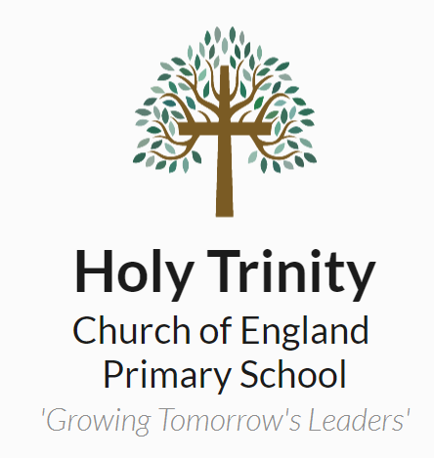
Holy Trinity C E Primary School
Dartford
Job Description 2020 - 2021

Post Holder:

Effective Date:

Job Title: PA to Headteacher

Responsible to: Senior Leadership Team

Pay Scale: KR3

FTE: 1

Purpose of Job:
- To provide a confidential and personal service to the Head Teacher.
- To maintain the efficient running of the school office, acting as a personal assistant to
the Head Teacher and administrative service to other staff.
- To be a prime point of reference for pupils and parents if they require information or
have a concern, in the absence Headteacher, or Deputy Headteacher.
- To liaise, with other school staff and others outside the school, particularly parents, professional associations and the local community, in a highly professional manner
and representing the high standards of the organisation.
- To oversee and ensure high quality and consistent communication from the school to the wider community. Including parentmail, newsletters and other Public Relations of the school.

Main Activities and Responsibilities:

- Undertake a diverse range of secretarial and administrative duties for the Headteacher and other staff, acting as personal assistant to the Headteacher keeping the diary, making arrangements and carrying out general office duties in order to free the Headteacher and other staff to concentrate on curricular issues and to ensure well-presented and accurate correspondence, reports and other documentation.
- Provide a first point of contact for pupils and parents at reception to deal with any problems that arise in the first instance or refer them on to ensure that problems are dealt with effectively.
- Produce and distribute all letters/correspondence to parents using Parentmail and postal system
- Ensure personal knowledge of new and updated administrative software is kept up to date.
- Assist in completing relevant forms for pupils leaving the school and send pupil’s files and records to the relevant secondary schools to ensure that procedures are complied with.
- Monitor sickness levels of all staff and children within the school and inform the Headteacher with termly reports. Assist in organising appropriate action to ensure that the disruptive effects of sickness/absence are minimised.
- Develop and maintain efficient and up to date manual and computer systems ensuring that information such as attendance records and admissions is kept confidentially and is accurate and readily available.
- To regularly check emails, correspondence and appointments to ensure the Headteacher is kept informed at all times.

Essential skills & knowledge
- Highly effective written and verbal communication skills – ability to compose letters accurately.
- Ability to work on own initiative and make decisions.
- Ability to work as a member of a collaborative team.
- Excellent organisational and planning skills.
- Ability to relate to all personnel and children within the school environment.
- Ability to approach all confidential matters with discretion, sensitivity and
- diplomacy, preserving the integrity of school information and complying with
- the requirements of the Data Protection Act.
- Knowledge and experience of whole school procedures, organisation and structure.

Pay Related Responsibilities
Dependant on individual pay scale, appendix 7 in the Teacher Pay & Reward Policy sets out clear expectations on our schools’ guidance for additional responsibilities related to teachers pay grades.

Safeguarding:
You may during the course of your duties, become aware of sensitive matters relating to an individual pupil or groups of pupils. Pupils may confide in you. If at any time a child confides in you, or you observe any incident that causes you concern, you must record factually what you have heard or seen on an appropriate form.
The appropriate form must be given to a Designated Safeguarding Lead. You have been provided with guidance and training on Child Protection and the LEA and Governing Body procedures for Child Protection must be followed correctly.

You must treat as confidential any matter relating to a child’s personal welfare or family circumstances. Such information must not be communicated to any person except those of the staff with legitimate interest or responsibility for the child, e.g.Headteacher, another member of the Senior Leadership Team or the Class Teacher.

Health & Safety:
All staff are responsible for Health and Safety. Should you notice any defect in the building or any spillage or body fluids, which compromises health and safety, this must be immediately reported to the Senior Leadership Team and recorded in the premise’s diary.

Signed …………………………………………………. Date …………………………………..

Signed ………………………………………………… Date ……………………………..……
(On Behalf of the Governing Body)

Criteria | Qualities
Qualifications and experience | - The successful candidate is likely to be educated to at least GCSE level, or equivalent, particularly in English and Mathematics.  - Speedwriting/shorthand experience.  - Full computer literacy – Microsoft Office: Word, Excel, Publisher, PowerPoint, Outlook and Internet.
Personal qualities | - Always maintain confidentiality.  - Good interpersonal skills; the ability to communicate effectively with a variety of people and to assess and diffuse confrontational situations, as well as make people feel positive and included.  - The capacity to remain calm and to cope with the unexpected.  - Excellent health and time keeping record.  - Committed and enthusiastic.  - Confident, positive and flexible attitude.  - Positive mindset.  - Willingness to learn and to deliver excellent service.  - Love of working in an environment that is centred on children.



