GLEBE SCHOOL
COMPLEX NEEDS PROVISION TEACHER
APPLICATION PACK

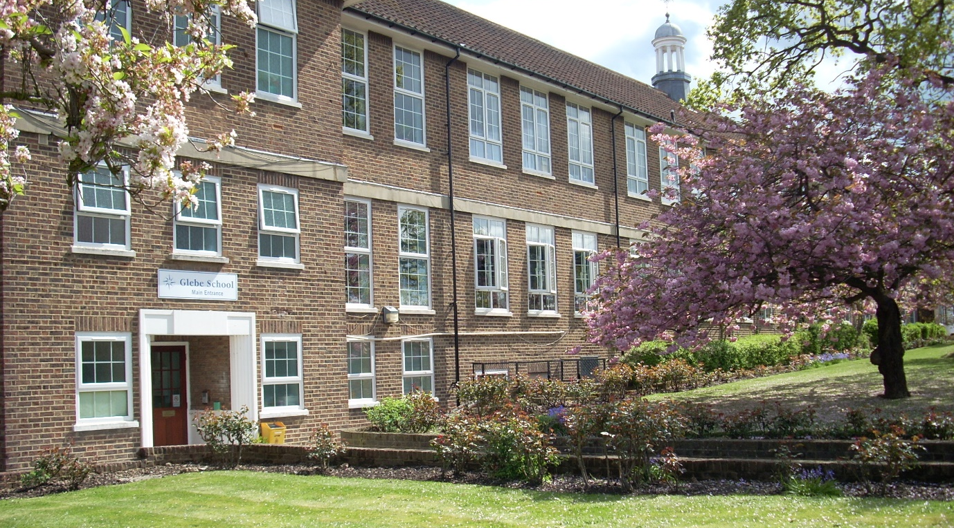

Hawes Lane
West Wickham
Kent
BR4 9AE
020 8777 4540
recruitment@glebe.bromley.sch.uk
Welcome to Glebe School

Dear Applicant,
Thank you very much for the interest you have shown in considering this position and the opportunity to become a Complex Needs Provision Teacher at Glebe School.
This school has achieved recognition of Outstanding Status in four successive inspections, with the last one being in December 2019. This is a testament to the commitment and dedicated professionalism of all our staff. I was very fortunate to be appointed to the role of Headteacher in January 2019 and this is now a fabulous opportunity for you to join the school team and contribute to the next phase of its development.
Glebe School performs in the top 10% of special schools in the country and there is ‘a culture where staff feel supported, valued and listened to and where work life balance is a reality’ - Ofsted 2019. However, Glebe is about far more than statistics. It is a friendly, safe environment which prepares students for life after school by promoting independence and enabling them to make and achieve realistic goals. We are a supportive and inclusive environment, providing encouragement for each student to gain independence, confidence and progression. Students achieve their goals through an individual, holistic approach. Staff, students, families and the community work together to guide and mentor students to reach their full potential.
Glebe is a happy, respectful community. Students are prepared for the future, building their confidence and resilience, offering them opportunities and choice in a safe environment with well-being at the heart of all learning, for students and staff.
Although a newly established Multi Academy Trust, currently with only a single school, we have worked hard to develop partnerships and Glebe is now the hub for the Specialist Learning Partnership (SLP), a collaborative partnership with special and mainstream schools from across south London. We are now looking for a Complex Needs Provision Teacher to build on and develop our strengths but equally with enthusiasm to help the team move forward in creating new opportunities for development in the future.
Please refer to our website, www.glebe.bromley.sch.uk for more details and information about the school. Additionally, I would be delighted to answer your questions about the school or the role. Contact us at recruitment@glebe.bromley.sch.uk to arrange a call back.
After discovering our school for yourself, we hope you will see it as your next exciting career opportunity and I very much look forward to meeting with you.
Yours sincerely,
Ian Travis - Headteacher

Guidance Notes

These notes are here to help you submit the best possible application you can. We strongly recommend that you read them before you start work on your application.

Read carefully all the information about the post, especially the person specification, which lists the skills, knowledge, experience and qualifications needed. Your application form and especially your supporting statement are the only pieces of information that we have about you. Unless you clearly demonstrate in your application how you meet the requirements of the post you may not be shortlisted.

Completing your application

The application form is a separate document and can be downloaded from the websites where the post is advertised or from the school website at www.glebe.bromley.sch.uk

Read the application form carefully before you start. We are an equal opportunities employer and select candidates for interview on how well they have completed the application form demonstrating how well they meet the requirements of the person specification.

Personal details

It is important that you fill in this section accurately and in full. The more information you give the better. Please do not leave any section blank and if it is not applicable please indicate with an N/A.

Present/most recent post and employment history

Start with your current or last employer and work backwards making sure the dates are in the correct order. Provide a job title with responsibilities and the period that you worked for them. It is important that you provide an explanation for any gaps in employment. Any voluntary work undertaken may also be included.

Education and training

Give a list of all the qualifications you possess and relevant training courses you have attended. Information here will be used to assess whether you meet the qualification requirements. Ensure nothing important is omitted. Please note you will be asked to provide original or certified copies of relevant certificates.

Rehabilitation of Offenders Act

The school has a duty to protect the children and young people in its care. Please ensure you complete this section fully. Successful applicants will be required to apply for an enhanced disclosure from the Disclosure and Barring Service.

References

References will be taken prior to interview. Any issues raised in the reference may be discussed at interview. Please do not submit open testimonials with this application form.
Supporting statement

This is the most important part of your application as it is where you can show how you have the skills and knowledge for this post.

Please ensure you read both the job description and the person specification to ensure that what you write is relevant. You will need to explain and provide examples of how your skills, knowledge and experience make you suitable for the job. It would be helpful if you could number your responses to match those on the Person Specification.

Sending your application

Your completed application form should be sent by email to recruitment@glebe.bromley.sch.uk or by post to the school address.

Please make sure you keep a copy of your application. Not only is this useful if you are called for interview but it will also assist you if you later need to enquire about your application.

Thank you for considering this post at Glebe School and good luck with your application.

