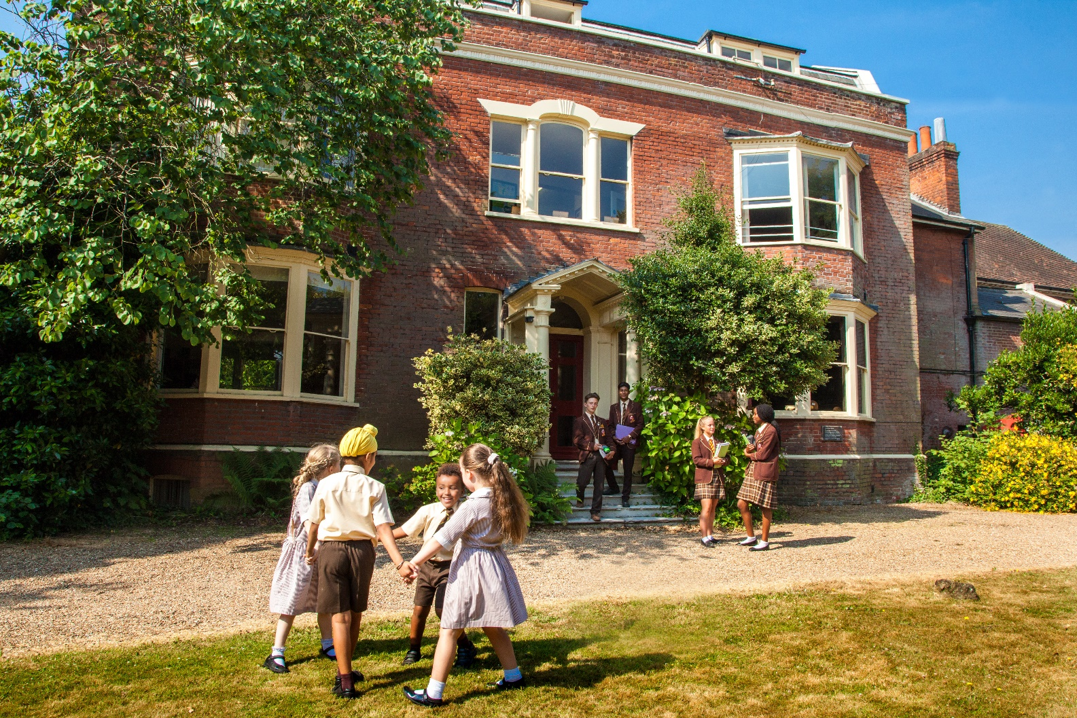

TEACHER OF SCIENCE (0.2)

Information for Candidates

www.gadshill.org
Gad’s Hill is an independent day school for boys and girls aged three to sixteen years, located near Rochester, Kent. Based within the former home of Charles Dickens, the School is ideally situated with easy access to the M2 motorway and high-speed rail connections to London. The School combines modern facilities with timeless values. The Kindergarten and Junior School occupy purpose-built accommodation opened in 2013. The Senior School occupies Charles Dickens’ former home, along with a range of other buildings including accommodation for specialist and practical subjects. At the present time, the School has about 315 pupils on roll and employs around 90 staff, approximately 40 of whom are qualified teachers.

Our Mission
Our mission is to enable our students to enjoy school, to achieve good academic qualifications and to develop those personal attributes and qualities which will guide them on their journey through life.

Our Vision
Our vision is to be the first choice independent school for families in Kent who value a well-rounded education for their children. It is our intention that our pupils leave Gad’s as confident, mature, articulate, pleasant and self-reliant young people who are well equipped to enter the world through a university education or career of their choice.

Our Values
We value excellence, enthusiasm, friendship and success. These attributes underpin all that we do. Our mission, vision and values are shaped by our commitment to educate children holistically, as articulated by our school motto: “First to thine own self be true”.

Our Ethos
We believe that children do well when they are happy at school and at Gad’s we pride ourselves on providing a friendly environment, where enthusiasm and hard work are the foundations for achieving success.

There is more to life than exam results alone and while Gad’s enjoys the reputation of receiving good GCSE results this is not our sole focus. We want to offer our pupils a foundation in life, working with them to become confident, motivated and articulate young people ready for the next stage in their education and life beyond.

Structure and Nomenclature
The School is structured as follows:

Section | Year Name | NC Year
Kindergarten | KN | Nursery
 | KR | Reception
 | K1 | Year 1
 | K2 | Year 2
Junior School | J3 | Year 3
 | J4 | Year 4
 | J5 | Year 5
 | Remove | Year 6
Senior School | Shell | Year 7
 | Lower 4th | Year 8
 | Upper 4th | Year 9
 | Lower 5th | Year 10
 | Upper 5th | Year 11

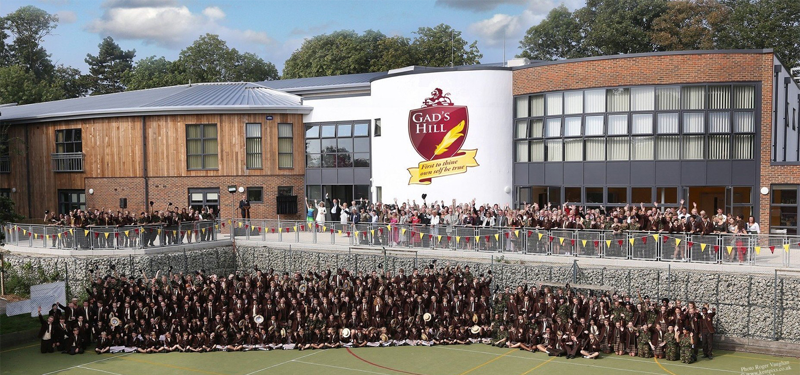
Our History
Gad’s Hill Place is world-famous as being the former home of author Charles Dickens, who lived here from 1856 until his death in 1870. It is here that he penned his classic novels “Great Expectations” and “A Tale of Two Cities”.

In the 1920s Gad’s Hill Place was converted into a school for girls and in September 2001 the school became fully co-educational, admitting boys throughout. Gone, however, are the days when the school could be housed solely in an 18th century country manor house. In recent years the School has developed the site, against the backdrop of the historic house. After a lengthy process, planning consent was finally secured in July 2010 to develop entirely new accommodation for the whole School.

Phase I (built) is the Kindergarten and Junior School along with a number of whole-school facilities. Phase II (not yet under construction) will be new accommodation for the Senior School.

The Present
Our new building is now the established home of Kindergarten and Junior School, along with a
number of facilities used by pupils of all ages: a music suite, sports hall, assembly hall and catering and dining facilities. These facilities provide future generations of pupils, aspiring sports stars, budding young musicians and actors with the resources that they need to thrive and excel.

The Future
It is hoped and anticipated that the second phase of the project will see the demolition of a mix of buildings erected through the School’s history, and the construction of a new Senior School. In recent months, some consideration has been given to working up a more phased approach to delivery of the new Senior School buildings. Once the new Senior School is complete, the historic house will be leased to a charity established to see the building used as a heritage and educational resource, celebrating the life and work of Charles Dickens.

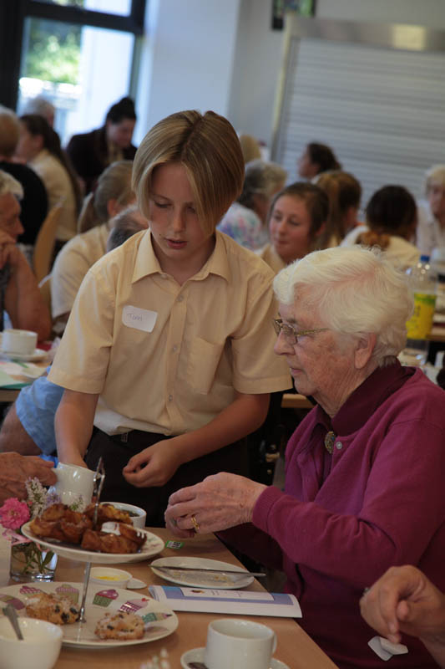

The School
Gad’s Hill School operates as three distinct departments within one school. The Kindergarten takes children from age three into the Nursery through to Year 2. Pupils follow the National Curriculum although there is a strong emphasis on play, physical education, music and drama with all pupils performing in a number of short productions each year. The school places particular emphasis on communications and therefore pupils from Reception upwards receive twice weekly lessons in Spanish and also ICT.

The Junior School is two-form entry from Years 3-6. Our Junior pupils receive a high proportion of lessons with subject specialists; in particular Modern Languages (Spanish), DT, ICT, Art, Music, Science & Games. By Years 5 and 6 nearly all lessons are delivered by specialist tutors. There is a particular emphasis upon team games and almost all of our students have the opportunity to represent the school in fixtures against other schools.

Kent and Medway local authorities operate the 11+ system whereby the top 25% of pupils are offered a place in a grammar school either in the Kent or Medway area. The remaining 75% of pupils are offered a place in either a local authority, non-selective school or an academy. Approximately 50% of our Year 6 pupils remain at Gad’s for their secondary education. About 60% attempt the local 11+ examinations each year in an effort to gain a grammar school place. Most are successful. It means that the majority of our Year 7 pupils fall close to the national average in CATs ability tests. Our strength is to make the most of our small class sizes and supportive atmosphere to add significant value to every individual.

The Senior school has a two-form entry. The curriculum is relatively broad, with all pupils taking a spread of subjects including Art, DT, Food & Nutrition, Spanish, Computer Science, Music and Drama. Students choose a range of options at the conclusion of Year 8. They follow a core of Maths, English (Literature & Language), Combined Science and CCF (BTEC – Teamwork & Personal Development). As options they may choose from History, Geography, Spanish, Art, Food & Nutrition, DT, Computer Science, Music, Drama and PE. Our GCSE curriculum is broad, suits most pupils and provides a firm foundation for sixth form and university entry.

At present there is no sixth form education at Gad’s and pupils currently depart for local grammar schools (80%) or colleges (15%) or other independents (5%). In the last year we have partnered with the University for the Creative Arts and several of our leavers have commenced Extended Diploma courses with them.

The school operates a good number of after school activities and would welcome new additions to the extra-curricular programme.

The Ethos
The Headmaster, Mr Paul Savage, was appointed in August 2018, having previously occupied the role of Head of Seniors. His vision is to provide generations of pupils with all the opportunities and individual care and guidance that an independent school can provide, but underpinned by a passionate commitment to the evaluation and refinement of quality teaching and learning, based on the latest educational research.

The school achieves good academic results with the vast majority of pupils leaving Gad’s to attend their first-choice sixth form destination. In 2019, we enjoyed a 100% pass rate in GCSE Maths and several option subjects, 93% in Science and 83% in English Language.
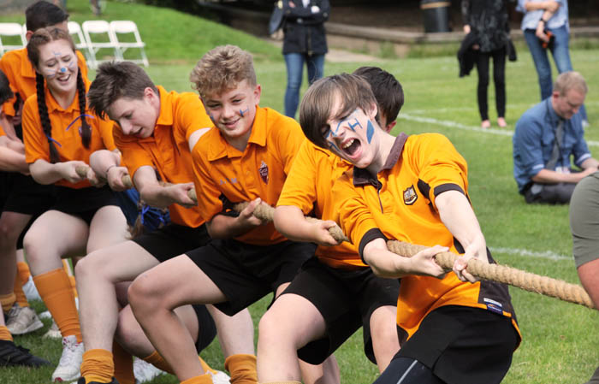
Gad’s is not an academic hot-house. We place a priority on our children enjoying school and one way in which we do this is to ensure that there are ample opportunities to experience drama, music, competitive games, swimming, trips, visits and CCF to keep our children occupied, challenged and inspired. Most of these things never appear in a league table but we believe that by ensuring children enjoy their time here they are much more likely to contribute in all aspects of their school life and this benefits the academic side too.

At Gad’s we pride ourselves on being a small friendly school, where academic success is valued along with the recognition that there are many other attributes which a good school will offer to best prepare a child to live their lives. The joy and agony of team games, the discipline and concentration of learning an instrument, the confidence and challenge of performing to an audience, the awareness of the complex world around them, the care and concern for others and the opportunity to shape their destiny.

Our Curriculum Intent

Gad’s Hill School’s One Curriculum is an ambitious and challenging curriculum for a child’s educational journey from 3 to 16. It is designed to deliver strong outcomes in a broad range of GCSE subjects and other valuable areas of achievement, allowing leavers to progress to their first choice of further study and equipping them with the teamwork, independence and leadership skills necessary for rewarding careers and adult life.

The One Curriculum covers issues of critical importance on a global scale, as well as reflecting the rich history and cultural diversity of Medway, Kent and the South East of England. The curriculum favours opportunities to make learning enjoyable and incorporates significant opportunities for speaking and listening to produce articulate and thoughtful young people who are capable of empathy for others and keen to serve their community.

The curriculum allows for learning to be supportive and personalised, taking advantage of the high levels of expert guidance within each classroom, while still offering excellent value for money in its delivery. Through the school’s curriculum, children learn how to look after their own wellbeing and develop compassion for the wider world.

The Purpose of the Role
Gad’s Hill School requires a talented and passionate part-time teacher of Science to join our team. Full details of responsibilities can be found within the job description but, in summary, the successful candidate will provide effective teaching, as part of an efficient and collaborative team, so that pupils learn and make good progress in Science.

Combined Science (Double award) is compulsory at GCSE and currently taught by two specialist teachers. Both are capable of teaching any aspect of the subject though we endeavour to deliver the subject as physics, chemistry and biology and to the strengths of the individual teacher. The school currently uses the AQA exam board. In 2019 the department achieved a 93% GCSE pass rate.

Gad’s Hill School requires a 0.2 teacher of Science, over one or more days, to provide additional teaching to senior science classes. Specific working hours are to be arranged with short-listed candidates. Candidates should have the ability to teach all three sciences at Key Stage Three and GCSE level. The post is a temporary contract until July 2021, however it is envisaged that a permanent contract may be offered during the course of the Summer Term 2021.
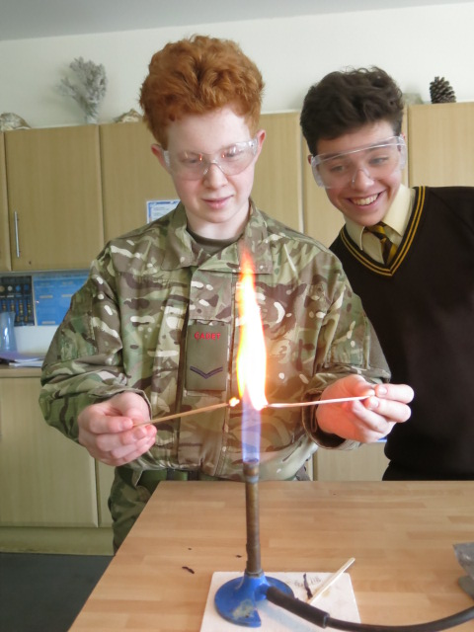

Key Accountabilities
- Provide effective and efficient teaching so that pupils learn and make good progress, including quality planning, preparation, marking, recording data, schemes of work and differentiation.
- Maintain an awareness of curriculum, educational, social and welfare issues at school, in Kent/Medway and nationally to ensure that the curriculum, programmes of study and teaching methods are up-to-date.
- Communicate with pupils, parents and other stakeholders as necessary to keep them informed of progress and developments.
- Meet published deadlines with respect to assessment data, marking & recording, reports, examination data, budgeting, registration/attendance data, coursework schedules, schemes of work, planning or any other tasks, to ensure that pupils, parents and the school are kept informed of progress and that the school has data available to track performance.
- Engage in teacher assessment & appraisal systems. Observe colleagues’ lessons. Engage in training in order to maintain and improve personal skills and departmental performance.
- Undertake supervisory duties out of the classroom in order to maintain pupil safety & welfare.
- Perform Form Tutor duties in order to support the pastoral development and welfare of pupils.
- Enhance learning opportunities for pupils using events (e.g. assemblies, plays, after school activities or clubs, subject revision sessions, visits, debates, parents’ evenings etc.) to extend pupil learning experiences.

Essential Qualities

An excellent teacher with very good relationships with students.

Committed to the highest expectations of students and their learning.

High personal standards of meeting expectations, organisation, paperwork, etc.

An excellent and effective communicator.

Able to use data appropriately to monitor and inform planning.

Able to demonstrate a commitment to ongoing CPD.

Able to work with colleagues in the Curriculum Group to develop collaborative solutions.
- Ability to teach Biology, Chemistry and Physics at Key Stage Three and GCSE level
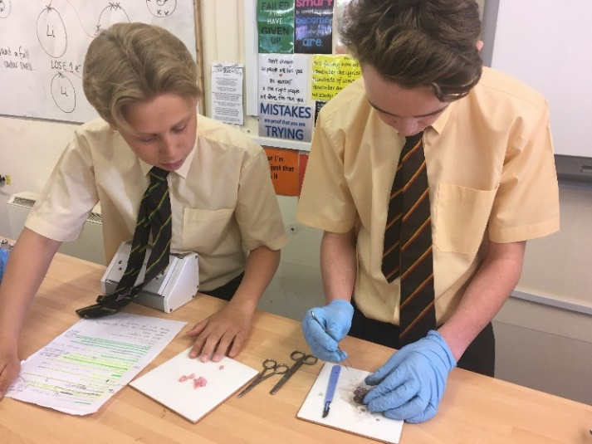

Essential Qualifications
- Bachelor’s Degree in Education, or in a relevant subject.
- Professional teaching qualification desirable.

The Process
Completed application forms are to be received by email only to the Headmaster, Mr Paul Savage, via his PA, Mrs Tracy Barker: t.barker@gadshillschool.org. Completed applications must be received by the School no later than 4pm on Friday 4th December 2020. Please note that if you do not receive an acknowledgement of your emailed application by this time please contact the School as a matter of urgency as you should assume your application has not been received.

Interviews will be held at the School as arranged with shortlisted candidates and it is hoped that the selected candidate will be able to commence employment as soon as possible in the Spring Term 2021.

Gad’s Hill is committed to safeguarding and promoting the welfare of children and we expect all staff to share this commitment. All posts are subject to enhanced Disclosure & Barring Service checks (DBS) and pre-employment checks will be undertaken before any appointment is confirmed. An overseas police check will be required by candidates who have worked or resided
outside of the UK, in the last 5 years.

The Benefits
As an independent school we have a slightly longer school day (pupils attend 8.30am-4pm) but enjoy a generous 16 weeks of school holidays.

Salaries are based on our own Gad’s Hill pay scales and teachers have access to the national Teachers’ Pension Scheme. Parking is provided on-site and a subsidised, home-cooked lunch is available each day in term time.

Children of all staff receive subsidised education at Gad’s Hill, subject to our policy and standard entry requirements.

And Finally…
We thank you for your interest in this exciting opportunity, and look forward to receiving your application.

