Student Supervisor
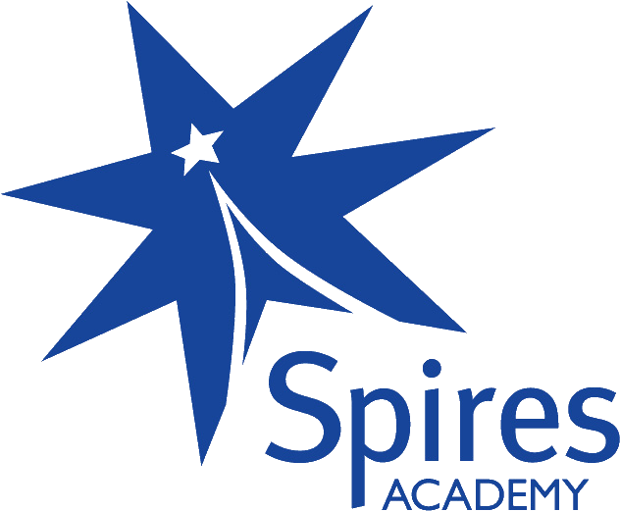
Vacancy Description Academy Band 5
Term Time Only
£19249.00
£16,242.95 (Pro-rata)

Fixed term contract until 30th April 2020

About Us
At Spires Academy we offer a distinctive small school environment where each individual is well known, listened to and encouraged to be the best they can be. Serving just 650 students enables us to maintain an inclusive and nurturing community atmosphere, where staff work with students to develop the skills, confidence and knowledge needed to reach their full potential.
This is an incredibly exciting time for Spires Academy, we are an expanding school with more students than ever before choosing Spires Academy.
About the Job
We seek to recruit a Supervisor to supervise whole classes in the absence of a teacher, responding to questions, assisting pupils to undertake set activities and managing the behaviour of those pupils. The role will also include supervision of at break and lunchtimes.
Core responsibilities will involve:
- Promoting and safeguarding the welfare of children and young persons for who you are responsible and with whom you come into contact.
- To provide classroom support for an absent teacher as requested.
- To manage and supervise classes of students and to teach the work set by the absent teacher in order for the students to continue to learn effectively.
- To maintain good discipline and reinforce appropriate standards for learning of classes in your care and to implement the Academy’s Behaviour Policy.
- To undertake the registrations assigned.
- To assist with planning and individual work programmes and reviewing work activities as requested by staff as appropriate.
- Where classroom cover is not required in a given period to support students as directed by the Principal or AVP responsible for cover.
- To supervise students during break and lunchtimes as per timetable.
About You
Applicants will have successful previous experience of working with young people. A strong desire and a genuine commitment to improving young people’s educational experience are essential and the ability to work effectively with a wide range of young people. You will be educated to at least GCSE level (or equivalent) in literacy and numeracy and be willing to undertake any necessary training or qualifications relevant to the position.
This role would suit a recent graduate who is interested in pursuing a career in teaching.
For full details please refer to accompanying job description.
Other Details
To apply complete the application form, and email to Gemma Lees, HR Officer glees@e21c.co.uk if you experience any difficulties or have any questions, please telephone 01227 710392.

