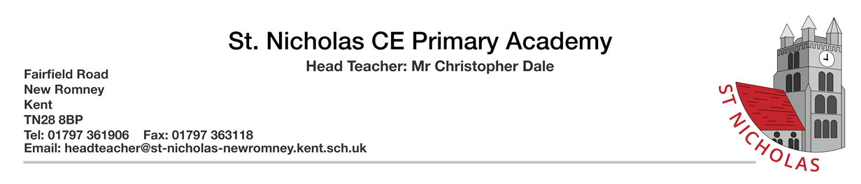
TEACHING ASSISTANT JOB DESCRIPTION
POST: Teaching Assistant
SALARY: Kent Range 3
RESPONSIBLE TO: Headteacher
LOCATION: St Nicholas CE Primary Academy, New Romney
WORKING PATTERN: 20 hours per week, 38 weeks per year
DISCLOSURE LEVEL: Enhanced

JOB PURPOSE:
To work under the guidance/instruction of designated teaching/senior staff to undertake work/care/support programmes, to enable access to learning for pupils and to assist the teacher in the management of pupils and the classroom. Work may be carried out in the classroom or outside the main teaching area under the guidance of teaching staff.
KEY TASKS:
Support for Pupils
- Establish rapport and respectful, trusting relationships with pupils, acting as a role model and setting high expectations.
- Supervise and provide particular support for pupils, including those with special needs, ensuring their access to learning resources.
- Ensure pupils’ safety, welfare and personal hygiene. (Basic First aid to be included where appropriate).
- Promote inclusion and acceptance of all pupils in the classroom by encouraging them to interact with each other and to engage in activities led by the teacher.
- Support the implementation of Provision Maps, Behaviour Plans, Personal Care Programmes, Curriculum Planning and Assessment.
- Promote self-esteem and independence amongst pupils.
- Provide feedback to pupils on their progress and achievement under the guidance of a teacher, in line with school policy. Evaluate learning and provide feedback to the teacher / parent / agency as needed.
- Be able and willing to undertake cover supervision for the teacher occasionally (not whole lessons). Support for Teachers
- Promote good pupil behaviour, dealing promptly with conflicts in line with school behaviour policies.
- Establish constructive relationships with parents and carers,
- Assist the teacher with the preparation of teaching and learning materials and resources.
- Undertake structured and agreed learning activities / programmes, being aware of pupil learning styles. Adjust activities according to pupil responses / needs

Support for Teachers
- Promote good pupil behaviour, dealing promptly with conflicts in line with school behaviour policies.
- Establish constructive relationships with parents and carers, promoting the School’s home/school liaison policy.
- Assist the teacher with the preparation of teaching and learning materials and resources.
- Undertake structured and agreed learning activities / programmes, being aware of pupil learning styles. Adjust activities according to pupil responses / needs.
- Work with pupils on programmes linked to local and national curriculum and learning strategies e.g. literacy, numeracy, early years, recording achievement, progress and feeding back to the teacher.
- Monitor pupils’ responses to learning activities and achievement as directed.
- Provide detailed feedback to teachers on pupils’ achievement, progress, problems etc. as requested.
- Undertake pupil record keeping as requested.
- Assist with the collation of pupil reports as requested by the teacher. This may involve data input.
- Support the effective use of ICT in learning activities and develop pupils’ competence and independence in its use.
- Maintain a purposeful, orderly and supportive environment, in accordance with lesson plans.
- Assist with the display of pupils’ work in the classroom and around school.
- Prepare, maintain and use equipment/resources required to meet the lesson plans/learning activity and assist pupils in their use.
- Administer and mark routine tests e.g. spelling, mental arithmetic and invigilate tests as required.
- Provide clerical support for teacher’s e.g. photocopying, filing, collecting notes / letters, administering coursework, production of work sheets for agreed activities.

Support for the School
- Be aware of and comply with policies relating to child protection, health & safety, confidentiality, safeguarding and data protection, reporting all concerns to a nominated person.
- Contribute to the overall work, smooth running and ethos of the school.
- Appreciate and support the role of other people in the team.
- Attend and participate in meetings as required.
- Improve one’s own practice through training, self-evaluation and performance management.
- Assist with the supervision of pupils out of directed lesson time, including before and after school and at lunchtime, within working hours.
- Accompany teaching staff and pupils on visits, trips and out-of-school activities as required and take responsibility for a group under the supervision of a teacher.

Contacts
• Teaching and other staff in the School.
• Pupils.
• Parents/relatives/carers.
• Peripatetic services.
• Educational Psychologists and other education or health care professionals.

Safeguarding children and young people
St Nicholas CE Primary Academy community is committed to safeguarding and promoting the welfare of children and young people. We expect all staff to share this commitment and to undergo appropriate checks, including an enhanced DBS check.
The above responsibilities are subject to the general duties and responsibilities contained in the Statement of Conditions of Employment.
The duties of this post may vary from time to time without changing the general character of the post or level of responsibility entailed.

Signed: ……………………………………………………….. (Postholder)

Signed…………………………………………………………… (Headteacher)

Date: ……………………………………………………………

