Information Pack for Candidates

Head Teacher’s Welcome
Dear Candidates
Thank you for your interest in The Norton Knatchbull School. We are a popular and highly regarded selective school for boys aged 11-18 which admits a growing number of girls into its Sixth Form.
Having proudly served the local community of Ashford in Kent since the 17th century, we combine traditional values with a forward-looking and vibrant learning environment where young people are nurtured to become considerate, confident and well-rounded individuals.

We provide an atmosphere in which all our students feel supported and inspired to strive for their personal best. Our approach to academic study is varied, disciplined and fosters a life-long love of learning. We value community and celebrate diversity. As a result, our young people are able to make informed and positive life choices, and are equipped to face the challenges of a fast-changing, competitive and increasingly global environment.
We are proud of our track record of strong examination results, the wealth of our extra-curricular provision and the strength of our careers education, advice and guidance. We benefit from a wide range of facilities which support learning in a variety of disciplines, styles and environments. As a team of professionals colleagues look to share and develop best practice across the school and maintain productive links with local schools and the wider national and international community.

It is a pleasure and a privilege to be Headteacher of this exciting, diverse and ambitious school. I would be delighted to receive an application from you to join our dedicated team.

Mr Ben Greene BA (Hons), NPQH

Our Vision
Our vision is to provide all our students with an inspiring and rigorous education which challenges them to reach their potential and gives them the confidence and skills to succeed in future life.
Our students
Our students are at the heart of everything we do. They are intelligent, ambitious, courteous and respectful. They are confident and keen to learn. Their drive and ambition results in success academically, in the arts and in sport. They have a strong sense of community spirit which extends beyond the school into the local community.
Our Staff
Our students are supported by a team of highly qualified, hard-working and caring teaching and support staff and a well informed and supportive Governing Body, all of whom are united in their desire to achieve the best possible outcomes for all.

High quality teaching and learning are at the heart of everything we do. All our teachers are subject specialists who place great emphasis on academic rigour as well as active learning. Our dedicated support staff team play a vital role in inspiring and motivating our students. Teamwork ensures are students are taught how to think and learn for themselves, developing reasoning, reflection, resilience, resourcefulness, respect and responsibility both inside and outside of the classroom. This results in a vibrant and inspiring learning atmosphere and equips students with the tools to become independent and lifelong learners.

Career Development
We, as a school, strongly believe in investing in people and helping them grow. We support our employees in career development and respect initiative and ambition. Staff progression is actively monitored through a thorough Performance Management Review (PMR) and constant opportunities for personal development are offered with our Continuing Professional Development (CPD) programme. As well as formal and informal training, we offer coaching, mentoring and peer support to ensure the progression of our staff. We always encourage staff to obtain new qualifications and actively support career progression. SLT have an open door policy should staff need to discuss anything on a one to one basis. Last but not least, as part of our CPD programme, we encourage staff to attend in-house "Well Being" sessions to learn new hobbies (photography, yoga...) or just relax with colleagues.
Teaching Facilities
Teaching takes place in designated and well equipped classrooms; specialist science laboratories; Art and Technology workshops; the sports hall and gymnasium, the drama studio and music rooms. In addition to our ICT suites, teachers and students make frequent use of our bookable laptop banks to support independent learning. The Ashfordian Library is a modern and flexible space which serves both as a silent study and reading area and as a bookable classroom. Our grounds boast ample playing fields which also serve as recreational outdoor spaces at break and lunch times.
We are an expanding school and have exciting plans, endorsed by KCC, to build a state of the art digital learning centre.
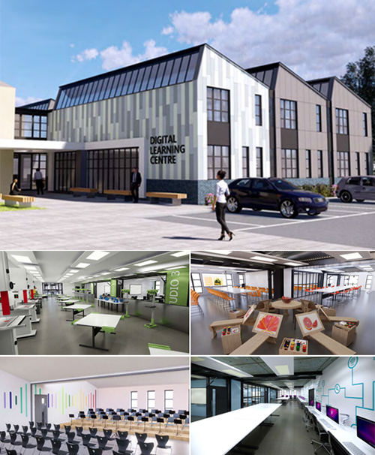

The Digital Learning Centre will bring together the technology changes which are currently affecting all of us in our day to day lives. It will bring these changes into focus in a modern, interactive learning environment. The DLC will be there to engage students in a way of learning which is relevant to the life they are leading outside School and which will absorb and interest them.

