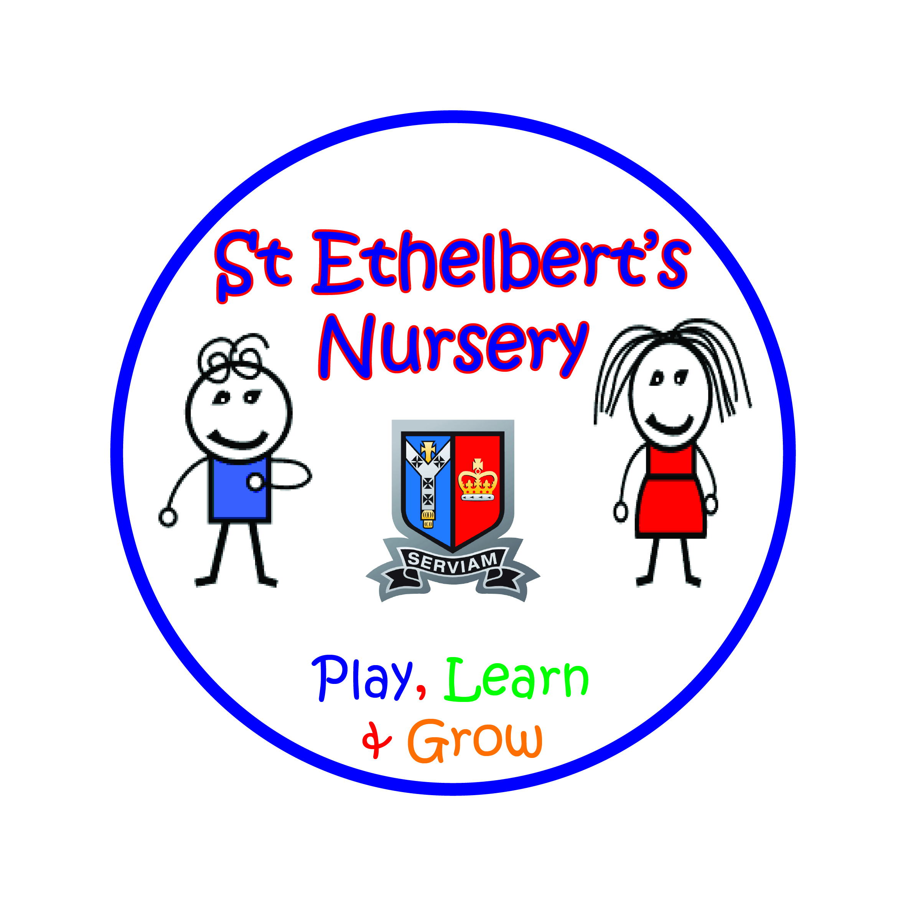
St. Ethelbert’s Catholic Primary School

Deputy HeadTeacher Job description

“I serve Jesus with my body, heart, mind and soul.”
Serviam means ‘I will serve’. Jesus Christ has taught us, ‘it is more blessed to serve than to be served’. At St Ethelbert’s school, following our Catholic faith, we serve the whole person – mind, heart, body and soul.
Body – because we care for our wellbeing, our parish neighborhood and our environment.
Heart – because we teach love and respect for all.
Mind – because we believe in excellent education.
Soul – because we learn to pray and become closer to God as his children.

The Deputy Head Teacher will assist the Head Teacher in leading and managing the school, in order to provide a Catholic educational community, sharing and communicating the vision and values of the school, so that all are enabled to achieve their highest potential. Under the delegated authority of the Head Teacher, the Deputy Head will have responsibility for the day to day organisation and operation of the school in the absence of the Head Teacher.
The successful candidate will work closely under the direction of the Headteacher. The Mission Statement, above, summarises the ethos which is at the centre of our Catholic School and the person appointed is expected to approach this post in the light of this statement. The Deputy HeadTeacher will be expected to maintain and develop an atmosphere and structure where all children and adults are valued and enables them to fulfil the school’s high expectations.

Teaching and Learning
The Deputy Head Teacher will assist the Head Teacher to:
- To have secure knowledge of EYFS, Key Stage 1 and Key Stage 2 curriculum
- Deploy all staff effectively in order to improve teaching and learning.
- Monitor, evaluate and review the quality of teaching and learning and standards of pupil’s achievements and identify strategies for improvement. Where there is underperformance, ensure effective remedial action.
- Secure and sustain effective teaching and learning throughout the school, modelling and leading excellent classroom practice and disseminating good practice found across the school.
- Play a leading role in the implementation of new initiatives, teaching and learning approaches and related pedagogy.
- Promote reflective practice in liaison with the staff team.
- Develop and implement programmes to increase parental and pupil engagement.
- Ensure the Diocesan policies on religious education, sex and relationship education and worship are implemented.
- Develop curriculum policies and practices, in consultation with the Governing Body, that meet statutory requirements, are relevant to the aptitude and stages of development of all pupils, including those with special needs, and provide for the spiritual, moral, cultural, social and emotional development of all pupils.
- Monitor assessment and data analyses to identify where intervention is needed and evaluate achievement of pupils.
- Take a leading role in the implementation, monitoring and review of the Behaviour and Antibullying Policies throughout the school in order to secure high standards of behaviour.
- Ensure the use of all resources is monitored, evaluated and reviewed to improve the quality of education for all pupils and to secure value for money.

Curriculum
- To lead on Religious Education
- To ensure that the teaching of Religious Education is the core of the curriculum.
- To be responsible for maintaining and developing a broad, balanced and cohesive curriculum suitable for all of the children and meeting national guidelines.
- To ensure that the curriculum is regularly reviewed, evaluated and applied.
- To ensure that the assessment requirements of the curriculum are appropriately carried out.
- Ensure that parents and pupils are well informed about the curriculum.
- To ensure that parents have timely access to appropriate information about the curriculum.

Children
- To ensure that children receive high quality education designed to promote excitement, enjoyment and enthusiasm in learning, leading to the pursuit of excellence.
- To ensure equality of opportunity for all, through the school’s policies, procedures and practices.
- To ensure that the activities in which children are engaged are conducted in a caring, disciplined, safe and healthy environment.
- To ensure all children are valued as individuals and ensure that all children are confident and able to achieve their full potential.
- To maintain a school environment and pastoral programme in which the needs and value of individual children are recognised and which also contribute positively towards their spiritual, social, cultural and moral development.

Catholic Ethos
- To reflect and develop the Catholic ethos and identity of St Ethelbert’s School.
- To maintain an ethos in which all individuals feel valued and where personal endeavour and responsibility are fostered.
- To maintain high personal moral standards and to set an example of these standards to others whilst demonstrating high quality leadership of the school.
- To ensure that the vision of St Ethelbert’s Catholic Primary School is reflected in strategic and development planning, and in a performance management structure, which is supported by consistent and coherent procedures and protocols.

Safeguarding
- To ensure that safeguarding is of paramount importance in our school.
- To be a deputy DSL
- To ensure the commitment of the Governing Body to safeguarding and promoting the welfare of children and young people is at the heart of the school and to ensure that all staff and volunteers share this commitment.

Strategic Direction and Development of School
The Deputy Head Teacher will assist the Head Teacher to:
- Ensure that the vision for the school is clearly articulated, shared, understood and acted upon effectively by all.
- Analyse and plan for the school’s future needs and further improvements. Identify and meet priorities and targets, taking into account appropriate data.
- Monitor, evaluate and review school policies, procedures and practice and take action where necessary.
- Ensure that resources are deployed effectively and efficiently in order to secure value for money and high standards in teaching and learning.
- Ensure equality of opportunity for all through the school’s policies, procedures and practice.
- Build a school culture and curriculum which takes account of the richness and diversity of the school’s communities rooted in the Catholic Christian faith.
- Develop the school’s improvement plan to promote and sustain ongoing improvement.
- To contribute to the teaching programme of the school and to encourage the development of outstanding teaching practice.
- To contribute to and ensure monitoring of classroom practice and the appraisal of the overall quality of teaching in the school at regular intervals.
- To encourage and develop positive co-operation between the school, home, parishes and the wider community.

Leading and Managing Staff
The Deputy Head Teacher will assist the Head Teacher to:
- Treat all staff fairly, equitably and with dignity and acknowledge their contributions by acknowledging and praising success.
- Motivate, support, challenge and develop staff to ensure school improvement, while maintaining a realistic culture of high expectation for self and others.
- Work directly with staff in order to raise standards of teaching and learning.
- Play a leading role in Staff Appraisal, ensuring process reflects school priorities and Diocesan guidance and advice.
- Develop and deliver CPD of a high quality, which is clearly relevant to the school’s and individual’s needs and development.
- Plan for and ensure the successful induction of all new staff.
- Have regard to the work/ life balance of individual members of staff
- To review own practice regularly, set targets and take responsibility for own development.
- Ensure effective planning, allocation, support and evaluation of work undertaken by teams and individuals, ensuring clear delegation of tasks and responsibilities.
- To organise and review timetabling e.g. gate duties, playground duties, PPA cover, acts of worship rota.
- To sort cover of staff in the situation of absence

Working with others
The Deputy Head Teacher will assist the Head Teacher to:
- To work with the Diocese, parishes and others to create a shared culture and positive climate that reflect the Mission of the Church in education.
- To liaise with other agencies and schools as appropriate, including to share good practice and to promote innovative initiatives.
- To ensure accurate and up to date records are maintained to satisfy safeguarding regulations.
- To reflect on own personal contributions to school achievement and to take account of feedback from others.
- To seek opportunities to invite parents, past pupils, community figures, businesses and other organisations into the school to enhance and enrich the school and its value to the wider community. To promote and develop the good reputation of the school within the local and wider community.

Main duties and responsibilities are indicated above. Other duties of an appropriate level and nature may also be required, as directed by the Headteacher. Please note that the post holder may be required to work outside of normal school working hours for extended school activities, school events, meetings and emergencies.

