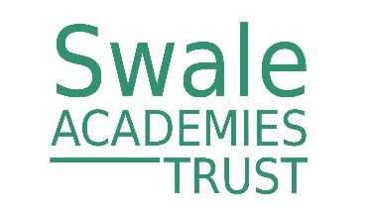****

**The Holmesdale School**

**Recruitment Pack**

**Part-Time Science Technician**

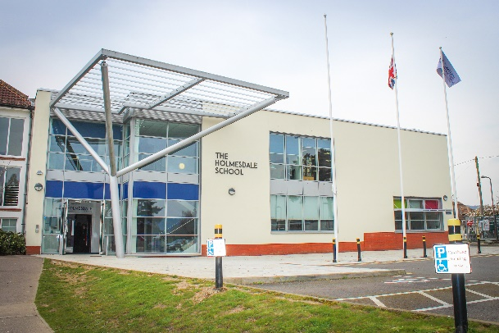 

**The Holmesdale School**

**Malling Road**

**Snodland**

**Kent**

**ME6 5HS**

**Contents**

* Welcome from Nicki Hodges, Executive Headteacher
* Safeguarding
* Job Description
* Person Specification
* The Application Process



**Letter from Nicki Hodges – Executive Headteacher**

Dear Applicant

***Part-Time Science Technician***

Thank you for expressing an interest in the advertised part-time Science Technician post. We hope you will take a look at the information enclosed with this letter and, should you wish, visit our school prior to applying.

I have recently joined the school as Executive Headteacher and look forward to taking the school from being in a category to good. I am an experienced Headteacher who has already taken The North School from special measures to good in little over three years. To achieve this we ensured that expectations were high and we prioritised support and development for teachers and are proud of the fact that teachers there have become recognised experts in their fields and have gone on to support other schools and departments.

The Holmesdale School is a small school with excellent facilities and a new dynamic leadership team that is already driving up standards. Pupils are keen to learn, come to school regularly and are rarely late. The school has a staff body that are committed to improvement and are keen to welcome new teachers into their team. This school provides an exciting opportunity for teaching professionals to make a significant difference to student’s lives and also to develop their own career.

At The Holmesdale School, we recognise that there is much work to be done and we are now working with the Swale Academies Trust to rapidly improve the progress of pupils. Swale Academies Trust is one of the leading Multi-Academy Trusts in the south east with a highly effective record in school improvement. Swale Academies Trust consists of a group of fifteen primary and secondary schools based in Kent and East Sussex. We have a very strong track record in school improvement and are looking for dynamic people who want to transform children's lives in some of the most challenging educational contexts in the region.

The successful applicants will therefore join a large dynamic organisation that puts learning at the centre of all that we do. At the heart of our desire to improve is a relentless drive to ensure that students make exceptional levels of progress. We therefore seek well-qualified, highly skilled, and enthusiastic leaders, who have the highest of expectations of both themselves, the staff and the students in their classes. We want leaders who enjoy working with a diverse staff and young people of all abilities and differing needs.

The Holmesdale School and Swale Academies Trust is committed to safeguarding and promoting the welfare of children and young people and expects all staff and volunteers to share this commitment. All posts are subject to an enhanced DBS check and references.

As a Trust dedicated to the principle of equal opportunities, we aim to ensure that staff recruitment is fair and open to all regardless of age, social class, disability, religion, ethnic origin or sexual orientation within the context of a detailed person specification.

We very much look forward to receiving your application.

Yours faithfully



**Mrs N Hodges**

Executive Headteacher

**Extract from Safeguarding Policy**

**Introduction and Ethos**

The Holmesdale School is a community and all those directly connected (staff, governors, parents, families and pupils) have an essential role to play in making it safe and secure. The Holmesdale School recognises our moral and statutory responsibility to safeguard and promote the welfare of all children with their best interests at the centre of our work.

The Holmesdale School recognises the importance of providing an ethos and environment within school that will help children to feel safe, secure and respected. As a staff, we are alert to the signs of abuse and neglect and follow our procedures to ensure that children receive effective support, protection and justice.

Our school core safeguarding principles are:

* We are an important part of the wider safeguarding system for children.
* It is a whole school responsibility to safeguard and promote the welfare of children as its paramount concern.
* All children (defined as those up to the age of 18) regardless of age, gender, ability, culture, race, language, religion or sexual identity, have equal rights to protection.
* All children have a right to be heard and to have their wishes and feelings taken into account
* All staff understand safe professional practice and adhere to our code of conduct and other associated policies
* All staff have a responsibility to recognise vulnerability in children and act on any concern in accordance with this guidance.

There are four main elements to our safeguarding policy

* **Prevention** (e.g. positive, supportive, safe school culture, curriculum and pastoral opportunities for children, safer recruitment procedures);
* **Protection** (by following the agreed procedures, ensuring all staff are trained and supported to respond appropriately and sensitively to safeguarding concerns);
* **Support** (for all pupils, parents and staff, and where appropriate specific intervention for those who may be at risk of harm);
* **Working with parents and other agencies** (to ensure appropriate communications and actions are undertaken).

The procedures contained in this policy apply to all staff (including temporary staff and volunteers) and governors and are consistent with those of Kent Safeguarding Children Board (KSCB).

**Job Description**

**School:** The Holmesdale School

**Job Title:** Part time Science Technician

**Grade:** KR4 (Actual salary £5,605-5,962)

**Responsible to:** Head of Science

**14 hours per week (Monday – Friday – working pattern to be agreed with Line Manager)**

**Term Time – 38 weeks per year plus 5 INSET days**

**JOB PURPOSE**

To work under supervision and direction as part of a professional team to support learning by providing technical assistance, through the preparation and day to day maintenance of teaching areas and equipment for pupils.

**KEY ACCOUNTABILITIES**

* Prepare specific resources / materials / equipment for lessons, as directed
* Maintain sufficient supplies of materials to enable delivery of lessons
* Safely and securely store allocated equipment and materials to prevent unauthorised access / misuse
* Clean and undertake day to day maintenance of equipment as needed and as directed to ensure it is clean and in good working order
* Perform duties in line with health and safety regulations and take action where hazards are identified, including reporting any serious hazards to the line manager
* Undertake basic record keeping as directed
* Ensure the safe treatment and disposal of used materials, including hazardous substances, and respond to actual or potential hazards
* Assist in delivering practical learning activities for pupils
* Provide clerical and administrative support as directed
* Order supplies as directed
* Attend support and staff meetings to continue own professional training and development as targeted through appraisal process
* Any other duties and responsibilities within the range of the salary grade.

**Safeguarding**

The Holmesdale School is committed to safeguarding and promoting the welfare of children and young people and all staff must ensure that the highest priority is given to following the guidance and regulations to safeguard children and young people. All staff are to have due regard for safeguarding and promoting the welfare of children and young people and to follow the child protection procedures adopted by The Holmesdale School. Any safeguarding or child protection issues must be acted upon immediately by informing the Designated Safeguarding Lead.

This job description reflects the policies agreed by the Governors. The duties, responsibilities and accountabilities highlighted in this job description are indicative and may vary over time. This job description will be reviewed regularly and is an integral part of the appraisal and line management process.

**Person Specification**

**School:** The Holmesdale School

**Job Title:** Part time Science Technician

**Grade:** KR4 (Actual salary £5,605-5,962)

**Responsible to:** Head of Science

|  |  |
| --- | --- |
| **ESSENTIAL** | * Level 2 qualifications in Maths, English and Science * Good level of ICT skills * Good communication skills both verbal and written * Knowledge of procedures for preparation of resources/ materials, setting up, cleaning and basic maintenance of equipment * Understanding of Health and Safety procedures especially as they relate to work in the Laboratory * Knowledge of appropriate use of relevant equipment (including handling hazardous substances safely) and ability to communicate this knowledge to staff and students * Knowledge of policies and procedures relating to child protection, health, safety, security, equal opportunities and confidentiality. |
| **DESIRABLE** | * Previous experience of working with secondary age children * First Aid qualification. |

**The Application Process**

Applications will only be accepted from candidates completing the appropriate application form. All sections of the form which are applicable to you must be completed as clearly and fully as possible.

Please note CVs will not be accepted in place of a completed application form.

All completed application forms must be sent either electronically to [Recruitment@holmesdale.kent.sch.uk](mailto:Recruitment@holmesdale.kent.sch.uk) or by post to the following address:

HR Team The Holmesdale School

Malling Road

Snodland

Kent

ME6 5HS

**The Shortlisting and Interview Process**

After the closing date for this post a panel will conduct the shortlisting process. You will be selected for interview based entirely on the contents of your application form, it is therefore important that you fully read the Job Description and Person Specification prior to completing your form.

After the shortlisting process has been completed candidates who have been selected for interview will be informed, and provided with full details of the interview programme. If you have not heard from us within four weeks of the closing date for this post, you have, on this occasion, unfortunately been unsuccessful.

All candidates who are invited to interview must bring the following original documents:

* Documentary evidence of right to work in the UK
* Documentary evidence of identity that will satisfy DBS requirements
* Documentary proof of current name and address
* Where appropriate any documentation evidencing change of name
* Certificates of educational or professional qualifications that are necessary or relevant for the post

**Conditional Offer**

Any offer of employment will be conditional upon the following:

* Verification of right to work in the UK
* Receipt of two satisfactory references
* Verification of identity checks and qualifications
* Satisfactory enhanced DBS check
* Satisfactory completion of a Health Assessment
* Satisfactory completion of six month probation period (where relevant)
* Satisfactory checks, as may be required in accordance with statutory guidance, if you have worked or been resident overseas in the previous five years.

**Retention of information**

All information is stored securely and any information supplied by unsuccessful candidates will be destroyed through the confidential waste system after six months from the date of the interview, in accordance with our retention of records procedure.