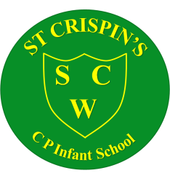

St Crispin’s CP Infant School
JOB DESCRIPTION

Position: Cleaner
Location: St Crispin’s CP Infant School
Responsible to: Site Manager
Hours: 11.25 hours per week (Mon – Fri) All year
Grade: Kent Range 2

Summary of Job:
Support teaching and learning in its widest sense at St. Crispin’s CP Infant School

Outline of Main Duties:
- Provide a comprehensive cleaning service to include dusting, vacuuming, washing floors, emptying bins, etc. to ensure high standards of cleanliness and hygiene at all times.

- Maintain clean toilets and washroom areas to ensure hygiene standards are met.

- Assist the Site Manager in other areas.

- Cover for each other in event of absence, to include replenishing hand towels and toilet rolls, to ensure the establishment’s needs are met.

- Report any defects to a senior member of staff to ensure health and safety procedures are followed and to enable repairs to be carried out.

- Undertake, during holiday periods, a complete clean of all areas including moving furniture to clean behind it, skirting boards, etc., to ensure all areas are clean and fresh. Time to be agreed with Site Manager.

- Comply with Health & Safety, Fire Regulations and other school policies.

- Attend meetings where relevant to ensure the school’s needs are met.

- Undertake training relevant to the needs of the position and for a member of staff working in a school.

- Any other reasonable and associated duties.

Signed by:
Post holder: Date:

Site Manager: _______ Date:

The governors are committed to safeguarding and promoting the welfare of children and all employees are subject to an Enhanced Disclosure Check with the Disclosure and Barring Service.

Note
1. This job description describes duties which the Post holder is expected and required to perform. It is not a comprehensive statement of procedures and tasks but sets of the main expectations of the School in relation to the Post holder’s professional responsibilities and duties.
2. This job description will be reviewed at least once per year and may be subject to modification at any time after consultation with the post holder.
3. St Crispin’s CP Infant School recognizes diversity and expects all staff to adhere to the school’s equality duties and treat all students and work colleagues fairly regardless of race, colour, gender, disability, age or religious belief.

