September 2019

Dear Applicant

RE: POSITION OF TEACHING ASSISTANT (LEVEL 1) MALE

KES/DC Payscale 3 (£16,156 – £17,306 p.a. pro rata)
One Year Fixed Term Contract Initially
Term Time only – 39 weeks per year/28.5 hours per week

Thank you for your interest in a position at this school.

You are invited to apply for this position by completing the application form and include an accompanying letter in which you outline the reasons for your interest in this post, and the experiences you have which equip you to undertake this position successfully.

King Ethelbert School is committed to safeguarding and promoting the welfare of children. This position is, therefore, subject to an enhanced Disclosure and Barring Service application.

Please note that the closing date for applications is Monday 30th September 2019 at noon.

I look forward to hearing from you.

Yours sincerely

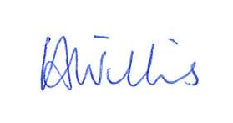

Mrs V Willis

Head of School

