Small Haven School Safeguarding Statement
At Small Haven School the student’s safety and happiness is of paramount importance. We believe that Small Haven School should provide a caring, positive, safe and stimulating environment that promotes the social, emotional, physical and moral development of the individual child or young person.
The school is committed to safeguarding and promoting the welfare of children and young people. This was reflected in the last Ofsted report (2012) that rated the welfare, health and safety of pupils as outstanding with every student stating that they ‘felt safe in school.’ We recognise that all adults, including temporary staff, volunteers and Directors, have a full and active part to play in protecting our students from harm. We believe that Small Haven School should be a safe environment for staff, parents, and students and we actively promote working together to create a safe and caring community.
We have a number of policies and procedures in place that contribute to our safeguarding commitment, including our child protection and online safety policies, which can be viewed on our website. All staff (including, volunteers and directors) must ensure that they are aware of these procedures. Parents and carers are welcome to hard copies of the Policies on request.
Sometimes we may need to share information and work in partnership with other agencies when there are concerns about a child or young person’s welfare. We will ensure that our concerns about our students are discussed with his/her parents/carers first unless we have reason to believe that such a move would be contrary to the child or young person’s welfare.
We have a dedicated safeguarding team (see below). If you are concerned about a child or young person’s welfare, please record your concern and any observations or conversation heard, and report to one of the Designated Safeguarding Lead’s as soon as possible the same day.
If your concerns relate to the actions or behaviour of a member of staff (which could suggest that s/he is unsuitable to work with children or young people) then you should report this directly to the Principal Head (or Tim Catherall Deputy Designated Safeguarding Lead if the concern relates to the Principal Head).
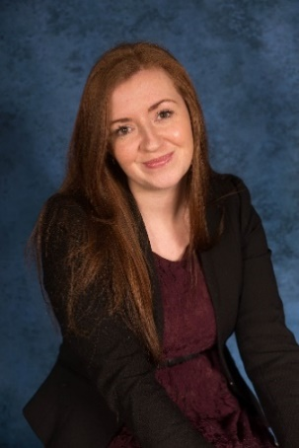
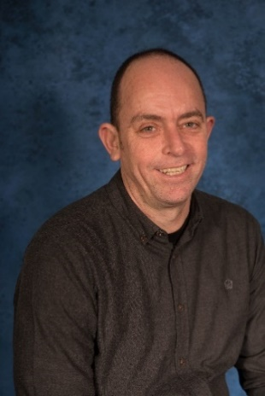
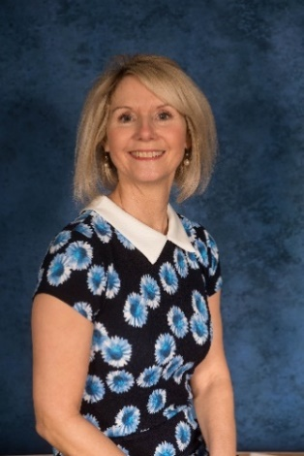

Designated Safeguarding Lead Deputy Safeguarding Lead Designated Director
Miss S White Tim Catherall Marissa Morgan

