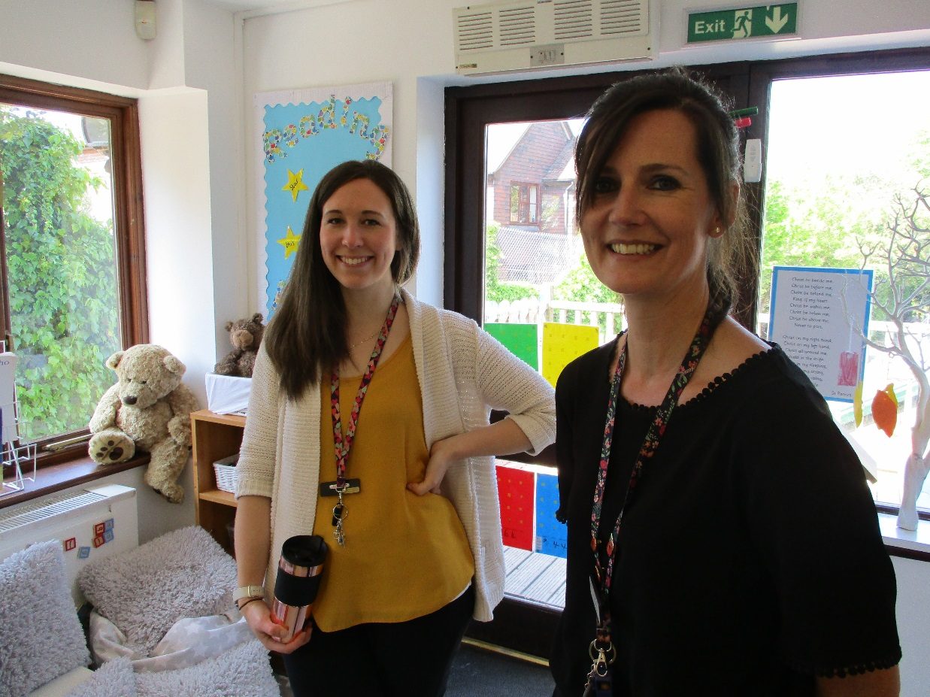

The experience of a Newly Qualified Teacher at Fordcombe: Ellie Saxty
Our aims at Fordcombe are simple: to offer pupils that come to our school the skills and knowledge to make the best possible start in life. As an NQT, I feel the same care and consideration has been offered to me in order to make the best possible start in my career as a fully-fledged teacher. The support and encouragement of the other staff has been second to none and, being a small team, I have always felt that an open door policy applies to our classrooms. The 'family feel' of the school ensures nobody is left feeling overwhelmed or unable to ask for help. I have received supportive and constructive feedback from my mentor and have been able to ask for support without judgement. I have seen my own teaching practice and leadership style develop positively as a result. I have also been given opportunities to lead subjects and whole school events, giving me vital experience to draw upon and reference when the time comes to progress my career.
A welcome from our Newly Qualified Teacher Mentor: Rebecca Hood
I am the NQT mentor at Fordcombe. I have taught at Fordcombe for almost 4 years in both Key Stage 1 and KS2. I can honestly say that after 20 years of being a teacher, this is the most outward-looking, forward thinking supportive school I have worked in. The staff are exceptionally open, creative and dedicated. The children's education, well-being and happiness is at the forefront of everyone's minds and we are always there for each other like family would be. For such a small school, our curriculum is rich in experience and broad, we have the autonomy to build creative, dynamic learning environments ensuring every pupil shines. Our results reflect the dedication and passion the staff have for the school. As a new member of staff you will be welcomed warmly into the school and ensure you are supported in developing as a passionate, creative teacher.

