May 2019

Dear Applicant,

Cleaners

Thank you for your enquiry about this vacancy. This letter forms part of the applicant pack which
includes an application form and details of the post.

Should you wish to apply I would be grateful if you could complete the application form and return it
with a covering letter outlining how you meet the requirements of the person specification and job
description.

The closing date for applications is 12 noon on 17th May 2019, with interviews to be held on 24th May 2019.

Meopham School is committed to safeguarding and promoting the welfare of children and young
people and expects all staff and volunteers to share this commitment. All posts are subject to an
enhanced DBS check.

As a school dedicated to the principle of equal opportunities we aim to ensure that staff recruitment
is fair and open to all regardless of age, social class, disability, religion, ethnic origin or sexual
orientation within the context of a detailed person specification.

In view of the large number of applications received we are unable to reply to each applicant
individually. If you have had no response from us within four weeks of the closing date, please
assume you have been unsuccessful. Please be assured however that each application will be
carefully considered.

Thank you for your interest in Meopham School, I look forward to receiving your application.

Yours sincerely,

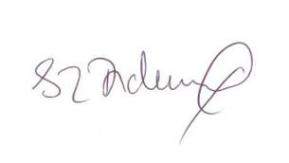
Mrs S Dickinson
Headtecher
Meopham School

