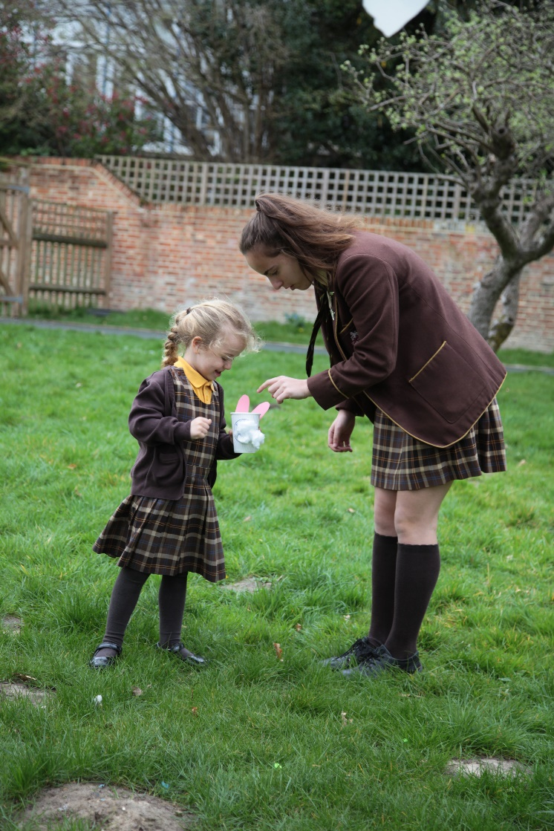

CANDIDATE INFORMATION

www.gadshill.org

Gad’s Hill is an independent day school for boys and girls aged three to sixteen years, located near Rochester, Kent. Based within the former home of Charles Dickens, the School is ideally situated with easy access to the M2 motorway and high-speed rail connections to London. The School combines modern facilities with timeless values. The Kindergarten and Junior School occupy purpose-built accommodation opened in 2013. The Senior School occupies Charles Dickens’ former home, along with a range of other buildings including accommodation for specialist and practical subjects. At the present time, the School has just under 310 pupils on roll and employs around 90 staff, approximately 40 of whom are qualified teachers.

Our Mission
Our mission is to enable our students to enjoy school, to achieve good academic qualifications and to develop those personal attributes and qualities which will guide them on their journey through life.

Our Vision
Our vision is to be the first choice independent school for families in Kent who value a well-rounded education for their children. It is our intention that our pupils leave Gad’s as confident, mature, articulate, pleasant and self-reliant young people who are well equipped to enter the world through a university education or career of their choice.

Our Values
We value excellence, enthusiasm, friendship and success. These attributes underpin all that we do. Our mission, vision and values are shaped by our commitment to educate children holistically, as articulated by our school motto: “First to thine own self be true”.

Our Ethos
We believe that children do well when they are happy at school and at Gad’s we pride ourselves on providing a friendly environment, where enthusiasm and hard work are the foundations for achieving success.

There is more to life than exam results alone and while Gad’s enjoys the reputation of receiving good GCSE results this is not our sole focus. We want to offer our pupils a foundation in life, working with them to become confident, motivated and articulate young people ready for the next stage in their education and life beyond.

Structure and Nomenclature
The School is structured as follows:

Section | Year Name | NC Year
Kindergarten | KN | Nursery
 | KR | Reception
 | K1 | Year 1
 | K2 | Year 2
Junior School | J3 | Year 3
 | J4 | Year 4
 | J5 | Year 5
 | Remove | Year 6
Senior School | Shell | Year 7
 | Lower 4th | Year 8
 | Upper 4th | Year 9
 | Lower 5th | Year 10
 | Upper 5th | Year 11

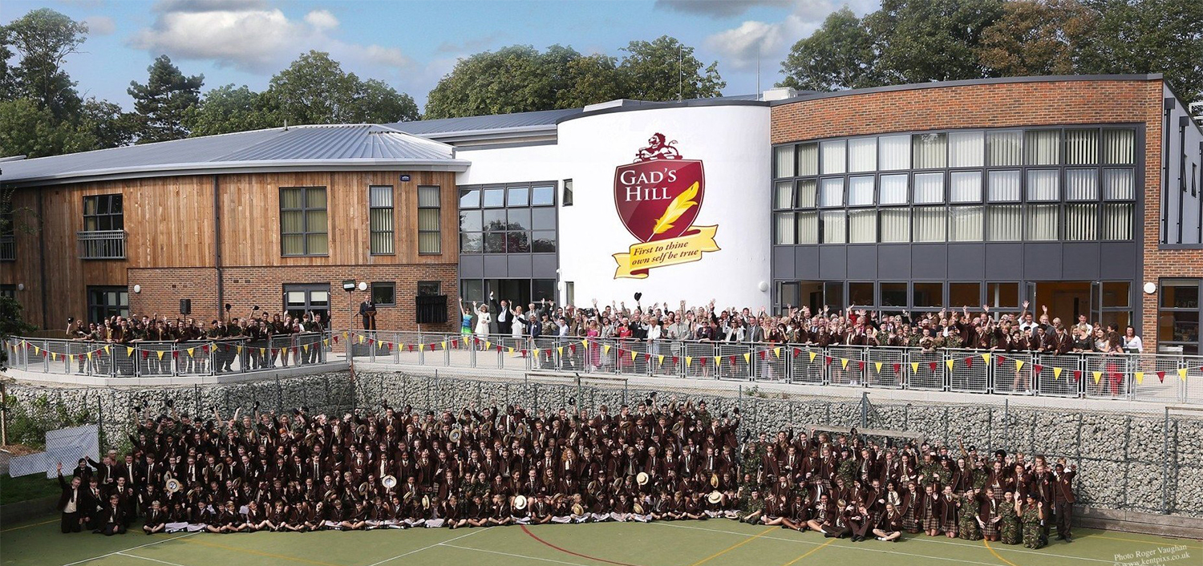
Our History
Gad’s Hill Place is world-famous as being the former home of author Charles Dickens, who lived here from 1856 until his death in 1870. It is here that he penned his classic novels “Great Expectations” and “A Tale of Two Cities”.

In the 1920s Gad’s Hill Place was converted into a school for girls and in September 2001 the school became fully co-educational, admitting boys throughout. Gone, however, are the days when the school could be housed solely in an 18th century country manor house. In recent years the School has developed the site, against the backdrop of the historic house. After a lengthy process, planning consent was finally secured in July 2010 to develop entirely new accommodation for the whole School.

Phase I (built) is the Kindergarten and Junior School along with a number of whole-school facilities. Phase II (not yet under construction) will be new accommodation for the Senior School.

The Present
Our new building is now the established home of Kindergarten and Junior School, along with a
number of facilities used by pupils of all ages: a music suite, sports hall, assembly hall and catering and dining facilities. These facilities provide future generations of pupils, aspiring sports stars, budding young musicians and actors with the resources that they need to thrive and excel.

The Future
It is hoped and anticipated that the second phase of the project will see the demolition of a mix of buildings erected through the School’s history, and the construction of a new Senior School. In recent months, some consideration has been given to working up a more phased approach to delivery of the new Senior School buildings. Once the new Senior School is complete, the historic house will be leased to a charity established to see the building used as a heritage and educational resource, celebrating the life and work of Charles Dickens.

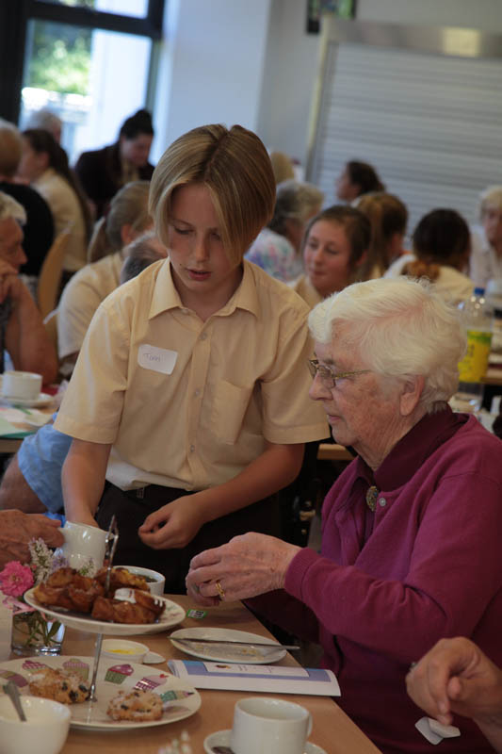

The School
Gad’s Hill School operates as three distinct departments within one school. The Kindergarten takes children from age three into the Nursery through to Year 2. Pupils follow the National Curriculum although there is a strong emphasis on play, physical education, music and drama with all pupils performing in a number of short productions each year. The school places particular emphasis on communications and therefore pupils from Reception upwards receive twice weekly lessons in Spanish and also ICT.

The Junior School is either one- or two-form entry from Years 3-6. The curriculum adheres to Key Stage two of the National Curriculum with Literacy and Numeracy (and some other subjects) being taught by form tutors. Our Junior pupils receive a high proportion of lessons with subject specialists; in particular Modern Languages (Spanish), DT, ICT, Art, Music, Science & Games. By Years 5 and 6 nearly all lessons are delivered by specialist tutors. There is a particular emphasis upon team games and almost all of our students have the opportunity to represent the school in fixtures against other schools. The Kindergarten is managed on a day-to-day basis by the Head of Kindergarten; Victoria Wilson and the Head of Juniors; Glynda Cullen.

Kent and Medway local authorities operate the 11+ system whereby the top 22% of pupils are offered a place in a grammar school either in the Kent or Medway area. The remaining 78% of pupils are offered a place in either a local authority, non-selective school or an academy. Approximately 50% of our Year 6 pupils remain at Gad’s for their secondary education. About 60% attempt the local 11+ examinations each year in an effort to gain a grammar school place. Most are successful. It means that the majority of our Year 7 pupils fall close to the national average in CATs ability tests. Our challenge is to make the most of our small class sizes and supportive atmosphere to add significant value to every individual.

The Senior school has a two-form entry. The curriculum is geared towards GCSE success with all pupils taking a broad spread of subjects including Art, Food & Nutrition, Spanish, Computer Science, Music and Drama. Students choose a limited range of options at the conclusion of Year 8. They follow a core of Maths, English (Literature & Language), Combined Science and CCF (BTEC – Teamwork & Personal Development). As options they may choose from History, Geography, Spanish, Art, Food & Nutrition, DT, Computer Science, Music, Drama and PE. Our GCSE curriculum is broad, suits most pupils and provides a firm foundation for sixth form and university entry.

At present there is no sixth form education at Gad’s and pupils currently depart for local grammar schools (80%) or colleges (15%) or other independents (5%).
At present the school operates a good number of after school activities and would welcome new additions to the extra-curricular programme.

The Ethos
The Headmaster, Mr Paul Savage, was appointed in August 2018, having previously occupied the role of Head of Seniors. His vision is to provide generations of pupils with all the opportunities and individual care and guidance that an independent school can provide, but underpinned by a passionate commitment to the evaluation and refinement of quality teaching and learning, based on the latest educational research.

The school achieves good academic results with the vast majority of pupils leaving Gad’s with GCSE A*-C/9-4 pass grades (including Maths & English) each year. In 2011 it was named by the BBC, Times, Telegraph as the top performing independent school in the country as well as the 8th best school (including state schools) overall.

Gad’s is, however, not an academic hot-house. We place a priority on our children enjoying school and one way in which we do this is to ensure that there are ample opportunities to experience drama, music, competitive games, swimming, trips, visits and CCF to keep our children occupied, challenged and inspired. Most of these things never appear in a league table but we believe that by ensuring children enjoy their time here they are much more likely to contribute in all aspects of their school life and this benefits the academic side too.

At Gad’s we pride ourselves on being a small friendly school, where academic success is valued along with the recognition that there are many other attributes which a good school will offer to best prepare a child to live their lives. The joy and agony of team games, the discipline and concentration of learning an instrument, the confidence and challenge of performing to an audience, the awareness of the complex world around them, the care and concern for others and the opportunity to shape their destiny.

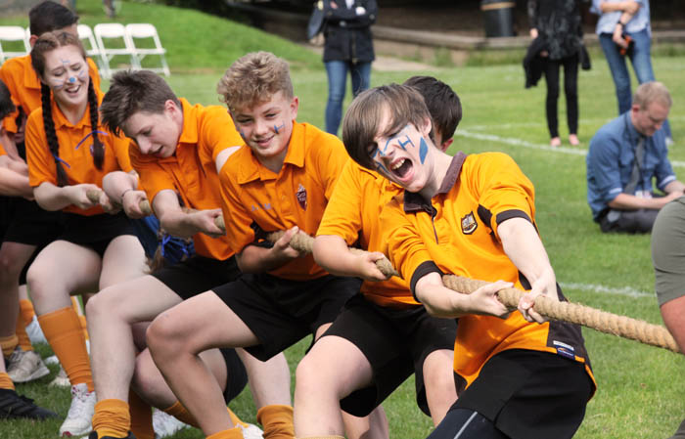

The Mathematics department at Gad’s Hill school consists of three qualified teachers. Miss Sameena Rana is the subject mentor for Mathematics and has taught at the school since 2013. Mathematics is a very successful subject at the school, with excellent GCSE results. Dr Stephanie Burke is the overall Initial Teacher Training Lead at the school.

Applying
The placement on offer is for a graduate of Mathematics to train via a SCITT place using training provider eQualitas. The placement is for one year, during which the candidate would train towards assessment for Qualified Teacher Status at the end of the academic year in Key Stages 3 and 4 Mathematics and would then be qualified and equipped to apply for NQT positions. The opportunity to upgrade to an additional PGCE qualification may be available. For the avoidance of doubt, you will not be an employee of the School. Government funding for the placement is paid directly by the Government to you.

Applicants would first need to apply for the placement at Gad’s and be accepted, then apply for the training position via UCAS for acceptance by the external training provider eQualitas. Help and support would be given by Gad’s and eQualitas in this application.

Funding
The trainee will receive DfE funding from which £6,000+VAT would need to be paid in tuition fees to eQualitas. Tax-free DfE scholarships of £22,000 or bursaries of £20,000 are available with the potential for early career payments in following years. The school does not charge for the placement, nor employ the trainee. Students may be able to obtain in addition a student loan for the tuition fee amount.

The training year
A trainee teacher at Gad’s meets weekly with a subject-based tutor, and receives weekly training from the ITT Lead along with any other trainees. Trainee teachers receive high-quality input to progress towards excellent assessment results for QTS. Trainee teachers have the opportunity at Gad’s to learn in an environment which provides small classes and high-quality support, enabling the trainee to develop into an excellent teacher equipped for teaching in any setting. Trainee teachers also take part in contrasting placements as part of the training year, which Gad’s arrange.

Training days are provided by eQualitas on a range of topics (included in the tuition fee cost). A subject tutor is also provided by eQualitas. The external tutor visits the student each term to monitor progress towards QTS, keeps in regular contact with the student, and ultimately assesses the student for QTS which is then verified by an additional external verifier before QTS is awarded.

The candidate
To apply for this placement, the following are essential:
- An undergraduate degree in Mathematics (or closely related subject) graded 2.1 or above
- An enthusiasm to train to become an excellent classroom teacher
- The willingness to complete all required aspects of the training year to a high standard

In addition, the following are desirable:
- A willingness to be involved in all aspects of school life
- Previous experience of working with children or young people

The benefits
- High quality training from eQualitas and at Gad’s from an ITT Lead with a Doctorate in Education
- Contrasting placements arranged for you
- Small class sizes and a supportive environment in which to learn
- Achievement of Qualified Teacher Status
- Tax-free government funding

Gad’s Hill is committed to safeguarding and promoting the welfare of children and we expect all staff to share this commitment. All posts are subject to enhanced Disclosure & Barring Service checks (DBS) and pre-employment checks will be undertaken before any appointment is confirmed. An overseas police check will be required by candidates who have worked or resided
outside of the UK, in the last 5 years.

