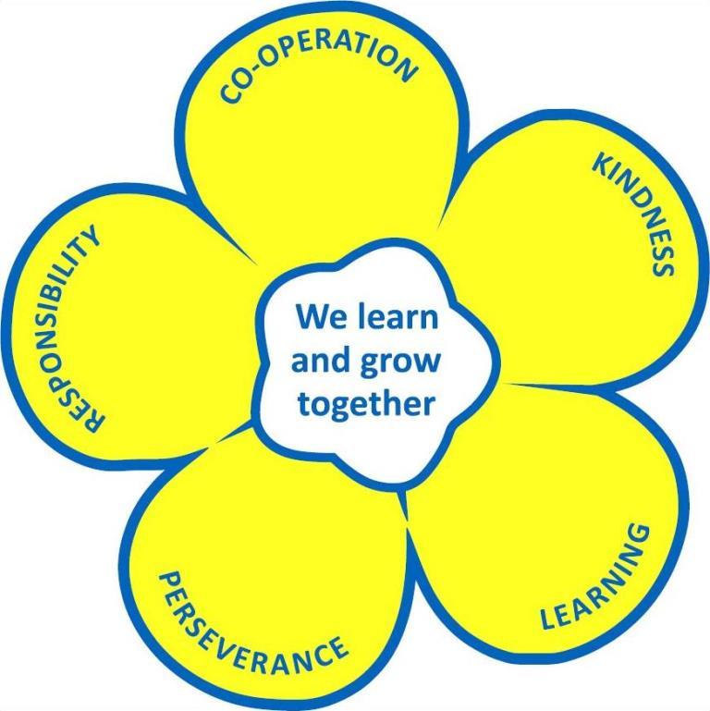
Herne Bay Infant School & Seashells Nursery

Job Description

SCHOOL: HERNE BAY INFANT SCHOOL

POST: Teacher in Charge of Nursery

NAME:

RESPONSIBLE TO: Deputy Headteacher/Headteacher

This position requires an Enhanced CRB Disclosure.

Herne Bay Infant School is committed to safeguarding and promoting the welfare of children and young people and expects all staff and volunteers to share this commitment. The post is subject to an enhanced Disclosure application to the Disclosure Barring Service and ISA Registration, plus verification of the right to work in the UK.

Purpose and Objectives:

The conditions of employment within the Education Act 1987 (School Teachers’ Pay & Conditions of Employment) specify the overriding requirements, general functions and professional duties of all teachers.

In addition to the above, the following also applies to this post:-

Principal Accountabilities:

- To be responsible for the development and management of the nursery.
- To secure the implementation of nursery policies by all staff which will result in high quality learning and teaching experiences for children.
- To model exemplary practice.

Main Tasks:

- To provide a high quality learning, and developmentally appropriate, environment through which all children access a broad and balanced inclusive curriculum, that fosters their intellectual, emotional, physical, spiritual, moral, social and cultural development.
- To enable all children to learn and develop skills, attitudes and understanding which prepare them for their continuing education.
- To ensure that all children have access to the curriculum and make progress commensurate with their developing abilities irrespective of their gender, ethnic or social background, disability or other special needs.
- To lead by example and to ensure that the learning activities and resources employed throughout the unit are appropriately matched to the age and stage of development of each child.
- To promote a positive mutually respectful interactive partnership between home and school in which individual progress is shared and next steps in learning discussed.
- To enable all children to develop positive dispositions for learning and high levels of well being and involvement.
- To develop effective policies for behaviour management appropriate to the age and stage of development of children in the nursery.
- To establish and maintain effective planning, assessment and record keeping systems and to train other members of the team in their use as necessary.
- To enable children to make an effective transition from home, pre-school to nursery and onto reception class.
- To manage all staff in the nursery.
- To keep abreast of educational initiatives and developments in nursery Education through a range of CPD activity and personal reading and research.
- To liaise with other outside agencies as appropriate e.g. health visitors.

SIGNED

SIGNED DATED

