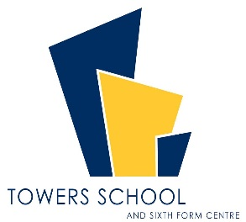
Person Specification
JOB TITLE: Main Scale Classroom Teacher
REPORTING TO: Principal and Head of Faculty
SUPERVISORY RESPONSIBILITY: The post-holder may be responsible for the supervision of the work of classroom assistants relevant to their responsibilities

Qualifications
- Qualified teacher status or recognised equivalent

Experience
- Teaching experience with the age range and/or subject(s) applying for.

Knowledge and skills
The ability to effectively:
- Create a stimulating and safe learning environment.
- Establish and maintain a purposeful working atmosphere.
- Plan, prepare and deliver the curriculum as relevant to the age and ability group/subject that you teach, other relevant initiatives and the school’s own policies.
- Assess and record the progress of pupils’ learning to inform next steps and monitor progress.
- Demonstrate a commitment to equal opportunities and use a variety of strategies and practices to promote the diverse cultural and equality issues in the classroom.
- Teach using a wide variety of strategies to maximise achievement for all children including those with special educational needs and high achievers and to meet differing learning styles.
- Encourage children in developing self-esteem and respect for others.
- Deploy a wide range of effective behaviour management strategies, successfully.
- Communicate to a range of audiences (verbal, written, using ICT as appropriate).
- Use ICT to advance pupils’ learning, and use common ICT tools for their own and pupils’ benefit.

Commitment
Demonstrate a commitment to:
  - equalities
  - promoting the school’s vision and ethos
  - high quality, stimulating learning environments
  - relating positively to and showing respect for all members of the school and wider community
  - ongoing relevant professional self-development
  - safeguarding and child protection

