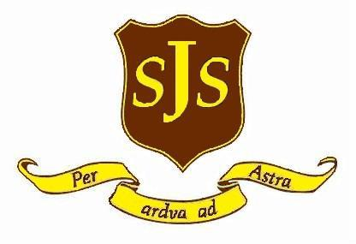 | PERSON SPECIFICATION  Teaching Assistant – S&L

Grade | Kent Range 3
Responsible to | Headteacher and Inclusion Manager

Essential
- Qualification in Maths and English GCSE or Equivalent Grade C minimum
- Excellent verbal communication skills
- Active Listening Skills
- Experience of working with young children
- Patience and ability to remain calm in stressful situations
- Demonstrate a working understanding of current theory and practice in relation to young people who have additional needs
- An ability to find solutions and be proactive, and the initiative to act or ask when unsure.
- Ability to use ICT effectively to support learning
- Able to work constructively as part of a team, understanding roles and responsibilities and your own position in these.

Desirable
- Experience of working 1:1 or small group work
- Qualification in speech and language development or similar experience
- Knowledge of SEN on SIMS
- Experience of working with pupils with identified SEN needs

