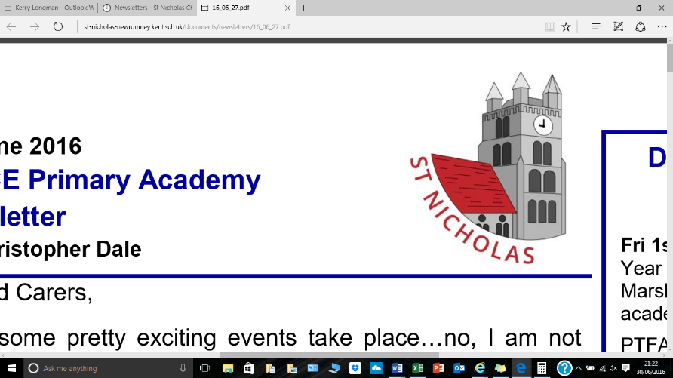



**Background Information**

St Nicholas CE Primary Academy, is situated in the heart of New Romney, set in beautiful surroundings and is well resourced to meet the needs of its 14 classes and 350 children, in this well-maintained school.

We have a committed and enthusiastic staff who are determined to enable every child to reach their potential by providing them a stable, caring environment where children are happy to attend, and are stimulated and keen to learn while developing their individual potential. We cater for a wide range of ability encouraging all children to achieve at their highest level.

Our church academy status means we have a strong Christian ethos and links to St Nicholas Church in New Romney which enriches both our collective worship and academy values.

New Romney is an ancient Cinque Port situated in rural Kent, with excellent road links to Ashford (20 minutes), Canterbury (45 minutes) and Folkestone (30 minutes) or if you live in East Sussex only 45 minutes from Hastings!

St Nicholas CE Primary Academy is a ‘values based community’, committed to the education of the whole child. The Values have been adopted by all the stakeholders and are based on Christian principles aimed at developing children to become both successful learners and valued members of society. Our values are:

**Ambition | Community | Friendship | Perseverance | Respect | Trust**

At St Nicholas, we believe everyone needs values to guide them through life. Without values, we have no anchor, nothing on which to base our decisions and priorities and we recognise the huge role parents have to play in helping us embed them.

We teach our values through everything we do and through our daily Acts of Worship and PSHE curriculum. Values displays are prominent within the school environment in the belief that a good education gives us the chance to live longer, enjoy success, create life chances, provide for a family and much more. We are confident every parent and carer wants these for their children. Our values are not just for show; they are at the very heart of everyone and everything at St Nicholas CE Primary Academy.

We invite you to visit our school and discover for yourself the unique benefits of St Nicholas.