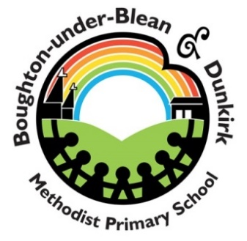

Boughton under Blean and Dunkirk Methodist Primary School
Teaching Assistant Job Description

Purpose of the Job
To work under the direct guidance of teaching staff and school leaders in order to enable access to learning for all pupils.
To support pupil’s educational development whilst also promoting and developing an appropriate level of independence.
To assist the teacher in ensuring the safety and well being of pupils at all times.

Tasks
- Be responsible for supporting the pupils engagement with classroom routines at different parts of the day
- Assist the teacher in behaviour management and ensuring pupils are kept on task
- To help maintain the learning environment and assist in preparing resources
- Give feedback to pupils on their learning (oral and written)
- To perform playground duties as designated by the SLT
- To ensure that the curriculum can be accessed and that learning takes place
- With support from the SENCO/ class teacher, facilitate any specialist programmes which are set out by external agencies.
- To promote and encourage the development of independent skills
- To carry out ongoing, informal, risk assessments to ensure high levels of safety at all times
- To assess when rest breaks may be needed and to facilitate these
- To offer some personal care such as dressing/ undressing and hygiene support such as washing hands
- To liaise with teaching staff about successes, challenges and needs or matters which need to be communicated to parents
- To promptly report any concerns to the class teacher/ SLT team particularly surrounding the medical needs of the pupil
- Follow school health & safety safeguarding policies and procedures

