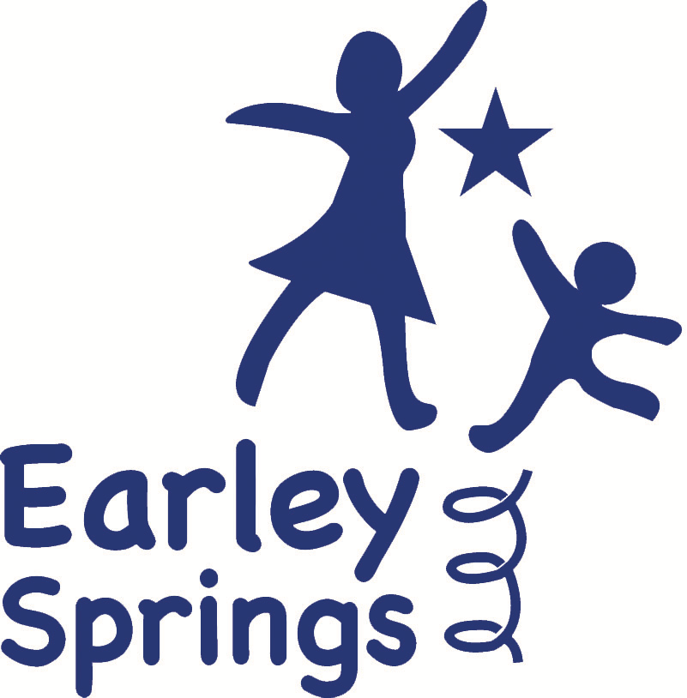

Teacher Job Description
Job Title: Teacher
Location: Earley Springs School, Harrietsham
Contract Type: Full-time, Term Time Only

Job Purpose
Earley Springs provides an inclusive, nurturing, and engaging learning environment for children aged 5–13 with communication and interaction needs. Our purpose is to enable every child to make meaningful progress, build confidence, and develop independence within a calm, structured, and supportive setting.
Due to expansion, we are seeking a committed and skilled Teacher to deliver well-planned, differentiated, and engaging learning experiences across our three pathways: Explorers, Discoverers, and Investigators. The successful candidate will plan and deliver high-quality teaching that is personalised, EHCP-led, and responsive to individual strengths and needs.

Principal Duties and Responsibilities
- Plan, deliver, and evaluate well-structured lessons that are carefully sequenced to meet the developmental needs of each pathway:
  - Explorers: Sensory-rich, experiential learning informed by Development Matters.
  - Discoverers: Practical and engaging learning experiences aligned with the Engagement Model.
  - Investigators: Academic and life-skills-focused learning aligned with the National Curriculum.
- Design and implement differentiated learning activities that promote progress in literacy, numeracy, communication, social development, and life skills.
- Adapt teaching strategies to meet a wide range of learning needs, ensuring all pupils can access learning in a meaningful and inclusive way.
- Create a positive, safe, and supportive learning environment that promotes independence, confidence, and emotional regulation.
- Work collaboratively with teaching assistants and other professionals to provide targeted support and interventions in line with EHCP outcomes.
- Assess, monitor, and record pupil progress using appropriate formative and summative assessment methods to inform future planning.
- Implement consistent and positive behaviour support strategies that promote emotional regulation, social interaction, and engagement with learning.
- Maintain effective communication with parents, carers, and external professionals, providing regular and clear updates on progress and development.
- Engage in ongoing professional development, including training in specialist SEN approaches such as Makaton, PECS, and the Engagement Model.
- Contribute positively to the wider school community through participation in staff meetings, CPD, and whole-school initiatives aligned with the school’s vision and ethos.
- Support pupils with personal care needs, including toileting, feeding, dressing, and changing, ensuring dignity, privacy, and respect at all times.
- Support pupils with specific medical needs and procedures, in line with training and school policies.
- Promote independence and the development of life skills through structured, real-world learning opportunities.

Essential Requirements
- Qualified Teacher Status (QTS) or equivalent.
- Experience teaching children with special educational needs, particularly communication and interaction needs.
- Ability to plan and deliver differentiated learning across the Explorers, Discoverers, and Investigators pathways.
- Strong organisational and communication skills, with the ability to work effectively within a multidisciplinary team.
- A clear commitment to safeguarding and promoting the welfare of children.

Desirable
- Experience working within a specialist or special school setting.
- Additional training or qualifications in SEN approaches, including SCERTS, Makaton, PECS, or similar.
- First aid training or a willingness to undertake training.

Benefits
- Competitive salary, dependent on experience and qualifications.
- Access to high-quality professional development and specialist training.
- A supportive, inclusive, and collaborative working environment.

Appointment Procedure
Candidates invited to interview will be offered the opportunity to tour the school and meet the Headteacher. Appointment to the post will be subject to the following checks:
- Enhanced DBS certificate
- Medical clearance
- Two satisfactory references

How to Apply
Interested candidates should submit a completed application form and personal statement to officeadmin@earleyspringsschool.com outlining their experience in SEN education and their commitment to inclusive, personalised learning.
Earley Springs School is committed to safeguarding and promoting the welfare of children and young people. All appointments are subject to enhanced DBS checks and professional references.

