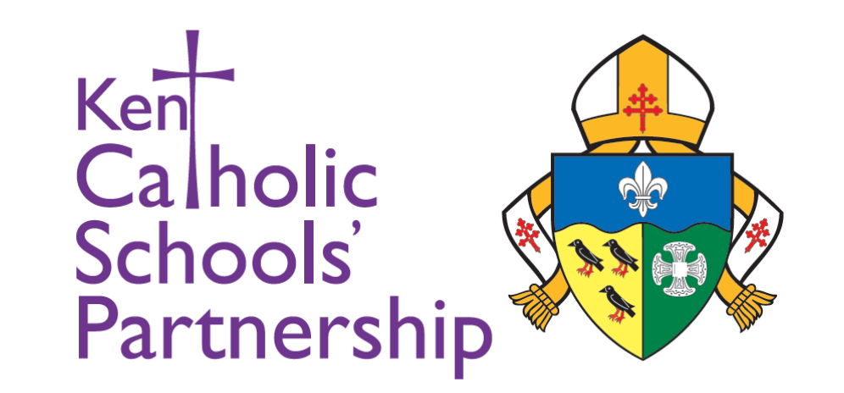
Knowledge-rich, skills led learning for all,
Christ at our heart,
Serving everyone in our community,
Partnership of love, ambition, joy, and peace.

Vacancy: Headteacher

Location: St Joseph’s Catholic Primary School, Aylesham, Kent

Salary Range: L8 - L21
Are you a practising Catholic with a heart for children, a passion for excellence, and the vision to lead a thriving school community? St Joseph’s Catholic Primary School is seeking an inspirational leader who can guide our wonderful school into its next chapter with faith, purpose, and joy.

St Joseph’s is proud to be part of the Kent Catholic Schools’ Partnership (KCSP), a family of 32 Catholic schools dedicated to providing high-quality Catholic education across Kent. Rooted in Gospel values, we place the wellbeing, formation, and success of every child at the centre of our mission.

About St Joseph’s
St Joseph’s is small but growing primary school, situated at the heart of the Aylesham community. Our pupils are nurtured, encouraged, and inspired to grow spiritually, academically, and personally within a warm, caring and supportive environment. With strong parish links, committed staff, and a friendly, family-orientated atmosphere, St Joseph’s is a place where every child is known, valued, and able to flourish.

The Role
Working closely with KCSP’s Area School Improvement Partner, the Headteacher will:
- Build on the strong foundations already in place
- Lead the day-to-day running of the school with clarity and compassion
- Inspire, support, and develop a dedicated and talented staff team
- Maintain the highest standards of learning, safeguarding, and pastoral care
- Champion and enrich the school’s Catholic mission and values: Love God, Love Learning, Love Life!

We are looking for a leader with drive, empathy, and vision—someone who will embrace all that makes St Joseph’s special while confidently leading the school forward.

Catholic Leadership
As Headteacher, you will play a central role in shaping and sustaining the Catholic life of the school. This is a reserved post, open to practising Catholics who:
- Have been sacramentally initiated into the Catholic Church
- Live in accordance with the teachings and moral life of the Church
- Demonstrate their faith through their actions, leadership, and example
This ensures the school continues to grow as a joyful, faith-filled Catholic community.

Visits and Applications
We warmly welcome visits to St Joseph’s — the best way to experience our community, ethos, and distinctive character first-hand. To arrange a visit, please contact the school office on 01304 840 370, or via email at: office@st-josephs-aylesham.kcsp.org.uk
To view the full Job Description and Person Specification, and to access the application form and supporting documents, please click here.
- Closing date for applications: 5pm on Wednesday 15 April 2026
- Interviews: Week commencing Monday 20 April 2026

We look forward to receiving applications from leaders who feel called to join the St Joseph’s family.

Please send your letter of application and related application documents directly to Sarah McBennett, Director of Education (Primary) c/o: office@kcsp.org.uk Your supporting statement should be limited to 2,000 words max. and should outline why you feel you are suited to this role, what you believe you can bring to the academy and detail your experience to date, skill set and qualifications.
St Joseph’s Primary and KCSP are committed to safeguarding and promoting the welfare of children, and require all staff, helpers and governance committee members to share this commitment. Offers of employment are subject to an enhanced disclosure and barring service check and a section 128 check.

