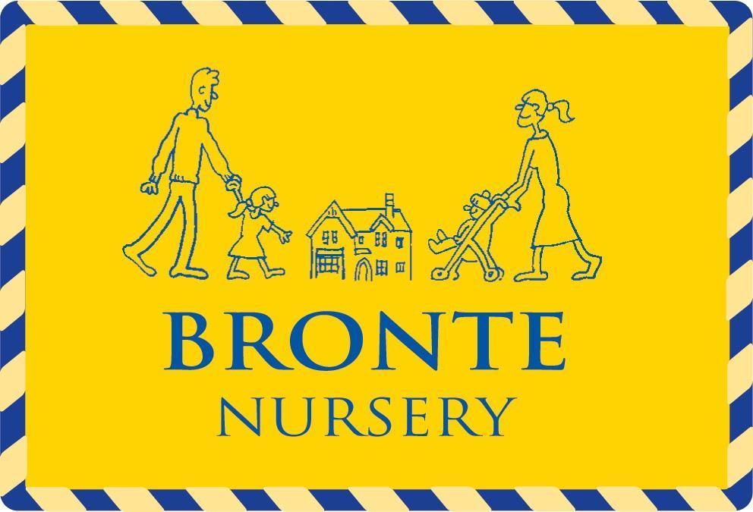

BRONTE SCHOOL & NURSERY

RECRUITMENT, SELECTION AND DISCLOSURES PROCEDURES

 | Date | Signed
Date reviewed | Sept 2025 |   (Mrs Siobhan Bradish, Bursar)
Date reviewed | Sept 2025 | 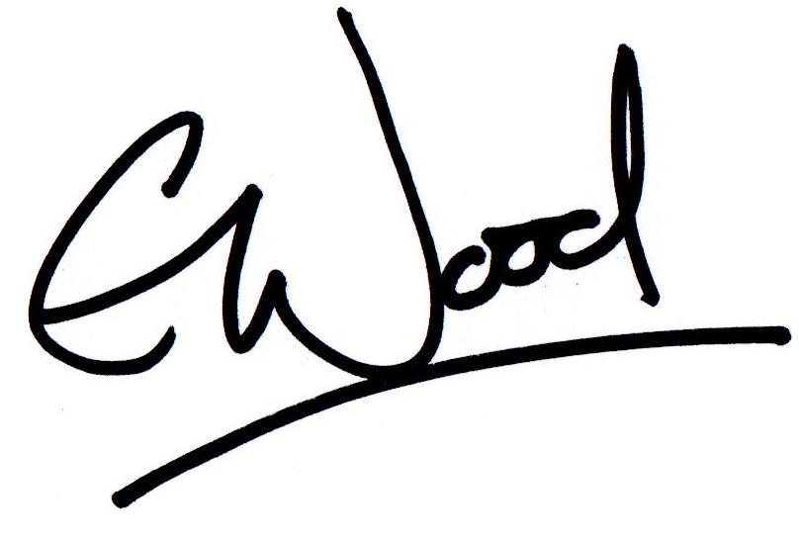  (Mrs Emma Wood, Headmistress & Nursery Director)
Date reviewed | Sept 2025 | 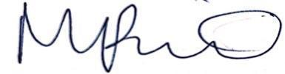  (Mrs Marie Pike, Nursery Manager)
Ratified by Proprietor | Sept 2025 | 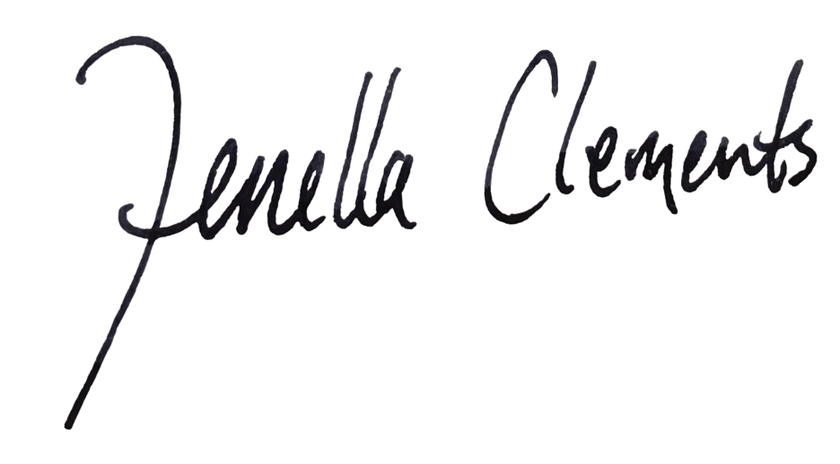  (Mrs. Fenella Clements, Proprietor)
Date of next review | SEPT 2027

This policy relates to Bronte School and Nursery.

General
Bronte School and Nursery is committed to providing the best possible environment for the children and young people in its care. Safeguarding and promoting their welfare is our highest priority.
We seek to recruit staff who share this commitment, ensuring no applicant is treated unfairly on the basis of a protected characteristic under the Equality Act 2010.
Recruitment and selection are conducted professionally, promptly, and in compliance with employment law, safeguarding legislation, and statutory guidance, including the latest KCSIE and Prevent Duty Guidance.
All recruitment queries should be directed to Mrs S Bradish (Bursar).
The Single Central Register includes all current staff, the proprietorial body, and individuals in regular contact with children, including volunteers, supply staff, and third-party contractors.
Bronte School and Nursery is owned by Fenella Clements, with DfE registration number 886/6026 for the School and EY48116 for the Nursery.
When appointing staff or trainees, references from authoritative sources are obtained in advance to assess childcare suitability (open references are not accepted). Safeguarding procedures include verifying identity, qualifications, and any concerns.
Scope of this Policy

The Recruitment, Selection and Disclosures Policy and Procedure herewith refers and applies to staff directly recruited and employed by the School and Nursery. In the Education (Independent Schools Standards) (England) Regulations 2014, the definitions are:
- Staff:
Any person working at the School or Nursery whether under a contract of employment, under a contract for services or otherwise than under a contract—and includes volunteers.
- Supply staff:
Any person working at the School or Nursery supplied by an employment business.

For agency and contract workers, the School and Nursery require written confirmation from the agency or company that all necessary checks have been completed. Identity checks are carried out by the School and Nursery on arrival. For agency staff, including supply staff, the School and Nursery must also receive a copy of their DBS check.
The School and Nursery confirm with the supply agency that all required checks have been completed, including identity, enhanced DBS (renewed every three years), right to work in the UK, barred list, prohibition, qualifications, overseas checks, two references, medical fitness declaration, and employment history. These checks are recorded on the Single Central Register, and the School and Nursery verify identity and sight the DBS disclosure in all cases.
Contractors who have not been fully checked are never allowed to work unsupervised. The level of supervision is determined by the School and Nursery based on the situation.
In line with the Prevent Duty Guidance, the School and Nursery ensure all visiting speakers are suitable and appropriately supervised.
Advertising

To ensure equality of opportunity and compliance with the Equality Act 2010, the School will advertise all vacant posts in a manner that encourages applications from a diverse field of candidates. This normally includes external advertising. All advertisements will clearly state the School’s commitment to safeguarding and promoting the welfare of children and young people, and to equal opportunities in employment.
All applicant information will be handled confidentially and in accordance with the School’s Data Protection Policy and applicable data protection legislation.
Application Form
The School and Nursery accept only fully completed application forms; CVs alone will not be considered.
Candidates are informed that all roles carry safeguarding responsibilities, varying by post. Job descriptions and person specifications are provided for employed positions.
Employment history will be reviewed to explain any gaps and verified against references; discrepancies will be discussed with the candidate.
Given the substantial access to children, applicants must provide accurate information. A criminal record does not automatically bar employment; the nature, timing, and circumstances will be considered. Such disclosures should be submitted confidentially in a sealed envelope for the Bursar or Headmistress/Nursery Director, or discussed by phone beforehand.
Applicants must declare any unspent convictions, cautions, reprimands, or warnings. Certain spent convictions and cautions are protected and need not be disclosed (see DBS guidance). The successful candidate must complete a DBS disclosure and inform the School or Nursery immediately of any reason they should not work with children, including disqualification from childcare or registration.
The statutory guidance Disqualification under the Childcare Act 2006 (2018) applies to those in early or later years childcare (including before/after school clubs for under-8s) and their managers. Anyone disqualified may apply to Ofsted for a waiver before working in relevant areas; please contact the Bursar for advice.
Failure to declare relevant convictions may result in disqualification or dismissal.
Under the Counter-Terrorism and Security Act 2015, the School and Nursery have a duty to prevent people being drawn into terrorism (Prevent Duty). DfE guidance can be found here.
For candidates currently or previously working with children, current and/or past employers will be asked about disciplinary offences, child protection concerns, and outcomes. If no child-related employment exists, the current employer will still be asked about suitability to work with children; where no employment history exists, character references may be requested.
Providing false information is a criminal offence and may lead to rejection, dismissal, and referral to the police or DBS.
Invitation to Interview
The School and Nursery shortlist applicants based on the relevance of their professional attributes and personal qualities to the role. Shortlisting is conducted by at least two people, who review any inconsistencies, employment gaps, and potential concerns.
As part of due diligence, an online search of shortlisted candidates is carried out to identify publicly available information relevant to their suitability to work with children, and any issues will be addressed at interview.
Shortlisted candidates are invited to a formal interview to discuss their skills, experience, and suitability in more detail. They must also complete a self-declaration form regarding any criminal record or other factors making them unsuitable to work with children, in line with Ministry of Justice guidance. Applicants sign a declaration confirming the accuracy of their information; electronic signatures must be supplemented with a physical signature at interview.
References are sought prior to interview wherever possible, so any concerns can be raised with referees or explored at interview.
All interviews are conducted in person by a panel of at least two members, chaired by the Head, Bursar, or another senior member of staff. For senior appointments, the Proprietor chairs the panel. At least one panel member will have completed safer recruitment training. Panel members must declare any personal knowledge of candidates; the Chair (or Vice Chair if necessary) decides if withdrawal from the panel is appropriate.
Candidates invited to interview must bring original or certified evidence of all relevant educational and professional qualifications. If unavailable, written confirmation must be obtained from the awarding body.
We request that all candidates invited to interview also provide:

- A current driving licence including a photograph or a passport or a full birth certificate;
- A utility bill or financial statement issued within the last three months showing the candidate’s current name and address;
- Where appropriate any documentation evidencing a change of name;
- Where the candidate is not a citizen of a country within the European Economic Area or Switzerland, proof of entitlement to work and reside in the UK.
- Right to work checks are required on all candidates who are not UK citizens

Please note that originals of the above are necessary. Photocopies or certified copies are not sufficient.

Candidates with a disability who are invited to interview should inform the School or Nursery of any necessary reasonable adjustments or arrangements to assist them in attending the interview.

Conditional Offer of Appointment: Pre-Appointment Checks

Any offer to a successful candidate will be conditional upon:

- Receipt of at least two satisfactory references (if these have not already been received);
- Verification of identity and qualifications including, where appropriate, evidence of the right to work in the UK;
- A satisfactory enhanced DBS check and if appropriate, a check of the Barred List maintained by the DBS;
- For a candidate to be employed as a teacher, a check that the candidate is not subject to a prohibition order issued by the Secretary of State. Teaching work is defined in The Teachers’ Disciplinary (England) Regulations 2012 to encompass:
- Planning and preparing lessons and courses for pupils
- Delivering and preparing lessons to pupils
- Assessing the development, progress and attainment of pupils
- Reporting on the development, progress and attainment of pupils;

- Verification of professional qualifications, where appropriate;
- Verification of successful completion of statutory induction period (for teaching posts – applies to those who obtained QTS after 7 May 1999);
- Where the successful candidate has worked or been resident overseas: Such further checks and confirmations as we may consider appropriate so that any relevant events that occurred outside the UK can be considered. This shall include the candidate providing us with a letter from the professional regulating authority in the country (or countries) in which they have worked confirming that they have not imposed any sanctions or restrictions, and/or that they are aware of any reason why they may be unsuitable to teach.;
- Satisfactory medical fitness;
- Confirmation that the candidate is not disqualified from providing childcare as set out in the statutory guidance “Disqualification under the Childcare Act 2006 (July 2018)” OR Receipt of a signed Staff Suitability Declaration form showing that the candidate is not disqualified from providing childcare as set out in the statutory guidance “Disqualification under the Childcare Act 2006 (July 2018)”
- Where the successful candidate will be taking part in the management of the School, a check will be carried out under section 128 of the Independent Educational Provision in England (Prohibition on Participation in Management) Regulations 2014. This applies to all Governors, Senior Management Team and teaching heads of department; and
- For a candidate that has lived or worked outside the UK, an EEA check using the Teaching Regulation Agency employer access system for information about any teacher sanction or restriction.
It is the School and Nursery’s practice that a successful candidate must complete a pre-employment health questionnaire. The information contained in the questionnaire will then be held by us in strictest confidence. This information will be reviewed against the Job Description and the Person Specification for the particular role, together with details of any other physical or mental requirements of the role i.e. proposed workload, extra-curricular activities, layout of the School or Nursery.
We are aware of our duties under the Equality Act 2010. No job offer will be withdrawn without first consulting with the applicant, considering medical evidence and considering reasonable adjustments.
References
The School and Nursery will request references for all shortlisted candidates, including internal applicants where appropriate, and may contact previous employers to verify experience or qualifications before interview. At least one reference must be from the current or most recent employer and must come from a senior individual with appropriate authority. Candidates who prefer references not be taken before interview, must notify us when applying.
Referees will be asked to confirm the candidate’s suitability to work with children and to disclose any substantiated safeguarding concerns or allegations meeting the harm threshold in Keeping Children Safe in Education. Allegations found to be false, unfounded, unsubstantiated, or malicious will not be included.
References will only be accepted directly from referees and not from the applicant, nor will open references or testimonials be relied upon. All references will be verified, and electronic references checked to ensure they come from a legitimate source.
Information from references will be compared with the candidate’s application, and any discrepancies discussed at interview.
Criminal Records Policy

The School and Nursery will refer to the Department for Education (“DfE”) document, ‘Keeping Children Safe in Education’ and any amended version in carrying out the necessary DBS checks.

The School and Nursery complies with the provisions of the DBS Code of Practice, a copy of which may be obtained on request, or accessed here:
https://www.gov.uk/government/publications/dbs-code-of-practice.

There are limited circumstances where the we will accept a check from another educational institution which are as follows:

This is where the new member of staff (“M”) has worked in:
- A School or a maintained School in England in a position which brought M regularly into contact with children or young persons;
- A maintained School in England in a position to which M was appointed on or after May 2006 and which did not bring M regularly into contact with children or young persons; or
- An institution within the further education sector in England or in a 16 to 19 Academy in a position which involved the provision of education or which brought M regularly into contact with children or young persons,

during a period which ended not more than three months before M’s appointment.

In these circumstances the School or Nursery may apply for a disclosure but is not required to do so. A new, separate barred list check will be obtained.

DBS Update Service

Where an applicant subscribes to the DBS Update Service the applicant must give consent to the School to check there have not been changes since the issue of a disclosure certificate. A barred list check will still be required.

If disclosure is delayed
A short period of work is allowed under controlled conditions, at the Headmistress/Nursery Director’s discretion. However, if an ‘enhanced disclosure’ is delayed, she may allow the member of staff to commence work:

- After a satisfactory check of the barred list if the person will be working in regulated activity and all other relevant checks (including any appropriate prohibition checks) having been completed satisfactorily;
- Provided that the DBS application has been made in advance;
- With appropriate safeguards taken (for example, supervision and completion of a risk assessment);
- Safeguards reviewed at least every two weeks by the Bursar and member of staff;
- The person in question is informed what these safeguards are; and
- It is recommended, but not a requirement, that a note is added to the single central register and evidence kept of the measures put in place.

Retention, Security of Records and Data Protection Obligations

The School and Nursery will comply with its obligations regarding the retention and security of records in accordance with the DBS Code of Practice and its obligations under its Data Protection Policy.

We will comply with its data protection obligations in respect of the processing of criminal records information. More information on this is included in the Recruitment Privacy Notice and the Data Protection Policy.

Appendix

Policy on the Recruitment of Ex-Offenders

We will not unfairly discriminate against any candidate for employment on the basis of conviction or other details revealed. The School and Nursery makes appointment decisions on the basis of merit and ability. If an individual has a criminal record this will not automatically bar him/her from employment within the School and Nursery. Instead, each case will be decided on its merits in accordance with the objective assessment criteria set out below.

All candidates should be aware that provision of false information is an offence and could result in the application being rejected or summary dismissal if they have been appointed, and a possible referral to the police and/or DBS.

Under the relevant legislation, it is unlawful for the School and Nursery to employ anyone who is included on the lists maintained by the DBS of individuals who are considered unsuitable to work with children. In addition, it will also be unlawful for the School or Nursery to employ anyone who is the subject of a disqualifying order made on being convicted or charged with the following offences against children: murder, manslaughter, rape, other serious sexual offences, grievous bodily harm or other serious acts of violence. It is also unlawful for the School or Nursery to knowingly employ someone who works in the relevant settings and is disqualified from providing childcare under the statutory guidance “Disqualification under the Childcare Act 2006 (July 2018)”.

It is a criminal offence for any person who is disqualified from working with children to attempt to apply for a position within the School or Nursery. We will report the matter to the Police and/or the DBS if:

- the School or Nursery receives an application from a disqualified person;
- is provided with false information in, or in support of an applicant's application; or
- The School or Nursery has serious concerns about an applicant's suitability to work with children.

In the event that relevant information (whether in relation to previous convictions or otherwise) is volunteered by an applicant during the recruitment process or obtained through a disclosure check, we will consider the following factors before reaching a recruitment decision:

- whether the conviction or other matter revealed is relevant to the position in question;
- the seriousness of any offence or other matter revealed;
- the length of time since the offence or other matter occurred;
- whether the applicant has a pattern of offending behaviour or other relevant matters;
- whether the applicant's circumstances have changed since the offending behaviour or other relevant matters;
- in the case of disqualification from providing childcare, whether the applicant has or is able to obtain an Ofsted waiver from disqualification; and
- the circumstances surrounding the offence and the explanation(s) offered by the convicted person.

If the post involves regular contact with children, it is the normal policy to consider it a high risk to employ anyone who has been convicted at any time of any the following offences: murder, manslaughter, rape, other serious sexual offences, grievous bodily harm or other serious acts of violence, serious class A drug related offences, robbery, burglary, theft, deception or fraud.

If the post involves access to money or budget responsibility, it is our normal policy to consider it a high risk to employ anyone who has been convicted at any time of robbery, burglary, theft, deception or fraud.

If the post involves some driving responsibilities, it is the normal policy to consider it a high risk to employ anyone who has been convicted of drink driving.

RECRUITMENT CHECKLIST

Action | Date |  | Completed by (please initial)
Name: Position: Salary: £
Advertisement placed
Send to Applicant:
· Application form
· Equal Opportunities Monitoring Form
· Job Description & Person Specification
· Child Protection Policy
· Application and Recruitment Process Explanatory note
· Recruitment Privacy Notice

Received from Applicant:
- Completed Application form
For shortlisted candidates only, consider carrying out an online search
Letter Invitation to Interview including Self-Declaration Form
At least two reference requests sent (ensure references for internal candidate are requested and followed up)
References followed up over telephone (including School where last worked) and electronic references verified as coming from legitimate source
Interview with written outcome

Record kept of reasons for any gaps in employment
Identification documents received (including name, address, and D.O.B.)

Hard copy of signed Self-Declaration Form
Evidence of right to work in UK
Qualifications
Rejection letter sent (if applicable)
Conditional offer made.
Sent to Applicant:
· Applicant completed online DBS application
· Contract of Employment
· Health Declaration & Questionnaire
· Self-Declaration Form
Health Declaration signed
Payroll documents completed
DBS check received and satisfactory
Barred list check received and satisfactory (where appropriate)
Where appropriate, verification of any award of Qualified Teacher Status, completion of teacher induction or probation
If the candidate is undertaking a leadership role, evidence that the candidate is not prohibited from participating in the management of independent Schools.
EEA Check for individuals who have lived or worked overseas (if applicable)
Prohibition Order check (for a candidate to be employed as a teacher)
For all applicants who have worked or been resident overseas: Such further checks and confirmations as the School may consider appropriate so that any relevant events that occurred outside the UK can be considered. This shall include the candidate providing the School with a letter from the professional regulating authority in the country (or countries) in which they have worked confirming that they have not imposed any sanctions or restrictions, and/or that they are aware of any reason why they may be unsuitable to teach
Receipt of a signed Staff Suitability Declaration form showing that candidate is not disqualified from providing childcare under the Childcare (Disqualification) Regulations 2018
Check single central register completed
Induction completed

Verified by Headmistress/Nursery Director ……………………………………
Date: ………………..

