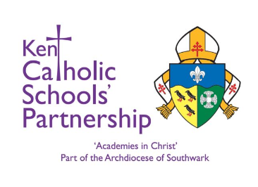

CANDIDATE INFORMATION

DOCUMENTS TO BRING TO INTERVIEW

Candidates are asked to bring a range of documentation for the purposes of establishing identity and to aid any pre- employment checks, including right to work in the UK.

Please ensure that:
- You bring original documents only (no photocopies or online versions)
- All documents must be in your current name
- One must verify your current address
- One must include your date of birth
- One must include a photo
- You may need to provide additional eligibility documentation stated within the advert, (e.g. qualification certificates)

Checklist

Please provide ONE of the following:

Full Valid Passport
Photocard Driving Licence

And TWO of the following (at least one must include your current address – if two items contain your address, both addresses must be current and match):

UK Bank/Building Society Statement (dated within last 3 months)

Credit Card statement at given address (dated within last 3 months)

UK Birth Certificate (original version issued at the time of birth)

Adoption Certificate (issued within 42 days of adoption order)

Driving Licence (if not used above – photo card or paper version)

Utility Bill sent to the candidate at the given address (dated within last 3 months)

Council Tax Bill sent to the candidate at the given address (dated within the current tax year)

