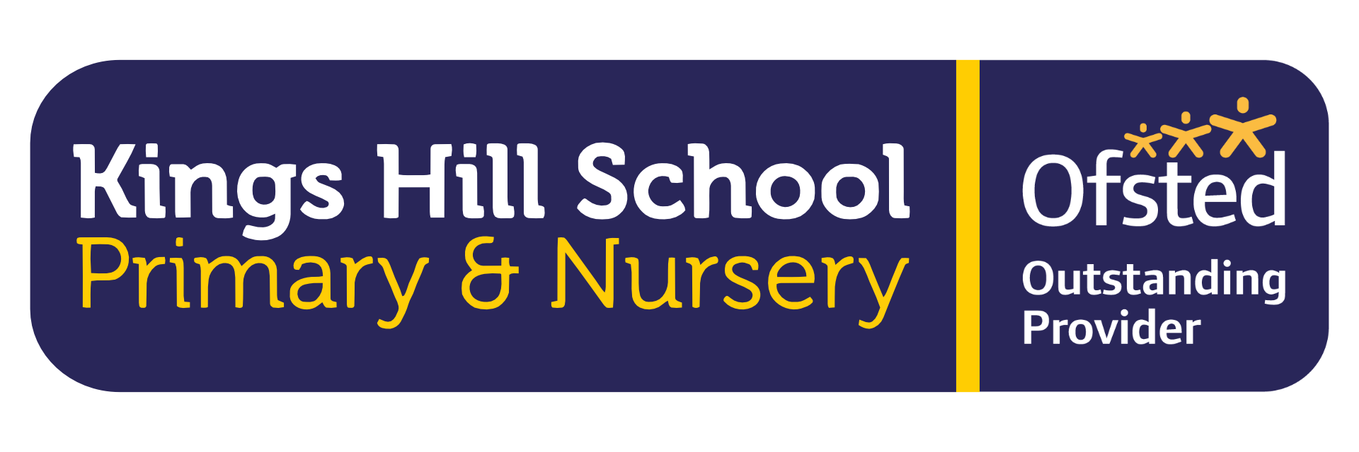

Job Specification – Nursery Teacher / Early Years Practitioner
Salary: £27,785 – £45,352 (dependent on qualifications and experience)
Contract: 4 days per week, permanent (Term-Time)

Job Purpose
To lead high-quality early years provision for children aged 2–4 within our school-based nursery. The post holder will inspire and develop a team of practitioners, ensuring an enriching curriculum and nurturing environment that reflects our school values: Kindness, Resilience, Respect, Courage, Cooperation and Responsibility.
Act within, the statutory frameworks, which set out their professional duties and responsibilities and in line with the duties outlined in the current School Teachers Pay and Conditions Document and Teacher Standards (2012)

Key Responsibilities

Teaching and Learning
• Plan, deliver and evaluate high-quality, play-based learning experiences reflecting children’s interests and developmental stages.
• Contribute to and develop a curriculum that meets the Early Years Foundation Stage (EYFS) requirements.
• Promote purposeful engagement and high levels of well-being and involvement.
• Ensure environments (indoor and outdoor) are stimulating, language-rich and inclusive.

Assessment and Progress
• Track children’s progress using observations and formative assessment.
• Identify next steps in learning and ensure interventions are put in place for children not making expected progress.
• Work collaboratively with the SENCO and wider team to ensure appropriate support for children with SEND, EAL or additional needs.
• Support practitioners in accurate assessment and record-keeping.

Leadership and Team Development
• Lead, motivate and inspire a team of qualified and unqualified early years practitioners.
• Model high standards of practice and positive interactions.
• Support staff through coaching, feedback and involvement in reflective practice.
• Contribute to staff development meetings and training.

Safeguarding, Inclusion & Wellbeing
• Promoting the safeguarding and welfare of children in line with school policy and statutory guidance.
• Ensure equality of opportunity and inclusive practice for all children and families.
• Build and maintain positive relationships with parents, involving them in their child’s learning journey.
• Contribute to a nurturing and values-led environment where children feel safe, respected and valued.

Collaboration and Professional Conduct
• Work in partnership with the Assistant Headteacher responsible for nursery, taking an active role in nursery development.
• Engage with professional development to remain current in early years pedagogy and practice.
• Contribute to whole-school priorities and represent the nursery as part of the wider school community.
• Uphold the ethos, vision and values of Kings Hill School in all interactions.
This job description is not your contract of employment or any part of it. It has been prepared only for the purpose of school organisation and may change either as your contract changes or as the organisation of the school is changed. Nothing will be changed without consultation.

Person Specification
Essential:
• Hold either a Qualified Teacher Status (QTS) or Early Years Teacher Status (EYTS) Early Years teacher status, Early Years Practitioner Status (EYPS).
• Strong understanding of child development and EYFS curriculum
• Proven ability to lead and inspire a team
• Commitment to inclusive, child-centered practice
• Excellent communication and relationship-building skills
• Knowledge of safeguarding and child protection procedures
• Reflective, innovative and keen to engage in professional learning
Desirable:
• Experience in a school-based nursery setting
• Experience in curriculum development and staff mentoring
• Experience working with children aged 2–4 specifically
• Additional EYFS/SEND training
• Experience liaising with external agencies
• Experience in leading parent consultations/workshops
• Paediatric First Aid trained

