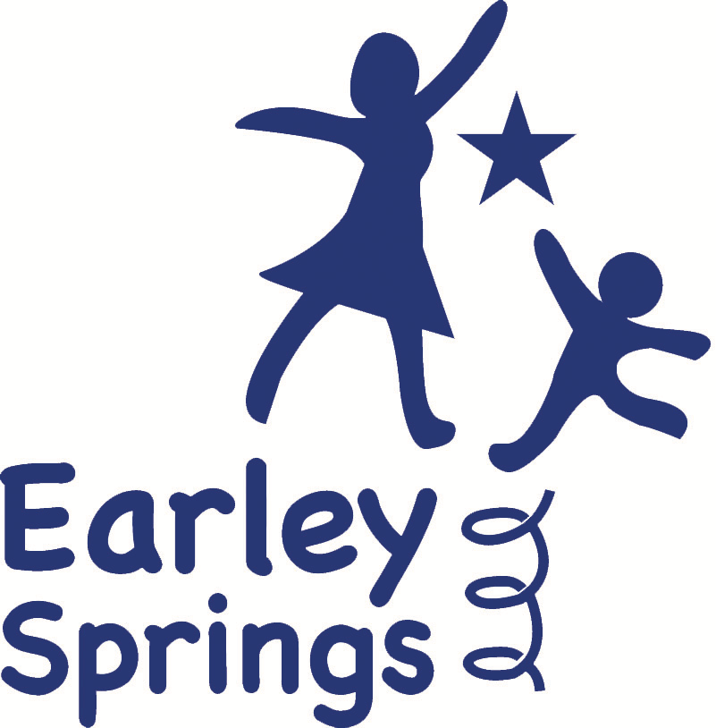

Teacher Job Description - Earley Springs
Job Title: Teacher
Location: Earley Springs School, Harrietsham
Contract Type: Full-time, Term Time Only
Job Purpose:
At Earley Springs, our mission is to provide an inclusive, nurturing, and engaging learning environment for children aged 5-13 with communication and interaction difficulties. Our aim is to inspire every child to reach their full potential, fostering confidence, independence, and resilience. For more information, please refer to our vision and mission statement: http://earleyspringsschool.com/schools-aim-ethos
We are seeking a committed and dynamic Teacher to deliver well-planned, differentiated, and engaging learning experiences across the three pathways – Explorers, Discoverers, and Investigators. The role involves planning and delivering high-quality lessons that meet the individual needs of each student, aligned with their EHCPs and personal targets.
Principal Duties and Responsibilities:
Develop and deliver well-structured lessons that are sequenced to meet the developmental stages of each pathway:
Explorers: Sensory-rich and experiential learning, based on P Levels and Development Matters.
Discoverers: Engaging, practical learning experiences aligned with the Engagement Model.
Investigators: Academic and life skills-focused lessons, aligned with the National Curriculum.
Plan and implement differentiated learning activities that promote progress in core areas such as literacy, numeracy, social communication, and life skills.
Adapt teaching strategies to meet the diverse needs of students with varying levels of ability, ensuring that learning is accessible, inclusive, and engaging.
Foster a positive and supportive learning environment that promotes independence, confidence, and self-regulation.
Work collaboratively with teaching assistants and therapists to provide targeted support and intervention, ensuring that all learning experiences align with EHCP objectives.
Assess, monitor, and record student progress, using formative and summative assessment strategies to inform future planning.
Implement behaviour management strategies that promote positive behaviour, emotional regulation, and social interaction.
Maintain open and effective communication with parents, carers, and external professionals, providing regular updates on student progress and development.
Engage in ongoing professional development, including training in SEN strategies such as Makaton, PECS, and the Engagement Model.
Contribute to the wider school community, participating in staff meetings, CPD sessions, and school initiatives that align with the vision and ethos of Earley Springs.
Assist with personal care tasks, including toileting, feeding, dressing, and changing, ensuring dignity, privacy, and respect for each child at all times.
Support students with specific medical procedures.
Promote independence and life skills development through structured, real-world learning experiences.
Essential Requirements:
Qualified Teacher Status (QTS) or equivalent.
Experience teaching children with SEN, particularly those with communication and interaction difficulties.
Ability to plan and deliver differentiated lessons across the three pathways: Explorers, Discoverers, Investigators.
Strong organisational and communication skills, with the ability to work effectively as part of a multidisciplinary team.
Commitment to safeguarding and promoting the welfare of children.
Desirable:
Experience working in a special school setting.
Additional qualifications in SEN, including SCERTS, Makaton, PECS, or similar.
First aid training or willingness to undertake training.
Benefits:
Competitive salary based on experience and qualifications.
Comprehensive professional development and training opportunities.
Supportive and inclusive working environment.
Appointment Procedure:
Candidates invited for an interview will be provided with an opportunity to tour the school and meet the Headteacher.
Appointment to the post will be based on the following checks:
- Enhanced DBS certificate
- Medical clearance
- 2 x satisfactory references
How to Apply:
Interested candidates should submit a completed application form and personal statement to admin@earleyspringsschool.com. Please outline your experience in SEN education and your commitment to supporting diverse learning pathways.
Earley Springs is committed to safeguarding and promoting the welfare of children and young people. All appointments are subject to a satisfactory Enhanced DBS check and professional references.

