** Marlborough School Overview**

# About Us

Marlborough School is a maintained split site special school for students aged 11-19 with complex and severe learning difficulties in the London borough of Bexley. Marlborough enjoys an excellent reputation within the local community and visitors often comment on the positive ethos, friendly atmosphere and commitment of the staff and resilience of our learners. Students are always at the heart of what we do and why we do it. Marlborough provides Outreach support to the borough, and has an Area of Excellence for Positive Proactive Strategies To Support The Wellbeing Of Pupils With Complex SEND through Challenge Partners.

## Our Vision and motto

Our vision is to achieve excellence where innovation, equality and wellbeing are at the heart of what we do. Our mission is to effectively meet the needs of all our students’ unique and holistic needs, enable them to thrive and effectively prepare them for adulthood. Our school motto is:

***Every moment is a learning opportunity***

Our Aims

To achieve this, we pledge to:

* Provide our students with an exciting and highly personalised, student led curriculum rich in creativity and challenge.
* Ensure exciting, engaging learning experiences provided by a dedicated and highly skilled workforce.
* Ensure that the development of communication, independence and physical skills are central to our teaching.
* Effectively promote student personal development and wellbeing through embedding our school values (HEART), positive behaviour support, a range of therapeutic approaches and partnership working with parents/carers.
* Effectively promote the students’ spiritual, moral, social and cultural development and enable all students to play a full and active part in the life of the school, local and wider community.
* Ensure that our bespoke holistic assessment system continuously drives learning and enables students to make the best possible progress.

**Our Values**

At Marlborough School, we are inspired by our learners and pledge to provide them with innovative practice that will have a positive impact on their lives today and in the future. We believe this is possible by creating a learning community in which all of its members can flourish and enjoy success. We pledge to uphold the 5 core values at the ‘HEART ‘of everything we do:

**Happiness -** At Marlborough, we recognise that all our learners do best when they are happy and engaged in their learning. We provide a safe, secure, supportive and inclusive learning environment that promotes physical and emotional wellbeing and where laughter, light, excitement and enthusiasm shines through.

**Empowerment -** At Marlborough, we are committed to empowering our learners to develop confidence and autonomy, to take ownership of their own learning and control over their lives. We support our learners to be honest and reflective and encourage them to enjoy the freedom to take risks and to learn from their mistakes.

**Aspiration** - At Marlborough, we are passionate and ambitious about learning and progress. We recognise the effort and resilience of our learners and celebrate all achievements. We are committed to a culture of continuous improvement in all our endeavours.

**Respect** - At Marlborough, we treat all members of our community with respect and foster self-respect. We provide equality of opportunity for all. We show compassion, kindness, understanding and unconditional positive regard for each other. We celebrate diversity and individuality and ensure everyone has their voice heard and valued.

**Teamwork** - We recognise that successes are achieved through our combined effort and collaboration with families and professionals. We recognise that positive personal relationships are central to ensuring the best outcomes for all. We model, and support our students to work with, enthusiasm, positivity, trust and integrity.

**Equality and Diversity**

Marlborough School is an inclusive school, where equality of opportunity is a reality for all our staff, students and community. We have a culture of inclusion and diversity, in which people feel free to be open and to participate fully in school life, and value difference. Marlborough School is committed to fulfilling the requirements of the 2010 Equalities Act. This means we:

* Challenge and eliminate discrimination, harassment, and victimisation
* Advance equality of opportunity between people who share a protected characteristic and people who do not share it;
* Foster good relations across all characteristics
* Support all staff through equity as well as equal opportunities

**Wellbeing and Mental Health**

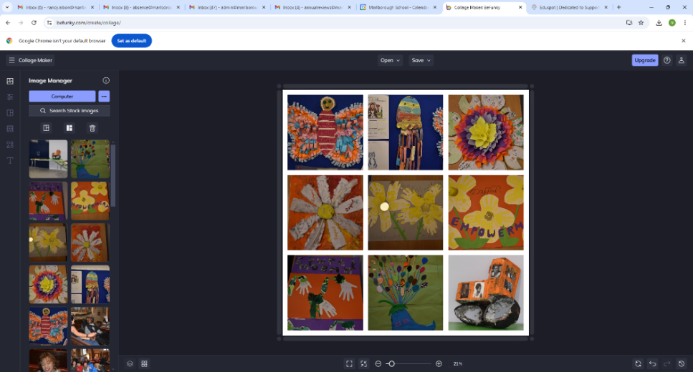The wellbeing of our students and staff is paramount. The school is located within beautiful parkland, allowing for lunchtime walks and visits to the school Café, as well as access to a variety of local shops and eateries just a few minutes’ walk away. It is a lovely feeling to be in the middle of the local community in which we have many charity partners. We have an active wellbeing staff committee who organise different staff events such as quizzes and staff breakfasts. We also have a dedicated Wellbeing room which staff can access any time they need to take some time out, or to use as a payer of reflection space.

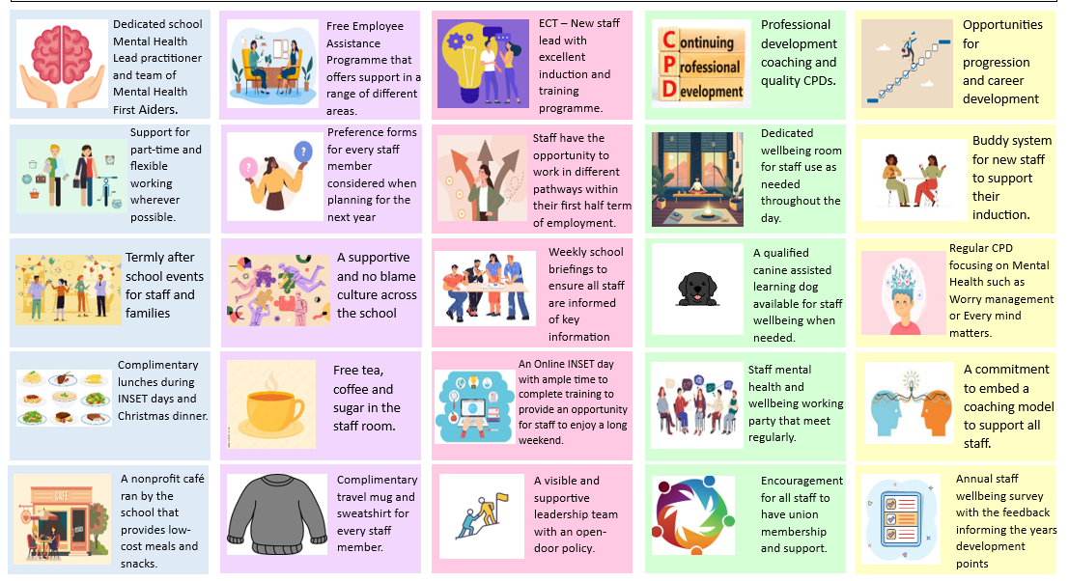We have signed the DfE’s *Education Staff Wellbeing Charter*, a declaration of support for, and a set of commitments, to the wellbeing and mental health of everyone working in education. In addition, we have created our own wellbeing charter. The Marlborough Wellbeing charter below takes into consideration the measures we have in place across the school to support all staff and also emphasizes the extra pressures many of our staff face associated with working in a Special Education setting. Our Wellbeing charter includes measures that encompass areas such as support, flexibility, community, benefits and commitment.

### Leadership Team

All members of staff are leaders, and we use a whole school distributed approach to support our students and drive improvements. Every class teacher leads a subject area, and our UPS teachers provide mentoring and coaching to ECTs, HLTAs and new staff. We have two TLR holders for Social, Emotional, Mental Health and Sensory, and Communication and Independence. We also have three specialist TAs - Health TA, Inclusion TA and an Intervention TA. Our formal senior leadership team consists of:

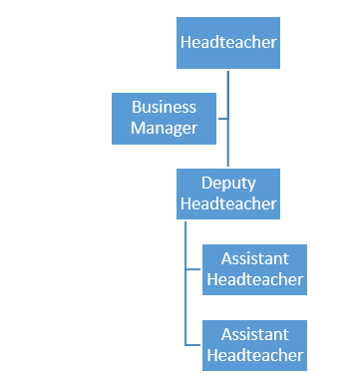

As a split site school, all senior leaders work across both sites – Marlborough Legacy and Marlborough Park Avenue, although the main base for our new SBM will be Marlborough Park Avenue. As a senior leadership team, we always work collaboratively together, providing support and challenge. We do not always agree but are always united once discussions are over and value constructive input.

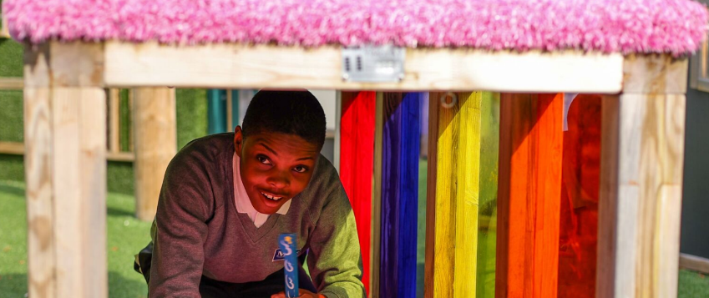

**What do our students think**

## Students say they feel happy and safe at school. They commonly associate these positive feelings with supportive relationships involving teachers, friends, teaching assistants, parents and family members, the bus driver, and engaging school activities like lunch clubs, swimming, music, and dance. Students use symbols and gestures to express themselves. Staff support student voice through observations of their reactions too.

## What do our staff think?

*“The students are amazing and it’s my privilege to work with them and their families”*

*“Working at Marlborough is a great opportunity to work in a lovely and local environment where professional development opportunities are given to all staff”*

*“Seeing the progress students make is really fulfilling, and I love working within a dedicated staff team”*

*“One of my favourite things is going to the Café when our students are doing work experience and dealing with the local community too – it’s great to feel part of!”*

## What do our parents think?

*"I am truly grateful for all your support and after the experiences I have had with previous schools in the past, it was really lovely to have a school that was so open to work so closely with my daughter and I"*

*"Thank you for only seeing the best in my son”*

*“My family and I would like to say thank you for being so supportive we are very grateful”*

*“I wanted to say thank you to you and Marlborough School for all you have done for my daughter. We loved the prom and sports day and thanks for facilitating overnight.”*

**Quotes from Challenge Partners Quality Assurance Review (March 2025)**

*“Every moment is a learning opportunity is the vision that is evident throughout the school, whether it is in the classroom, community partnerships or break times. It lends to a calm, purposeful learning environment which exudes joy and exuberance from staff for their pupils.”*

*“Pupils are supported by a highly skilled workforce to develop a range of skills to prepare pupils for adulthood.”*

*“Professional development for all staff is impressive. Coaching is being rolled*

*out across the school. Meetings are organised on a coaching model so that staff become more reflective practitioners and come to solutions themselves.”*