Outstanding Teacher Application Pack

**To become part of our team as an Outstanding Class Teacher you will need to:**

✓ Be a good/outstanding classroom practitioner in

KS1 or EYFS

✓ Have high expectations of yourself and others and have a

proven record of good/outstanding teaching which results in accelerated progress and attainment for children

✓ Be a proactive learner, using support and advice to

enhance teaching and learning

✓ Have a passion and expertise in challenging and stretching

all children to exceed their targets

* Be able to adjust teaching methods and activities to provide a personalised curriculum for all pupils
* Have a good understanding of early child development and play
* Understand and use strategies to de-escalate behaviour differences, having a flexible but consistent approach in line with the school policy and child’s needs

✓ Be highly organised, motivated and flexible with the ability

to inspire and challenge children

✓ Demonstrate the vision and values of the school in

every day work and practice

* Have lots of energy and a good sense of humour
* Have a flexible approach and a positive work ethic
* Be enthusiastic, reliable and work well as part of a team

**Are you looking for a new challenge?**

We are seeking to appoint an exceptional class teacher who is committed to working in partnership with our SLT team and teaching team in raising standards and securing the best possible achievements for every child.

**We can offer you:**

* Outstanding support from three Senior Leaders of Education for ECTs and Early years
* Delightful children who are full of enthusiasm and an eagerness to learn
* Shared child centred vision and values
* Working as part of CATS collaboration in Ashford
* Strong support for your further professional development through opportunities to learn from outstanding practitioners
* An opportunity to work as an outstanding teacher sharing your expertise and practice with colleagues and with other schools
* A strong forward-thinking leadership team
* Highly motivated staff who are full of inspiration and thrive from new initiatives and ideas
* Experienced governors who have high expectations and the drive to challenge and support
* A vibrant and stimulating learning environment in which to work

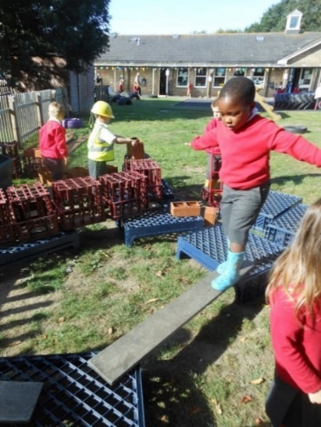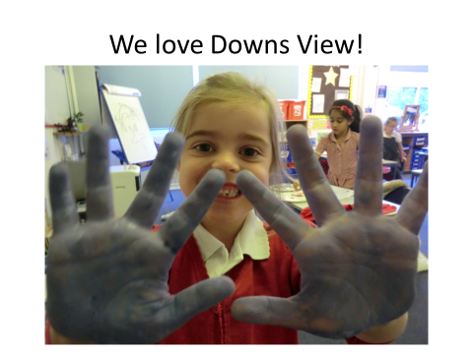

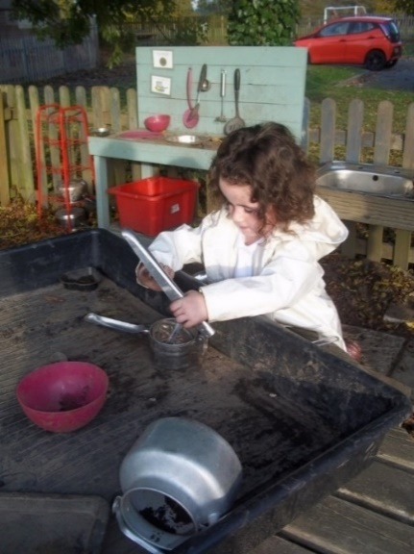

**Downs View is committed to safeguarding and promoting the welfare of children and expects all staff to share this commitment. Successful candidates will be required to complete an enhanced DBS check.**

**All employees have a duty to immediately disclose to the Headteacher (or Chair of Governors) prior to the start of their employment, at the start of their employment, or during the course of their employment, any change in their circumstances or any information which may affect or is likely to affect the suitability of the employee to undertake their job role or work with children/young people or in a school setting.**

**Downs View is an equal opportunities employer and positively encourages applications from suitably qualified and eligible candidates regardless of sex, race, disability, age, sexual orientation, gender reassignment, religion or belief, marital status or pregnancy and maternity.**

**The recruitment process**:

**PAYSCALE:** **MAINSCALE RANGE 1-6**

This is a full-time position for a class teacher.

1 The closing date is **Friday 6th June 2025**

2. Shortlisting will take place on **Monday 9th June afternoon**.

3. Interviews will be on **Thursday 12th June 2025.**

4. References will be sought for the short-listed candidates as part of the recruitment process.

***Visits to the school are recommended, so please come and soak up the atmosphere and meet our amazing children and staff in action! Please contact Sarah Collins to make an appointment on:*** **01233 632339**

**We have the right to interview applicants before the closing date should we wish to, therefore we encourage you to apply as soon as possible**

***We look forward to receiving your application!***