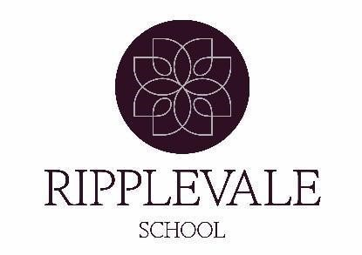

Ripplevale School and College – Rochester

Teaching Assistant Personal Specification

**Essential Qualities and Skills:**

* **Communication:**

Strong verbal and written communication skills, including the ability to communicate effectively with students, parents, and other staff.

* **Patience and Empathy:**

The ability to remain calm under pressure, demonstrate empathy, and understand the needs of diverse learners.

* **Teamwork:**

The ability to work collaboratively with teachers and other support staff.

* **Knowledge and Skills:**

Understanding of relevant curriculum, child development, and basic ICT skills.

* **Behaviour Management:**

Experience and skills in managing student behaviour and promoting a positive learning environment.

**Desirable Qualities and Skills:**

* **Experience:**

Experience working with children, particularly those with special educational needs (SEN).

* **Literacy and Numeracy:**

Excellent literacy and numeracy skills, potentially demonstrated through GCSEs or equivalent.

* **Subject-Specific Knowledge:**

Skills and interests that can enrich learning, such as in languages, cooking, gardening, or music.

* **Organizational Skills:**

Ability to organize classroom activities, prepare materials, and manage time effectively.

* **Personal Qualities**

To demonstrate a Calmness, patience and a positive attitude towards supporting students with diverse needs.

Additional Considerations:

* **Safeguarding:** Commitment to child protection and safeguarding policies and procedures.
* **Continuous Professional Development (CPD):** A desire to enhance skills and knowledge through further training and professional development.
* **Adaptability:** Flexibility and willingness to adapt to changing classroom needs and circumstances.