

**Downs View Infant School**











Business Manager Application pack

**Are you looking for a new challenge?**

We are seeking to appoint a Business Manager who is committed to working in partnership with the school administrator and the Headteacher.

**We can offer you:**

* An Good school (OFSTED October 2023)
* Delightful children who are full of enthusiasm and an eagerness to learn
* A strong forward thinking leadership team
* A vibrant and stimulating learning environment in which to work with an outstanding school administrator and team to work alongside
* Strong support for your further professional development
* Shared child centred vision and values
* Working as part of a strong collaboration of Ashford Schools, offering support and further professional development opportunities
* Highly motivated staff who are full of inspiration and thrive from new initiatives and ideas
* Experienced governors who have high expectations and the drive to challenge and support

**To become part of our team as a Business Manager, you will need to:**

* Have experience of working as part of an administrative, finance or business team, in a school or other establishment
* Have excellent interpersonal skills in order to negotiate and liaise with a range of stake holders
* Have a financial qualification and/or relevant experience within a financial background
* Be committed, flexible and well organised
* Be computer literate, especially in accounting methods, spread sheets and data based software.
* Be able to maintain and monitor budgets efficiently
* Effectively control income and expenditure in compliance with legal, local and national requirements
* Be forward thinking, planning creative ways to save money and raise income
* Have the ability to work effectively as part of a team
* Be able to lead a small team of support staff to maximise the most efficient and profitable business solutions
* Willingness to research and attend training to further develop skills and keep abreast of new requirements
* Be a happy approachable person at the front of the school, liaising with parents, young children, staff and visitors in a friendly manner
* Be able to work in a busy office as part of a team whilst still working in isolation to complete tasks efficiently
* Take a sense of pride in the environment and ensure outstanding standards around the school are maintained in relation to cleanliness, tidiness and safety
* Demonstrate the vision and values of the school in

everyday work and practice

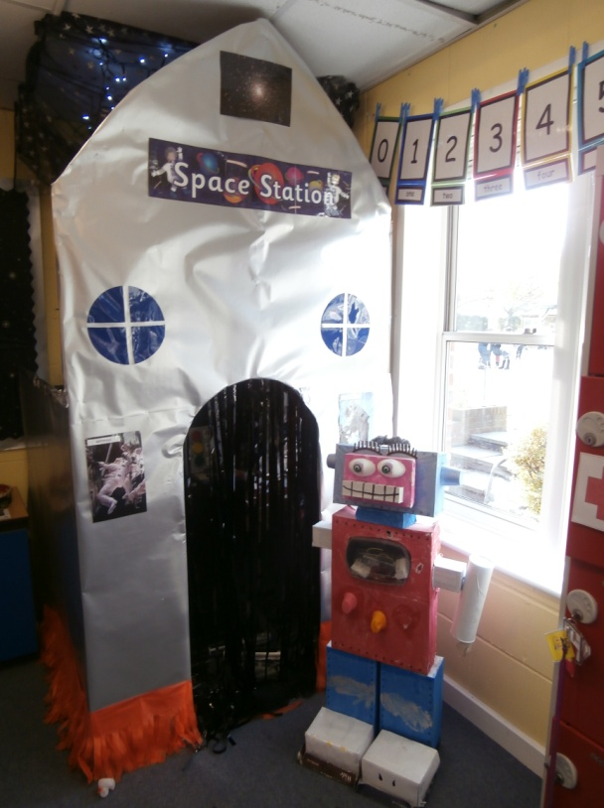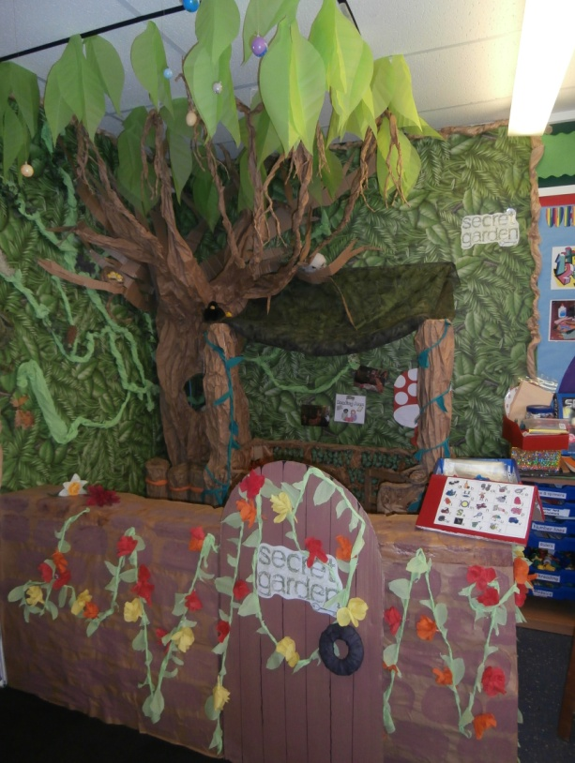

**PAYSCALE:** **KSF £30,404- £33,752**

**PRO-RATA: 6.6 weeks holiday pay Actual salary: £23,769.54 - £26,386.98**

**Salary equates to minimum KSF range based on 32.5 hours**

**HOURS**

**40 weeks per year. 32.5 hours per week –**

**4 days - 9.30am – 4.30pm**

**1 day - 8 – 3 pm (which day can be flexible)**

**(½ hour lunch break)**

**These times are negotiable if timings equate to 32.5 hours per week**

**from Monday - Friday**

Downs View is committed to safeguarding and promoting the welfare of children and expects all staff to share this commitment. Successful candidates will be required to complete an enhanced DBS and Barring check. Downs View is an equal opportunities employer and positively encourages applications from suitably qualified and eligible candidates regardless of sex, race, disability, age, sexual orientation, gender reassignment, religion or belief, marital status or pregnancy and maternity. If you have any queries then please contact the school on: **01233 632339 or email Sarah Collins/Tracy Kent via** [**office@downs-view.kent.sch.uk**](mailto:office@downs-view.kent.sch.uk)

***We look forward to receiving your application!***

**The Recruitment Process**

1 The closing date is **Monday 2nd June 12pm.**

2. Visits prior to application or interview are strongly encouraged with the Co- Headteachers.

3. Shortlisting will take place on **Monday 2nd June after 12pm.**

4. References will be sought for the short listed candidates as part of the recruitment process

5. Interviews will take place on **Thursday 5th June**

You would be expected to stay at school for **a minimum of 2 hours.**

Kent County Council

**Job Description:** Business Management – Level 1

|  |  |
| --- | --- |
|  | **DOWNS VIEW INFANT SCHOOL** |
| **Grade:** | **KSF** |
| **Responsible to:** | **Headteacher** |

**Purpose of the Job:**

Responsible for the planning, development, and delivery of the support function for the school.

**Key duties and responsibilities:**

**Individuals in this role may also undertake some or all of the following:**

1. Responsible for business and financial management of school resources
2. Assist the Headteacher in the preparation of the annual budget and any changes agreed to the three-year budget plan; inputting, analysing, interpreting and profiling information to ensure adequate provision is made to cover increasing costs.
3. Prepare, implement and reconcile all financial transactions relating to the school’s income and expenditure to ensure compliance with legal requirements and accurate accounting and control of the school’s budget.
4. Format salary and project proposals in line with the school development plan for the Headteacher and Governing Body in order to co-ordinate an annual budget of income and expenditure for the school
5. Maintain and monitor all budgets and present regular management reports to the Headteacher, Governing Body and budget holders ensure efficient and effective control of income and expenditure in compliance with legal, local and national requirements
6. Arrange provision, analysis and evaluation of data and detailed reports and information to the senior leadership team, the Governing Body and outside agencies
7. Manage the schools support function through planning, developing, designing and monitoring support systems and procedures which may include finance, HR and facilities management.
8. Assist the Headteacher and Governing Body with income generation activities and in promoting and marketing the school.
9. Arrange provision, analysis and evaluation of data and detailed reports and information, (using Excel and other appropriate programs) to the senior leadership team, the Governing Body and outside agencies as necessary.
10. Manage the procurement process, including securing appropriate service contracts, licences and insurance.
11. Contribute to the development of policies for school support function
12. Management and organisation, including researching and booking CPD for staff in relation to the priorities of the school plan.
13. Management of facilities, including premises, lettings and liaising with external contractors.
14. Lead small support staff team; Site manager and cleaners, including holding regular meetings and training, being responsible for their appraisal and ensuring that the school is safe and clean on a daily basis.

**Individuals in this role may also undertake some or all of the following:**

1. Prepare and submit bids for funding from outside agencies under the direction of the Co-Head teachers.
2. Be responsible for health and safety issues within the school and how they impact on pupils, staff and visitors to the school.
3. Housekeeping across the school to ensure outstanding standards are maintained.

**Footnote:** This job description is provided to assist the job holder to know what his/her main duties are. It may be amended from time to time without change to the level of responsibility appropriate to the grade of post.

Kent County Council

**Person Specification:** Business Management – Level 1

The following outlines the criteria for this post. Applicants who have a disability and who meet the criteria will be shortlisted.

Applicants should describe in their application how they meet these criteria.

|  |  |
| --- | --- |
|  | **CRITERIA** |
| **QUALIFICATIONS** | * Financial qualification e.g. Level 3 Diploma or equivalent. (Desirable but not essential) * Have in place or have willingness to work towards Certificate of School Business Management (CSBM). |
| **EXPERIENCE** | * Significant experience in administrative / finance roles is essential. * Experience of working in a school is desirable but not essential. |
| **SKILLS AND ABILITIES** | * Analytical skills for business and financial management of school resources over the medium term, involving a range of complex issues, situations and problems. * Keep detailed records of daily revenue and cash flow * Requires skills for the motivation of staff, negotiations with suppliers, advice to the governing body and liaising with external bodies; deals with sensitive issues e.g. contracts, HR. * Strong interpersonal and communication skills – written and verbal to negotiate and liaise with a range of stakeholders. * Ability to meet demanding deadlines and work accurately under pressure. * Leadership skills for a small team of support staff, guiding their work efforts toward the most efficient and profitable business solutions. * Initiative and flexible approach to maximise applications * Commitment to confidentiality * Ability to work as part of an effective office team in a busy open plan office, to support in the smooth running of the school * Honest and trustworthy |
| **KNOWLEDGE** | * Thorough technical knowledge of day to day financial administration processes and protocols. * Sound working knowledge of site, personnel and office administration and processes. * High level IT skills. * Assured manner. High level customer service skills and professional ethos. * Good organisational & time management skills, ability to manage priorities & meet deadlines whilst remaining methodical and giving attention to detail. * Initiative / proactive / ‘can do’ approach. |