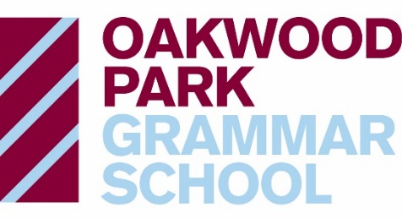

Job Description
Whole School Careers and Higher Education Lead

Job Title: Whole School Careers and Higher Education Lead

Accountable to: Director of Sixth Form

Job Purpose
To lead on all aspects of careers education, information, advice and guidance (CEIAG) across the school. This pivotal role focuses on driving forward the school’s strategic approach to post-16 and post-18 progression, including transition to the Sixth Form, UCAS applications, Oxbridge, Early Entrance, Degree Apprenticeships, and wider careers provision across the whole school.

Key Responsibilities
UCAS & Higher Education
- Lead the full UCAS application process for all Year 13 students, ensuring high-quality applications and personal statements.
- Arrange visits to Universities and Fairs.
- Lead on Student Finance information and university bursary support
- Coordinate practice interviews and preparation for early entry candidates (e.g. Medicine, Oxbridge, Veterinary Science).
- Work closely with the Sixth Form team to shape and implement an effective Oxbridge strategy.
- Organise Enrichment Days and Form Times on the UCAS process.
- Work with Director of Sixth Form and Year 13 Director of Study to support in ensuring extenuating circumstances are forwarded to Examinations Manager

Careers Education & IAG
- Oversee the school’s careers programme, ensuring compliance with the Gatsby Benchmarks.
- Lead the delivery of impartial and high-quality information, advice, and guidance (IAG) across all year groups.
- Organise and manage work experience placements for Year 10 students, ensuring meaningful and safe opportunities aligned with student interests and aspirations.
- Manage relationships with external careers advisors and services, ensuring regular student access.
- Coordinate Unifrog, enrichment activities, and the school Careers Fair.
Degree Apprenticeships
- Support the development of a clear school approach to Degree Apprenticeships, including awareness, application support, and employer links.
Year 11–12 Transition
- In collaboration with the Director of Sixth Form (DoS 12), support the transition from Year 11 to 12, including guidance interviews, taster days, and application support.
Wider Sixth Form Contribution
- Support the planning and execution of events and initiatives that raise aspirations and ensure students are well-prepared for life after school.

Person Specification
Essential:
- Strong knowledge of post-16 and post-18 progression routes including UCAS, apprenticeships, and employment.
- Experience working in a school, college or education setting, ideally with post-16 students.
- Excellent organisational and communication skills.
- Confidence in delivering one-to-one and group sessions.
- A student-centred mindset and ability to inspire young people to achieve their goals.
Desirable:
- Experience with platforms like Unifrog or similar careers tools.
- Familiarity with the Gatsby Benchmarks and the CDI Framework.
- Experience supporting Oxbridge or early entry university applications.

What We Offer
- A supportive and collaborative staff team
- Opportunities for professional development and training
- The chance to make a significant difference in students' futures
- Flexible working when required
- Generous pension scheme

Our Values
At OPGS, our school values are underpinned by kindness, tolerance, and respect. These principles shape our community and guide everything we do. We are committed to fostering a positive, inclusive, and supportive environment for both students and staff.
OPGS is committed to creating an inclusive workforce. We welcome applications from all individuals regardless of background, identity, or personal circumstances, and we actively promote equality of opportunity for all.

