**Downs View Infant School**

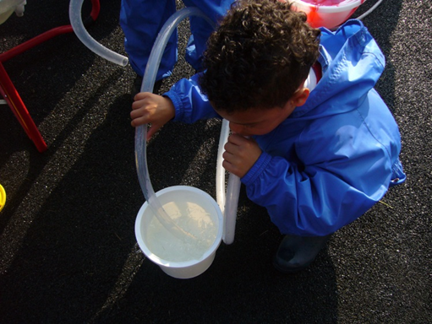

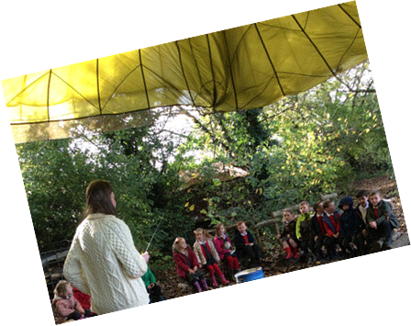

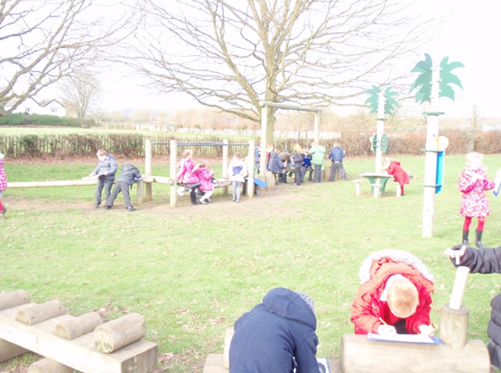

Learning Support Assistant/ Key Worker Application Pack

**Are you looking for a new challenge?**

We are seeking to appoint an exceptional Learning Support assistant who is committed to working in partnership with the Class teacher and KS1/EYFS team in raising standards and securing the best possible achievements for every child.

**We can offer you:**

* A Good school with Outstanding areas (OFSTED October 2023)
* Outstanding support from teachers
* Delightful children who are full of enthusiasm and an eagerness to learn
* Shared child centred vision and values
* Working in a school which is part of a collaboration (CATS) of 14 schools, providing high quality school to school support and training
* Outstanding and regular support from the Inclusion Leader and Class teacher
* Strong support for your further professional development through opportunities to learn from outstanding practitioners
* An opportunity to work as an outstanding teaching assistant, sharing your expertise and practice with colleagues and with other schools
* Positive partnerships with outside agencies
* A strong forward thinking leadership team
* Highly motivated staff who are full of inspiration and thrive from new initiatives and ideas
* Experienced governors who have high expectations and the drive to challenge and support
* A vibrant and stimulating learning environment in which to work

**To become part of our team as an Outstanding Learning Support Assistant you will need to:**

* Have experience of working with children or a child with additional needs within a school setting
* Understand early child development and how to support a child, particularly with speech and language, hearing impairment, social and emotional development and social communication skills
* Able to use initiative to adjust teaching methods and activities to suit the need of the child
* Have a good understanding of early child development and play
* Be able to use non-verbal ways to communicate with children who require it. Makaton and or British Sign Language would be desirable but not essential as full training will be given
* Have a flexible approach and a positive work ethic, to work across EYFS/KS1
* Have high expectations of yourself and children and have a proven record of good/outstanding practice which resulted in accelerated progress for children
* Be a proactive learner, using support and advice to enhance teaching and learning opportunities for children
* Have the energy and drive to support the class teacher in getting the best outcomes for this child and others
* Be highly organised, motivated and flexible with the ability to inspire and challenge this child and others
* Have lots of energy and a good sense of humour
* Are enthusiastic, reliable and work well as part of a team
* Demonstrate the vision and values of the school in everyday work and practice

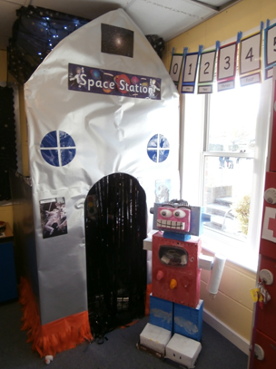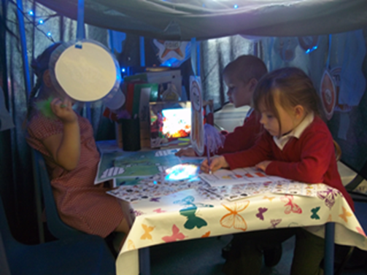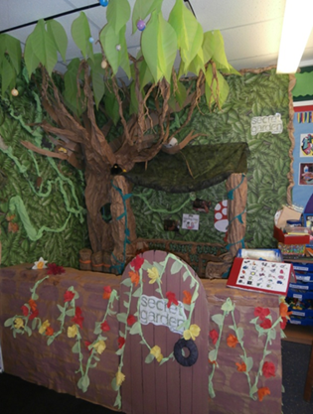

Downs View is committed to safeguarding and promoting the welfare of children and expects all staff to share this commitment. Successful candidates will be required to complete an enhanced DBS check.

Downs View is an equal opportunities employer and positively encourages applications from suitably qualified and eligible candidates regardless of sex, race, disability, age, sexual orientation, gender reassignment, religion or belief, marital status or pregnancy and maternity.

Visits to the school are recommended, so please come and soak up the atmosphere and meet our amazing children and staff in action! Please contact Tracy Kent, Sarah Collins or Katie Norman to make an appointment on: 01233 632339

**W*e look forward to receiving your application!***

The recruitment process: **PAYSCALE: KSB: From £25.126** (term time only pro-rata) Starting point will be dependent upon experience. **Fixed term contract until 31st August 2025**.

**Hours :** **Monday - Friday 8.20am -3.25pm**

as part of Reception/ KS1 team 38 weeks per year (term time only)

1. The **closing date** is **Friday 9th May 12pm**

2. **Shortlisting** will take place on **Friday 9th May pm**

3. References will be sought for the short- listed candidates as part of the recruitment process

4. **Interviews** will take place on **Wednesday 14th May 2025.** Please prepared to be at school for 2-3 hours.

***School visits prior to application/interview strongly encouraged.***

**Applications will be considered in the order in which they are received. The school reserves the right to interview at any point during the recruitment process and early applications are encouraged.**

**Kent County Council**

**Job Description: Teaching Assistant – Additional Needs**

|  |  |
| --- | --- |
| **School:** | **Downs View Infant School** |
| **Grade:** | **Kent Range 4** |
| **Responsible to:** | **Inclusion Leader/Headteacher** |

**Purpose of the Job:**

**To work with teachers as part of a professional team to support teaching and learning for SEND pupil(s). Providing learning support to pupil(s) who need particular help to overcome barriers to learning, such as those with learning difficulties and/or behavioural, social, communication, sensory or physical disabilities**

**(Roles at this level do not deliver “specified work” as defined in the guidance to Section 133 of the Education Act 2002)**

**Key duties and responsibilities:**

1. **Assist with the implementation of planned learning activities/teaching programmes as agreed with the teacher, adjusting activities according to pupils’ responses as appropriate.**
2. **Participate in planning and evaluation of learning activities with the teacher, providing feedback to the teacher on pupil progress and behaviour.**
3. **Support the teacher in monitoring, assessing and recording pupil progress/activities.**
4. **Provide feedback to pupils in relation to attainment and progress under the guidance of the teacher.**
5. **Support learning by arranging/providing resources for lessons/activities under the direction of the teacher.**
6. **Support pupils in social and emotional well-being, reporting problems to the teacher as appropriate.**
7. **Share information about pupils with other staff, parents / carers, internal and external agencies, as appropriate.**
8. **Understand and support independent learning and inclusion of all pupils as required.**
9. **Work with pupils on therapy or care programmes, designed and supervised by a therapist/care.**
10. **Attend to pupils’ personal needs including toileting, hygiene, dressing and eating, as well as help with social, welfare and health matters, reporting problems to the teacher as appropriate. Physically assist pupils in activities (may involve guiding, where mobility is an issue).**
11. **Deal with behaviour appropriately, following school’s policy, procedures and specialist training using appropriate manual handling approach.**

**Additional Support Needs Assistants at this level may also undertake some or all of the following:**

1. **Administer medication in accordance with an agreed plan under direction of healthcare practitioner and following appropriate training.**
2. **Update pupil records.**
3. **Assist with break-time /lunch time supervision including facilitating games and activities.**
4. **Assist with escorting pupils on educational visits.**
5. **Support pupils in using basic computing skills.**
6. **Undertake moving and handling activities as required.**

**Footnote: This job description is provided to assist the job holder to know what his/her main duties are. It may be amended from time to time without change to the level of responsibility appropriate to the grade of post.**

**Person Specification: Learning Support Assistant – Additional Needs**

**The following outlines the criteria for this post. Applicants who have a disability and who meet the criteria will be shortlisted.**

**Applicants should describe in their application how they meet these criteria.**

|  |  |
| --- | --- |
|  | **CRITERIA** |
| **QUALIFICATIONS** | * **Level 2 Diploma (or equivalent) not essential but any childcare or SEND qualification would be an advantage** * **First Aid qualification would be an advantage.** |
| **EXPERIENCE** | * **Previous experience of working with children in a school /nursery setting essential.** * **Previous experience of working or knowledge of children with SEND/Autism.** |
| **SKILLS AND ABILITIES** | * **Good standard of Numeracy and Literacy skills.** * **Basic Computing skills.** * **Specialist training such as Manual Handling, Autism, language development or a willingness to attend appropriate specialised training** * **Ability to relate well to children and adults, understanding their needs and being able to respond accordingly.** * **High level of patience and flexibility with a willingness to adjust role to suit the needs of the individual.** |
| **KNOWLEDGE** | * **Requires knowledge and procedures for supporting and leading learning activities.** * **Understanding of early child development, particularly social and emotional development and social communication skills.** * **Knowledge and compliance with policies and procedures relevant to child protection, health and safety, security, Equal Opportunities and confidentiality.** |