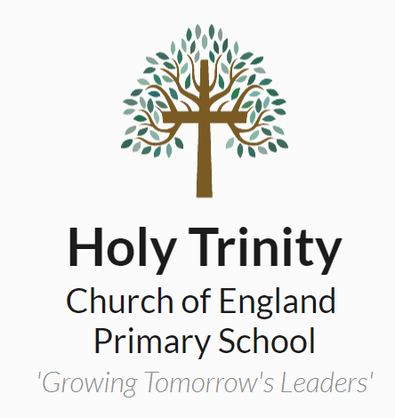
Holy Trinity C E Primary School
Dartford
Job Description 2021-2022

Post Holder:

Effective Date: 1st September 2021

Job Title: Class Teacher

Responsible to: Senior Leadership Team

Pay Scale: M

FTE: 1

Purpose of Job:
- To support the Headteacher, Leadership Team and Governors in creating and maintaining an effective environment and ethos for teaching and learning while supporting the Christian character of the school.
- To be a role-model to our pupils, leading by example in behaviours, appearance, speech etc.
- Fulfil the professional responsibilities of a teacher, as set out in the School Teachers’ Pay and Conditions Document.
- To ensure all teaching is driven by our Christian Values in aspiring to be an outstanding practitioner keeping the needs of the pupils at the heart of all that we do.
- Meet the expectations set out in the Teachers’ Standards (attached to this document) and SEND Code of Practice.

The Governing Body expects that all Class Teachers will deliver at least consistently good teaching thus ensuring that progress is at least good.

Main Activities and Responsibilities including Area/Subject Leadership:

- To be responsible for and show impact in one or more areas of the curriculum, assigned by negotiation with the Headteacher, making best use of skills and subject knowledge gained during undergraduate, initial teacher training or subsequent professional training.
- To be responsible for the long-term planning (with the Headteacher / Leadership Team) and the monitoring of the assigned area(s) of the curriculum.
- To ensure proper and appropriate records and evidence are maintained in the assigned area(s) of curriculum responsibility and that these are passed on when responsibilities change.
- To carry out all other appropriate responsibilities in respect of the assigned area of responsibility.
- To complete subject observations, book moderations and pupil conferencing to monitor progress in respect of the assigned area of responsibility.
- To lead and motivate colleagues by good example in the classroom.
- To oversee and assist with assessment in your subject area and the curriculum.
- To provide guidance and support for colleagues (teachers and teaching assistants) by means of meetings, working alongside individual colleagues and by observing their work.
- To monitor curriculum delivery to ensure that children throughout the school are receiving their entitlement in the assigned area of responsibility, and to report to the Headteacher so that Governors can be regularly informed of the effectiveness of the curriculum and the quality of teaching in the designated area(s) of the curriculum.
- To ensure that appropriate specialist guidance and support organisations are consulted and used as necessary.
- To advise and guide colleagues in the preparation of policy in all areas of the curriculum with regard to the assigned area of responsibility.
- To maintain the resources, including books and equipment specific to and needed for successful teaching in the assigned area(s) of responsibility.
- To be accountable to the Head Teacher / Senior Leadership Team.
- To comply with Health and Safety, Fire Regulations and other school policies.
- Carrying out any other duties that may reasonably be required by the Senior Leadership Team.
- To actively engage in developing your teaching / leadership further and work with the Head Teacher / Senior Leadership Team on areas identified either by yourself or by the Head Teacher / Leadership Team.

Pay Related Responsibilities
Dependant on individual pay scale, appendix 7 in the Teacher Pay & Reward Policy sets out clear expectations on our schools’ guidance for additional responsibilities related to teachers pay grades.

Safeguarding:
You may during the course of your duties, become aware of sensitive matters relating to an individual pupil or groups of pupils. Pupils may confide in you. If at any time a child confides in you, or you observe any incident that causes you concern, you must record factually what you have heard or seen using our schools safeguarding system.

You will be provided with guidance and training on Child Protection and the LEA and Governing Body procedures for Child Protection must be followed correctly at all times.

You must treat as confidential any matter relating to a child’s personal welfare or family circumstances. Such information must not be communicated to any person except those of the staff with legitimate interest or responsibility for the child, e.g. Headteacher, another member of the Senior Leadership Team or the Class Teacher.

Health & Safety:
All staff are responsible for Health and Safety. Should you notice any defect in the building or any spillage or body fluids, which compromises health and safety, this must be immediately reported to the Senior Leadership Team, and recorded in the premise’s diary.

Signed …………………………………………………. Date …………………………………..

Signed ………………………………………………… Date ……………………………..……
(On Behalf of the Governing Body)

Criteria | Qualities
Qualifications and experience | - Qualified teacher status  - Degree  - Successful primary teaching experience.
Skills and knowledge | - Knowledge of the National Curriculum.  - Knowledge of effective teaching and learning strategies.  - A good understanding of how children learn.  - Ability to adapt teaching to meet pupils’ needs.  - Ability to build effective working relationships with pupils.  - Knowledge of guidance and requirements around safeguarding children.  - Knowledge of effective behaviour management strategies.  - Good ICT skills, particularly using ICT to support learning.  - Knowledge and understanding of Assessment for Learning (AfL).
Personal qualities | - A commitment to getting the best outcomes for all pupils and promoting the ethos and values of the school.  - High expectations for children’s attainment and progress.  - Ability to work under pressure and prioritise effectively.  - Commitment to maintaining confidentiality at all times.  - Commitment to safeguarding and equality.  - Dedication to the role.  - Good time management skills.  - A passion for making a difference.

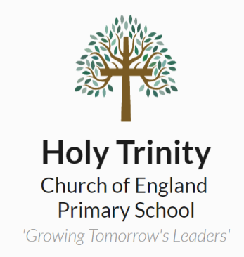 |  |  |  |  |  |  |  |  |  |  |  |  |  |  |  |  |  |  |  |  |  | Headteacher | Strategic leadership of the school, including vision setting and distributing workload effectively.
 |  |  |  |  |  |  |  |  |  |  |  |  |  |  |  |  |  |  |  |  | Deputy Headteacher | Support and assist the Headteacher by providing dynamic and professional leadership and management and taking responsibility for leading specific areas/initiatives to secure further school wide improvements. NPQSL or equivalent.
 |  |  |  |  |  |  |  |  |  |  |  |  |  |  |  |  |  |  | UPR |  | Contributing significantly to implementing and reviewing workplace policies and practice. Having an extensive knowledge and understanding of how to use and support others with teaching, learning and behaviour management strategies. Having sufficient depth of knowledge and experience to be able to raise standards within any area of the school and to be able to support colleagues on their school development. Provide coaching and mentoring to other teachers or colleagues. Within two years of completing NPQML or equivalent.
 |  |  |  |  |  |  |  |  |  |  |  |  |  |  |  |  |  | Teacher  M6 | As below, mentoring and improving staff performance.
 |  |  |  |  |  |  |  |  |  |  |  |  |  |  |  |  | Teacher  M5 | As below, plus opportunity for Middle leadership responsibility, whole school project for improvement & appraisal for support staff. Support wellbeing of pupils.
 |  |  |  |  |  |  |  |  |  |  |  |  |  | Teacher  M4 |  |  | As below, with a larger whole school responsibility with evidence of improvements from previous subject developments i.e. core subject lead.
 |  |  |  |  |  |  |  |  |  |  |  | Teacher  M3 |  |  | Continued plus other wider school community involvement i.e. worship, club, staff training.
 |  |  |  |  |  |  |  |  |  | Teacher  M2 (ECT) |  | Successful completion of ECT framework, good or better teaching is maintained which is evident and moderated in pupil outcomes. Commits to subject responsibility, including completion of audit, action plan and evaluation.
 |  |  |  |  |  |  |  | Teacher  M1 (ECT) |  | Has used ECT time to complete observations of other teaching across the school and externally. Provides recorded and dated evidence of this. Follows school expectations as per school handbook.
 |  |  | UQTS |  |  |  | On a three-year progression towards Early Career Teacher (ECT). Foundation degree equivalent.
 |  | HLTA |  | To cover whole classes undertaking activities provided by a teacher including the marking, during PPA time or in the short-term absence of a classroom teacher. The primary focus is to maintain consistency and to keep pupils on task of the lessons to be taught. Level 4 or equivalent Qualification.
 | Teaching Assistant | To work with teachers to support teaching, learning and assessment, providing general and specific assistance to pupils and staff under the direction, guidance and direct supervision of the classroom teacher. Contributing to a safe and engaging learning environment. Level 3 Teaching Assistant Qualification.
Midday Supervisor | A mid-day Supervisor works in the school dining hall, playground and on the field. They are responsible for setting up and clearing away the hall before and after lunch, working co-operatively with and contributing to the work of the whole lunchtime supervisory team and the changing needs of the school implementing positive play scheme, engaging in pupils’ play and supporting our Christian Values at all times.

