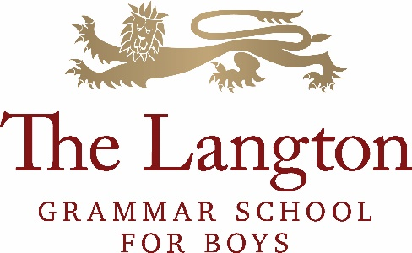

**THE GEOGRAPHY DEPARTMENT**

**Head of Department: Dr W Gleave**

The Geography Department at The Langton is well qualified, vibrant and demonstrates a

commitment to the highest levels of teaching and learning. The department consists of two full-time geographers and a senior member of staff who is also a geographer. Geography is taught throughout KS3 (Y7 to Y9) as an independent subject. There are approximately 80 students studying at KS4 and 30 students at KS5. Currently, there are three teaching groups in Year 10, two groups in Years 11 and 12, and one group in Year 13.

There is a strong commitment to the enquiry approach in both classroom teaching and fieldwork. Consequently, the students are encouraged to develop independent learning skills throughout all key stages. Teaching geography dynamically with an emphasis on place and topicality is a key feature of the departmental teaching and learning strategy. For this reason, the Edexcel B specification is taught at GCSE, which provides an excellent foundation for the Edexcel GCE specification studied at A level. These specifications have a strong fieldwork and research focus, which enhance the geographical experience for the student.

We are looking to appoint an enthusiastic teacher of geography with excellent subject knowledge for maternity cover. The teacher appointed will be someone who can communicate an enthusiasm for the subject to the students, and who is committed to innovation and to the further development of good practice in teaching geography. The successful candidate will be able to contribute to the programme of fieldwork and extra-curricular visits offered by the department.

**The Curriculum**

Our KS3 curriculum at The Langton aims to inspire a sense of wonder about the world, the uniqueness of place, and how we relate to our local and global environment. It provides students with a broad synthesis of a range of human and physical geography topics, which will help them to understand and interpret contemporary issues, and their place within local, regional and global contexts. In Y7 we study units including: ‘Making sense of our local area’, ‘What is the role of China in the 21st Century?’ and ‘What problems does South Africa face?’. In Y8 we study India, urbanisation and life in India. In Y9 we examine topics including Russia, the Middle East, Iceland, and UK sustainability, addressing topical issues such as the role of Russia as an energy superpower, the European migrant crisis, and the impact of climate change.

The KS4 curriculum aims to further develop students’ knowledge and understanding of place, process and interaction by introducing them to global and UK-related issues, including two fieldwork investigations. Although students follow the Edexcel GCSE syllabus, this is used as a guide and learning is expected to go beyond it, examining extended case-studies and more advanced geographical concepts. The aim of the KS5 (A-Level) curriculum at The Langton is to provide an opportunity to develop an in-depth and nuanced understanding of physical and human geography, the complexity of issues linked to people and environment, and to become critical, reflective and independent learners.

**After The Langton**

Many students go on to study geography and related subjects at university, and the Geography

Department wants all of those studying geography to explore the wide range of possibilities the subject has to offer. Students have previously had the opportunity to participate in extra-curricular research projects including an ecology project with Oxford and Oxford Brookes Universities, and a climate project with Nottingham University.

The nature of the discipline, combined with the training geography students receive at university,

makes graduate Geographers highly employable. Geography graduates go on to diverse careers,

using direct geographical knowledge or transferable skills including: law, financial sector, marketing,

industry, management, environmental consultancy, development, tourism, conservation, planning

and academic research.