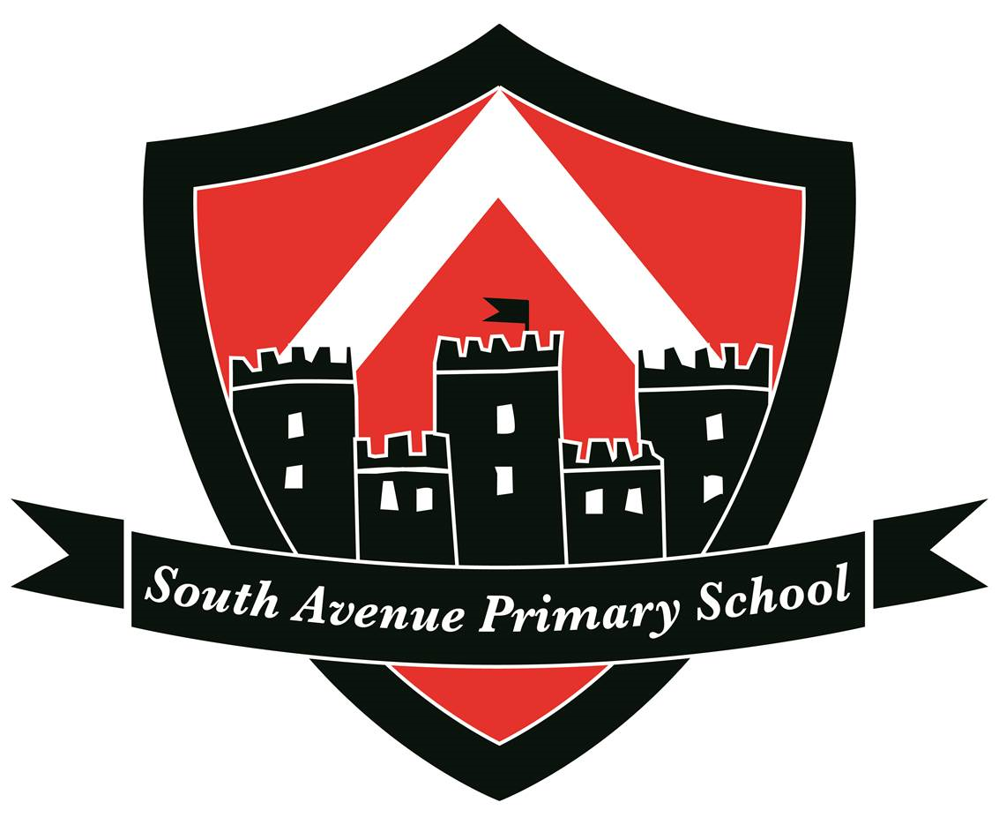
South Avenue Primary School
(Part of Fulston Manor Academies Trust)

Job Title: Teacher

Salary: Main Scale

responsible to: Head of School
The responsibilities of the post are to be performed in accordance with the provisions of the most up to date edition of the School Teachers’ Pay and Conditions document and within the range of teachers’ duties set out in that document.

Job Role:

- To carry out professional duties and to have responsibility for an assigned class.
- To be responsible for the day-to-day work and management of the class and the safety and welfare of the pupils, during on-site and off-site activities.
- To promote the aims and objectives of the school and maintain its philosophy of education.
- To create and manage a caring, supportive, purposeful and stimulating environment, which is conducive to children’s learning.
- To plan and prepare lessons in order to deliver the National Curriculum ensuring breadth and balance in all subjects.
- To identify clear teaching objectives and learning outcomes, with appropriate challenge and high expectations.
- To develop and maintain, positive relationships with pupils through establishing clear routines and expectations
- To organise and manage groups or individual pupils ensuring adaptations are made for all learning needs, reflecting all abilities.
- To plan opportunities to develop the social, emotional and cultural aspects of pupils’ learning.
- To maintain a regular system of monitoring, assessment, record keeping and reporting of children’s progress.
- To prepare appropriate records for the transfer of pupils.
- To ensure effective use of support staff within the classroom, including parent helpers and volunteers.
- To participate in staff meetings as required.
- Contribute to the development and co-ordination of a particular area of the curriculum.
- To be part of a whole school team, actively involved in decision-making on the preparation and development of policies and programmes of study, teaching materials, resources, methods of teaching and pastoral arrangements.
- To ensure that school policies are reflected in daily practice.
- To communicate and consult with parents over all aspects of their children’s education
- To liaise with outside agencies when appropriate eg. Educational Psychologist.
- To continue professional development.
- To meet with parents and appropriate agencies, to contribute positively to the education of the children concerned.
- To support the Head of School/SLT in promoting the ethos of the school.
- To promote the welfare of children and to support the school in safeguarding children though relevant policies and procedures.
- To promote equality as an integral part of the role and to treat everyone with fairness and dignity.
- To recognise health and safety is a responsibility of every employee, to take reasonable care of self and others and to comply with the Schools Health and Safety policy and any school-specific procedures / rules that apply to this role.
- To fulfil the Teachers’ Standards

This school is committed to safeguarding and promoting the welfare of children and young people and expects all staff and volunteers to share this commitment.

South Avenue Primary School
South Avenue

Sittingbourne
Kent ME10 4SU
Tel: 01795 477750

