Person Specification
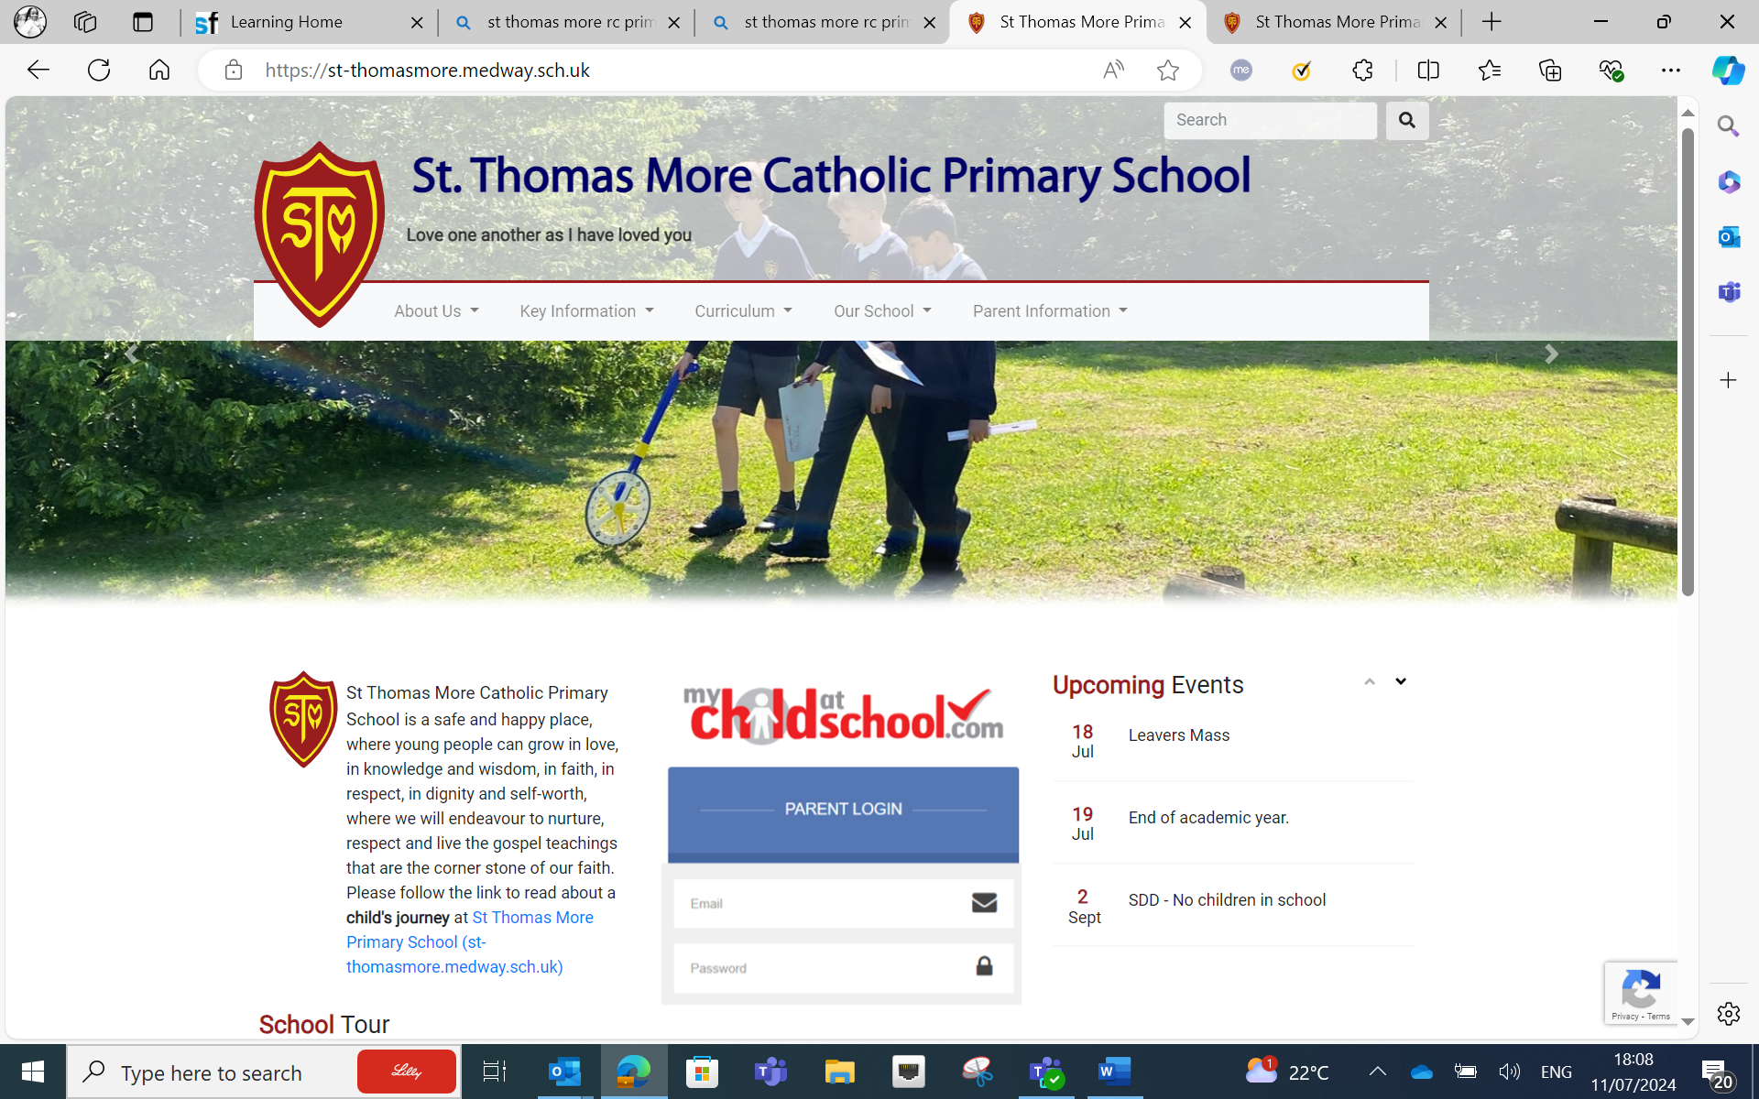
Introduction
- St Thomas More is a 'Good' Catholic Primary School. The school serves the parish of St Simon’s Stock Church. We are very proud that St Thomas More has established a reputation for high standards and high achievement. Our aim is not simply to provide an outstanding academic education, but to develop in our pupils an understanding of, and respect for, spiritual and moral values within a caring Christian community.
- The core purpose of the Headteacher in a Catholic school is to provide leadership in the context of a community rooted in the Christian faith. Thus it is an essential requirement the person appointed to the post at St Thomas More Catholic Primary School has a strong, personal faith and recognises the opportunities and challenges facing our school as a vibrant part of the mission of the Church in education.
- The Governing Board is seeking to appoint a highly effective, dynamic and inspirational Catholic leader with a passion for inclusive community building to lead St Thomas More Catholic School on its improvement journey. The successful applicant will be a practising Catholic who can demonstrate how this can be achieved by making the school’s Values, Aims and Purpose a reality for all the pupils, staff and the wider community.
- The successful candidate will have strong leadership skills, a deep understanding of educational best practices and a commitment to fostering a positive and inclusive learning environment for all pupils and staff. If you are ready to take on this rewarding and influential role, we encourage you to apply and be part of our family.
- You will witness the dedication and commitment of our staff in providing the highest quality education to our pupils. Together, we have achieved numerous successes, and we are proud of the positive impact we have made on the lives of our children and families. The position of Headteacher at St Thomas More offers a unique opportunity to lead an exceptional team of educators, support staff, and pupils in achieving academic excellence and fostering a nurturing learning environment. We are confident that with the right leadership, St Thomas More will continue to thrive and maintain its reputation for excellence in education.
- We encourage qualified candidates with a passion for education, strong leadership skills, and a commitment to fostering a culture of inclusivity and academic excellence to apply for the position. The successful candidate will have the opportunity to build upon the foundation has been laid and lead St Thomas More into its next chapter of continued success.
A practising Catholic is someone who has been sacramentally initiated into the Catholic Church and who adheres to those substantive life choices which do not impair them from receiving the sacraments of the Church and which will not be in any way detrimental or prejudicial to the religious ethos and character of the school. Inspired by the Gospel and sustained by God’s grace, a ‘practising Catholic ’will give sincere external expression to their interior faith through specific religious, moral and ethical behaviour which is in accordance with the teaching of Christ and the Catholic Church.

Person Specification
Qualities and Knowledge | Essential or Desirable | Evidence
A practising Catholic, evidenced by a priest reference | E | I/R
Qualified Teacher Status | E | A
Degree | E | A
NPQH or similar | D | A
CCRS | D | A
Teaching and leadership experience in one or more Catholic primary/secondary schools | D | A/I/R
Lead by example and be a positive role model with excellent communication skills | E | I/R
Ability to articulate a clear vision and purpose for Catholic education and to share their Catholic faith with a range of colleagues who may or may not be Catholic | E | A/I/R
Personal impact and presence | E | I/R
Participation in a parish community | E | A/I/R
Ability to lead the spiritual development Of staff and pupils | E | I/R
Understand the current educational provision and the wider school systems | E | A/I
Political and financial astuteness | E | A/I/R
Demonstrate and experience of working alongside clergy and faith leaders. | E | A/I/R
Pupils and Staff | Essential or Desirable | Evidence
Have ambitious standards and high expectations for all pupils | E | A/I/R
Excellent understanding of high quality teaching and learning | E | A/I/R
Promote the development of the whole child | E | A/I/R
Use data analysis to effectively drive whole school improvement | E | A/I/R
Encourage staff and pupils to develop their unique potential, character | E | A/I/R
Identify emerging talent, develop excellence and clear succession planning | E | A/I/R
Systems and Process | Essential or Desirable | Evidence
Effective strategic leadership and astute and understanding of school finance | E | A/I/R
Ensure the safety of all staff and pupils, at all times | E | A/I/R
Promote excellent behaviour and positive attitudes to school life | E | A/I/R
Systems for appraisals to hold all staff to account | E | A/I/R
Skills to challenge underperformance | E | A/I/R
Understanding the importance of strong governance to hold the school to account | E | A/I/R
Ensure value for money in deploying resources and budgets, for the best outcomes for all | E | A/I/R
Promote distributive leadership throughout the school | E | A/I/R
School Improvement | Essential or Desirable | Evidence
Knowledge and experience of working with other schools and organisation | E | A/I/R
Develop effective partnerships with other professionals | E | A/I/R
Use evidence based research to achieve excellence | D | A/I/R
Provide opportunities for high quality staff development | E | A/I/R
A confident and innovative approach to school improvement | E | A/I/R
Provide inspiration and encouragement for all members of the community | E | A/I/R
Child Protection | Essential or Desirable | Evidence
Ensure all CP policies and procedures adopted by governors are fully implemented and adhered to by staff | E | A/I/R
Ensure that sufficient resources and time are allocated to enable staff to perform their CP related responsibilities effectively | E | A/I/R
Securing Accountability | Essential or Desirable | Evidence
Fulfil all commitments arising from contractual accountability to the governing body | E | A/I/R
Ensure individual staff accountabilities are clear, understood, agreed, reviewed and evaluated | E | A/I/R
Work with the governing body to enable it to meet its statutory responsibilities | E | A/I/R
Develop an accurate and understandable account of the school’s performance for a range of stakeholders | E | A/I/R
Personally contribute to school achievement, taking account of feedback from others | E | A/I/R
Strengthening the Community | Essential or Desirable | Evidence
Build a culture and curriculum which takes account of the richness and diversity of the community’s Catholic faith | E | A/I/R
Create and promote strategies for challenging racial and other prejudices | E | A/I/R
Ensure that learning experiences are enriching and are linked into and integrated with the wider community | E | A/I/R
Collaborate with agencies in providing for the academic, spiritual, moral, social, emotional and cultural wellbeing of all | E | A/I/R
Develop and maintain an effective partnership with parents and carers | E | A/I/R
Share effective practice, working in partnership with other schools | E | A/I/R
Application Form and Letter | Essential or Desirable | Evidence
The appropriate form to be completed in full and legible | E | A
Supporting statement to be clear, concise and related to the post being applied for and appointment criteria (No more than 2 sides of A4 in font size 11) | E | L
Confidential References and Reports | Essential or Desirable | Evidence
A positive and supportive written faith reference from a priest where the applicant regularly worships | E | R
A positive recommendation from current employer or Headteacher | E | R
A second professional reference | E | R

Please note: Any applicants wishing to apply, will have to use the CES (Catholic Educations Service) application form as well, under the “Senior Leadership” tab. The link for this is below:
https://www.catholiceducation.org.uk/resources/model-application-forms
This need to be used, as there is a box to fill in regarding your Catholic faith and that one of the references has to be your Parish Priest.
If you do not use this form and have this reference, you cannot be shortlisted.

