St. Thomas More Catholic Primary School

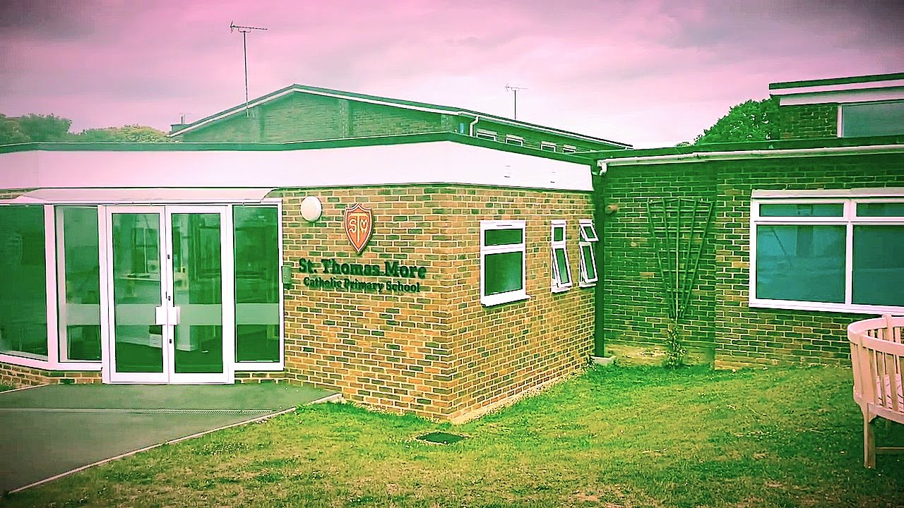
Our Family.
We often refer to ourselves as ‘The St Thomas More Family’, our school is a place of care, kindness, support and happiness for all our children and adults. We achieve excellent academic results but what is even more important to us is that every child is known as an individual and cared for in the exact way they need.
School size/Age range.
St Thomas More Catholic pupils age between Reception classes from the ages of 4 years old and Year 6 classes up to the age of 11 years old. We currently have 414 pupils attending our school.
School demographic.
This location falls within the parliamentary constituency of Chatham and Aylesford Co, represented by the Labour MP, Tristan Osbourne. At the last general election Conservative won control with a majority of 18,540 votes over Labour. A breakdown of voting at the last election is shown above.
Extra-curricular offer.
At St Thomas More Catholic Primary School, we are committed to delivering a broad and balanced curriculum that fosters academic achievement, personal growth and a love for learning. Though each of our terms, we offer the pupils from Year 1 to Year 6 an opportunity to grow sociably and mentality in a wide range of activities that help nurture and develop their well well-being. They include, Dancing, Football, Basketball, Rounds, Netball, Table Tennis, Cricket to name a few. Our school also helps pupils with team building classes and they can be part of the Chaplaincy Team, Science, Cultural Capital team, Digital Leaders, Eco warriors and our Forest School Team.

Number and breakdown of staff.
Senior Team Leaders – 4
(inc 1 Exec Head Teacher currently until a new Head Teacher is appointed)

Teaching & Curriculum Team – 19
(14 teachers in class, Opal teacher, 2 x teachers covering curriculum)

Learning Support Staff – 22

Administration & Support Team – 17
(3 office, Pastoral Manager, SEN admin, Caretaker, Cleaning Company, 7x MMS, 3 x breakfast/afterschool club)

Support offered to staff.
We ensure the effective management and deployment of teaching and support staff together with appropriate systems of delegation and discipline through the management structure of the school.
School website.
A child’s journey starts at St Thomas More Catholic School. Please see below our website for the start of your journey…
https://st-thomasmore.medway.sch.uk/
Parish Links.
Our school has strong links with our parish church, St. Simon Stock Parish, Walderslade, which enhances the spiritual and moral development of the community we serve with the guidance of our Parish Priest, Father Pawel.
https://stsimonwalderslade.co.uk/

Our Location

School Name – St Thomas More Catholic Primary School
School Full Address – Bleakwood Road, Walderslade, Chatham, Kent, ME5 ONF
Telephone Number – 01634 864701
Email Address - office@st-thomasmore.medway.sch.uk
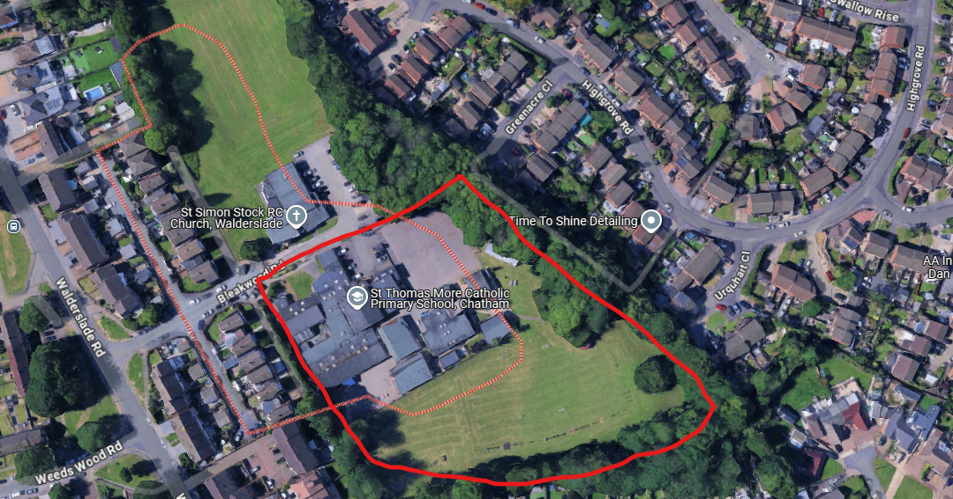

- Main Road Links - Bleakwood Road comes off Walderslade Road in Chatham and is in the Southeast region. The postcode is within the Wayfield & Weeds Wood area which is in the constituency of Chatham and Aylesford.
- Train/bus links – Chatham Train station is 2.6 miles and Chatham Bus Station (bus176 and 184) is 2.9 miles.

