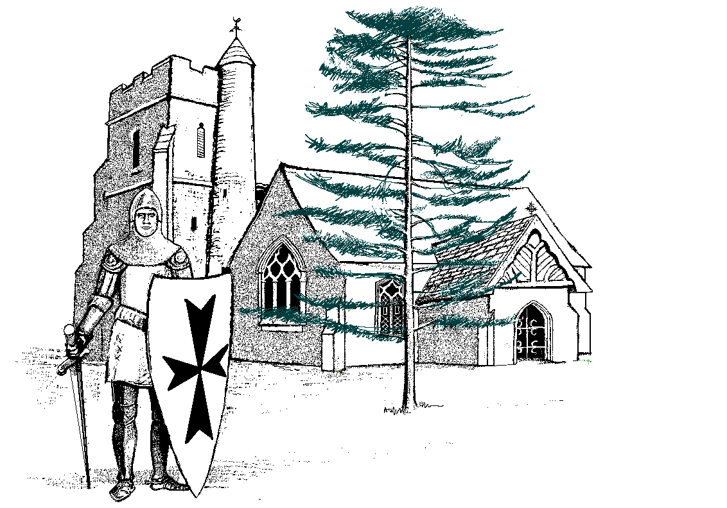
Sutton-at-Hone C of E Primary School

Church Road Sutton-at-Hone

Dartford Kent DA4 9EX

Tel 01322 862147
www.sutton-at-hone.kent.sch.uk
E-mail office@sutton-at-hone.kent.sch.uk

Head of School Mrs K Trowell

Job Role: Mid Day Meal Supervisor
Reporting to: Deputy Headteacher
Grade: KR3

JOB DESCRIPTION
- Job Purpose

To supervise the pupils during the mealtime period and play time to minimise any disruption, ensure they are safe, active and well behaved and maintain their safety.

- Principal Accountabilities
- Ensure pupils enter the dining room in a safe and orderly fashion and behave appropriately when queuing for their meal in order to maintain safety and wellbeing of all pupils.
- Put out tables (where applicable), in time for the mealtime period to ensure there are sufficient settings for the number of pupils eating that day.
- Ensure pupils eating meals are seated in an orderly fashion to maintain safety and wellbeing of the pupils. (including checking that pupils have or are provided with a drink and/or that sufficient amounts of their meal has been eaten).
- Assist the pupils, as necessary, during the meal break to ensure their wellbeing. (This may include providing them with a drink, helping with spillages, cutting up food and caring for pupils’ personal needs).
- Ensure plates, etc., are cleared from tables in an appropriate manner to maintain a clean and tidy environment and to free up space for any further sittings where applicable.
- Ensure once meals are finished that the dining area is wiped down, etc., and is left in a clean and tidy manner to maintain a clean and tidy environment.
- Assist in collecting pupils from collection point and escort to hall/classroom or patrol and supervise school areas used by the pupils at mealtimes, to ensure safety and appropriate behavior is observed, as applicable.
- Operate, where applicable, a first aid service, during the mealtime and on the playground and to deal with any accidents that occur safely and quickly.
- Promoting outdoor and indoor during wet play, active play encouraging pupils to play in a constructive and safe manner.
- Being an appropriate role model to all pupils, promoting the vision statement and ethos of the school.
- To initiate and supervise structured play with the children and encourage them to participate.
- To have the ability to organise activities and games with small groups of children whilst maintaining strong supervision over the rest of the playground area.
- To ensure that play equipment is inspected for damage before use and report to the supervisor.
- To ensure that play equipment is used in an appropriate and safe manner.
- To ensure that no children are inside the building during playtime without permission and supervision.
- To encourage calm behavior on the playground.
- To report to the Deputy Headteacher any issues that are required to be referred in accordance with the schools behaviour policy.

