

**Priory Infant School**

**Relationship and Behaviour Policy**

**Safe, Kind, Ready**

Written: September, 2022

Reviewed: November, 2023

Agreed by the Governing Body: January, 2024

To be reviewed: September, 2024

**Introduction**

This policy and our practice has been hugely inspired and influenced by the following:

* Nurture Schools UK
* Paul Dix (2017)- ‘When the Adults Change, Everything Changes’
* Education Endowment Foundation (2021)- ‘Improving Behaviour in Schools’
* THRIVE training and development

Priory Infant School prides itself on being a caring school and the most important aspect of this is that our pupils feel valued, safe and secure through strong, supportive relationships between staff and pupils. Staff are fair and consistent with children and always consider individual needs. Our children understand that staff are in control which enables them to feel safe. Staff are approachable, kind and are there to help and discipline but not punish. Staff understand the importance of being a positive role model to our pupils and their essential role in teaching and modelling behaviours we expect in school. Staff treat the children how they wish to be treated. Staff remain calm and do not allow their own emotions to affect situations. Where a member of staff has difficulties, they seek support in order to make a positive change.

This policy has been developed to ensure guidance for staff, and information for parents and governors, to promote safe, kind, ready behaviours in school. The procedures and guidance in this document provide a consistent approach across the school and enables children, parents and staff to understand our approaches to the management of behaviour at Priory Infant School.

For some of our pupils it is recognised by all staff that variance on procedures may be made to meet specific individual needs or disability which requires a personalised approach. Guidance for this should be discussed with the SENCo. Understanding a pupil’s individual context will ensure we provide effective responses to any inappropriate behaviour.

**Being ‘fair’ is not about everyone getting the same (equality) but about everyone getting what they need (equity).**



**Aims**

The aims of this policy are…

* To provide a safe, secure, caring environment which encourages our pupils to achieve their own potential.
* To enable staff to support children with their feelings and behaviour using effective strategies.
* To ensure that our children and staff have a sense of belonging, feel safe, secure valued and are listened to.
* To maintain a calm, purposeful working atmosphere.
* To provide a clear, fair and consistent approach to behaviour.
* To foster, nurture and value strong and healthy relationships.
* To encourage and develop intrinsic motivation within our pupils.

**Our Golden Rules:**

**Safe: We look after ourselves, each other, and the school.**

**Kind: We use kind words, hands, and feet.**

**Ready: We are ready to learn and do our best.**

**Positive systems to promote safe, kind and ready behaviours**

Rewarding expected behaviours through positive praise is paramount within school and aims to foster an intrinsic motivation within our pupils. At Priory Infant School we recognise that most of our pupils can self-regulate their behaviour and behave very well every day, and this is encouraged and celebrated in school in a variety of ways including:

* Adults welcome the child to the classroom each morning with a smile and a greeting and say ‘goodbye’ at the end of the day.
* Staff use positive body language and tone, model respect and understanding- reinforcing unconditional positive regard at all times.
* Regular whole school or class assemblies to describe, model and encourage expectations of behaviour (Safe, Kind and Ready).
* Weekly whole school celebration assemblies- awarding of certificates and stickers.
* End of term celebration assemblies- awarding of certificates and stickers.
* Verbal and written praise from school staff for good learning, effort and/or behaviour- focusing on the positive.
* Interactive recognition boards in each classroom to recognise those children who go ‘above and beyond’.
* Daily positive messages home via face-to-face conversation, notes or telephone calls to share success with parents/carers.
* Positive praise at the start and end of each lesson/activity and throughout the session- always draw attention to the positive.
* Staff focus on providing attention to the children showing the expected behaviours- ‘naming and faming’ (10:1 challenge)
* Every day is treated as a ‘new day’.
* Quality First Teaching enables all pupils to access the curriculum, engage with lesson content and participate in their learning appropriate to their individual needs and level of development.
* ‘Zones of Regulation’ check ins within the classroom to identify how children are feeling throughout the day.
* Thumbs up/down ‘check ins’ after break and lunchtime.
* Assertive, scripted language (see Appendix 3)

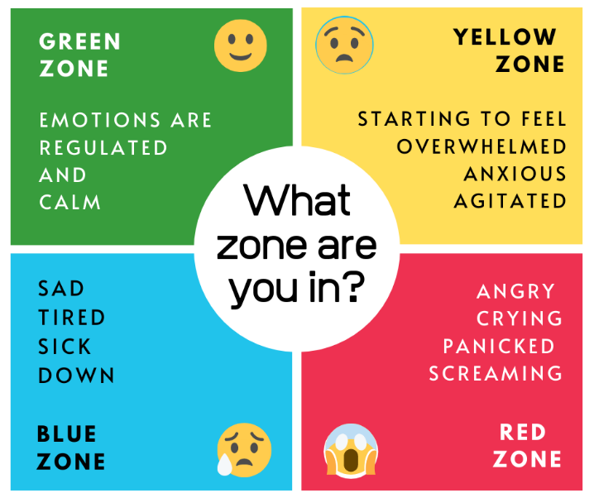

**Supportive systems to meet the needs of children displaying unsafe behaviours**

Priory Infant School understands that children may on occasions behave inappropriately and we recognise that universal behaviour systems are unlikely to meet the needs of all our pupils. For children who exhibit more challenging behaviours, the approach must be adapted to meet their individual needs. Training for staff is ongoing to support them to develop the strategies to support our children with complex needs. Some regular strategies to support our children include:

* Use of fidget/sensory toys
* Use of calm boxes
* Calm spaces
* Sensory circuits
* ‘Now and next’ boards
* Movement breaks
* Visual communication cards
* Ear defenders
* Home/school contact books
* Timers
* Individual learning stations
* Social stories
* Quiet room
* Additional adults
* Use of Makaton
* Personalised timetables
* Risk assessments
* Nurture/THRIVE assessments/groups/interventions
* Attention autism (bucket) intervention
* Wobble cushions
* Boxall profiling
* THRIVE assessments
* Use of WING phrases- I wonder…, I imagine…, I notice…, I guess…

Many of the above strategies are helpful for all our children, regardless of any specific need and they form part of our whole school nurture approach to effectively manage the needs of *all* our pupils.

Pastoral support plans are in place for children who have additional support over and above what every classroom offers, and these plans are reviewed regularly to monitor progress of the children and the effectiveness of personalised interventions that are in place.

Across the school, whether inside or outside of the classroom, all staff at Priory Infants will manage all behaviour positively- it is everyone’s responsibility to ensure the school is a calm, purposeful environment where children feel safe and secure. All adults in school are role models to the children. Sometimes all that may be needed is a distraction, a quiet word with a child or a non- verbal cue so that the child is reminded of the expected behaviour in school. All unwanted behaviours will be dealt with promptly, according to the needs of the child, to alleviate any escalation. Some strategies to support this are:

* Non-verbal signals e.g., a shake of the head; use of visuals and Makaton
* Seating child in a different place to help them concentrate e.g., next to an adult
* Calm reminder of expectations and praise for those children doing the right thing
* Quiet word with child away from the rest of the children
* Distraction such as a movement break
* Providing some ‘thinking time’ and space
* Use of the PACE approach (playful, acceptance, curiosity and empathy)
* Consideration of ‘HALT’- is the child hungry, angry, lonely, tired?
* Use of scripts and visuals to reduce language and brain overload (see Appendix 3)

Priory Infant School staff work as a team and will support each other to help children to self-regulate by asking “Do you need any help?” rather than stepping in without questioning.

Staff use Makaton signs and/or other visual clues to help support children’s communication skills and understanding wherever needed.

At Priory Infant School we support children to be safe, kind and ready through our calm, consistent conversations with them:

1. **Initial verbal reminder (make explicit the expectation)**

e.g., “I am/we are expecting you to … (not talk when I am talking, etc)

“It was the rule about…. (walking safely around school) that was broken then”

“This behaviour is stopping learning. What do you need to do to behave safely?”

1. **Second verbal reminder (make explicit the expectation again followed by consequence)**

e.g., “I am/we are expecting you to complete your work. When children do not finish their work, they need to stay in to finish it at playtime”

“I am/we are expecting kind hands at all times. When children don’t use kind hands they need to sit/play separately from others so everyone can be kept safe”

“I am/we are expecting you not to spit. When someone spits I need to keep them inside so everyone can be kept safe, spitting is not safe. I/we will need to talk with parents about this.

1. **Implement consequence as highlighted in 2nd stage.**
2. **If behaviour is repeated again**

e.g., “I can/we can see you are still finding it hard to …/not to…I am not going to give up on you, how can I/we help?”

1. **Introduce support plan with parents**

Class teachers will inform parents promptly if their child is finding it difficult to manage their behaviour in school and strategies implemented to support will be discussed. Behaviour logs will be kept by staff to monitor incidents. These will be discussed with the SLT if strategies show little impact and behaviour incidents are not reduced.

If a personalised plan is needed this will be shared with parents/carers and staff to ensure collaboration and effective communication. The SENCo, working with the class teacher, may also access external agency support which will be enabled via contact with the Local Inclusion Forum Team (LIFT) or other agencies. This will be agreed in discussion with parents/carers.

Risk assessments will be compiled for children who exhibit unsafe behaviours, and these will be shared with parents/carers and relevant staff.

Personalised plans will be reviewed every two terms (however these are working documents and will be updated when necessary) and if impact is not seen the SENCo will actively seek further external outside agency support as necessary.

Where there are concerns that a child’s behaviour is unsafe, and may cause harm to themselves and/or others in school, the Leadership Team will contact parents to discuss.

**Nurture**

Priory Infant School recognises that children may have experienced Adverse Childhood Experiences (ACES) such as the Covid pandemic, attachment difficulties, domestic violence, bereavement. These children are more likely to have social and emotional difficulties which can significantly impact on their behaviours in school. A nurturing approach to supporting all our children is a key part of our work at Priory Infant School.

At Priory Infant School, we were awarded Nurturing School status in September 2023 as part of the National Nurturing school programme. This means that within every aspect of the school environment we are encompassing and promoting the six principles of Nurture UK in every part of our Priory community.

Nurture is an excellent programme to develop and support our student’s resilience, wellbeing and for promoting positive relationships and mental health for all at Priory Infant School. Mrs Rogers is our Nurture Lead

The 6 Principles of Nurture are:

**Children’s learning is understood developmentally**- the foundations of learning begin at birth and develop through a close relationship with an adult. Children develop independence through dependence and social empathy and learning develops from being valued and encouraged by others. All staff respond to each pupil at whatever emotional or social age s/he appears to be and plans accordingly. Boxall profiling is used across the school to identify gaps in social and emotional development and assess progress.

**The classroom offers a safe base-** all classrooms provide a routine bound structure to the day with a visual timetable available for all pupils. Adults are fair and consistent and set boundaries without causing children to feel negative. Space is available for children who need extra support to manage their emotions and opportunity to share and discuss concerns is provided such as worry monsters/worry boxes, visits to the quiet room.

**The importance of nurture for the development of wellbeing**- all children and staff are valued, listened to and treated as individuals. Achievements are noticed and praised at every opportunity and time is given to share successes. Shared activities such as play, reading, circle time and other learning activities allow the opportunity to problem solve and discuss together in a purposeful environment.

**Language is understood as a vital means of communication**- the importance of language as a way of putting feelings into words is crucial however we realise that sometimes our children will not have the appropriate vocabulary and may therefore ‘act out’ how they feel. Informal opportunities are provided in school to support our pupils in developing their understanding of emotions including circle time, zones of regulation, assemblies, social stories, restorative conversations.

**All behaviour is communication**- understanding that a child is communicating through behaviour enables staff to respond in a firm but not-punitive way by not being provoked or discouraged. Staff do not take the behaviour personally and remain calm, seeing the behaviour as an expression of need. If a child senses their feelings are being understood this can help to diffuse difficult situations and staff use appropriate de-escalation strategies as recommended by Thanet Inclusion Support Service (Appendix 1). It is the adult’s job to make the links between what the child is saying and doing, and how they must be feeling. This principle underlines the adult response to the children’s often challenging or difficult behaviour- *‘Given what I know about this child and their development, what is this child trying to tell me?’*

**Transitions are significant in the lives of children-**a whole school nurture approach helps the child to make the difficult transition from home to school. However, there are numerous transitions a child makes daily, for instance, between activities, between different adults, different rooms. All transitions big or small are treated with care and consideration of how the child could be feeling. Changes in routine can be extremely difficult for some children and this is carefully managed with preparation and support from staff using strategies such as now/next boards, visual timetables, timers, countdowns, songs and rhymes.

Priory Infant School has written their own 6 child-friendly nurture principles that the children understand and follow:

We all learn in our own way

Nurture helps us to feel good on the inside

Our behaviour is telling you something

Our awesome classroom makes us feel safe

The words we choose are important

Nurture helps us to manage changes

**Nurture provision**

All classrooms at Priory Infant School embody the whole school nurturing ethos with an outline of classroom non-negotiables in place (see Appendix 2), however we recognise that some children may need extra, specific Nurture support during their time at Priory. This may be on an ad-hoc basis in that there has been an unforeseen circumstance (such as a bereavement or family breakdown) that has affected a child’s wellbeing. Whereas other children may have been identified and assessed as needing more specialised support to support gaps in their development. A timetable of intervention sessions will be delivered for identified children to allow them to successfully access learning within the classroom. Individual plans, written and reviewed by class teachers, will be in place for these children and are reviewed regularly to ensure progress is being made.

Our FLO who has undertaken THRIVE training, may also be involved to support specific individual needs of the child. This will be in collaboration with the SENCo and parents/carers.

**Restorative approach**

When children display unsafe behaviour, a restorative approach is used at Priory Infant School. This approach promotes good relationships so that people can work together with the common purpose of helping everyone learn. Restorative approaches are based on 4 key features:

**RESPECT**- for everyone by listening to other opinions and learning to value them

**RESPONSIBILITY-** taking responsibility for own actions

**REPAIR**- developing the skills within our school community so that its individual members have the necessary skills to identify solutions that repair harm and ensure behaviours are not repeated

**RE-INTEGRATION**- working through a structured, supportive process that aims to solve the problem and allows young people to remain in mainstream education

Priory Infant School uses restorative approaches to encourage everyone to take responsibility for their behaviours appropriate to the young age of our children. Staff have been trained in restorative approaches and apply them to situations in school. All staff have a copy of the restorative questions on their lanyards.

**Process of a restorative approach**

When using restorative questioning the questions will always be asked in a quiet, appropriate area of the learning space once everyone is calm and ready to talk.

Only one person speaks at a time.

No interrupting.

Listen carefully.

Confidential- only between people involved and parents as necessary.

The following questions are asked:

**What happened?**

**How did you feel about it?**

**Who has been affected/hurt/harmed?**

**What needs to happen to put things right?**

**What can we do differently next time to avoid this happening again?**

Actions to repair the harm are reasonable and meaningful and related to the incident. They will be chosen and agreed by those involved. If a child has been harmed, parents of all parties will be informed of the incident. Parents will be made aware that the situation was dealt with in a restorative manner. The Senior Leadership Team will also be made aware of the incident and the process that has been followed.

Accident report forms will be completed where a child or adult has been hurt within school. These are to be countersigned by the Headteacher or Deputy Headteacher and filed in the Health and Safety File in the school office. Staff will, wherever possible, be offered recovery time following such an incident and parents will be informed.

**Positive handling**

If a pupil’s behaviour escalates and it is necessary to remove a child from a situation using ‘reasonable force’ (no more force than is needed) to safeguard children, staff or the environment this will always be recorded on an Incident Report Form. This form will be countersigned by the Headteacher or Deputy Headteacher and parents will be informed of the situation that occurred. These forms will be filed in the SENCo office.

Several staff in school have received PROACT SCIPr Training to help support them in minimising the use of any physical intervention as this should only be used as a last resort.

DfE Use of Reasonable Force Guidance (publishing.service.gov.uk)

**Searching, screening and confiscation**

If it is necessary, in order to provide a safe environment for staff and pupils, to search a pupil at Priory Infant School, two members of staff (one being the Headteacher) would always be present and all DfE guidance (2022) would be adhered to in such a situation.

Searching, Screening and Confiscation (publishing.service.gov.uk)

**Parental Involvement**

At Priory Infant School we always aim to work collaboratively with our parents/carers as we recognise the important role they have in helping their child to behave appropriately at school. Good communication with parents/carers is vital. As part of transition, parents are asked to sign the Home School Agreement in which behaviour expectations are outlined.

Parents receive regular feedback from teaching staff regarding their child’s behaviour and positives will always be given in order to develop effective relationships. Any conversations regarding unacceptable behaviour will be given discreetly to parents/carers either in person or via a telephone conversation. Home/school contact books may be implemented to aid communication with positive behaviours always noted.

**Exclusion**

Priory Infant School will do all it can to create an environment where school exclusion is not necessary as pupil behaviour does not require it. However, there may be occasions where all behaviour management approaches have been exhausted and suspension or exclusion is necessary as a last resort. If this is deemed necessary, all relevant school, local and national policies/guidance will be adhered to.

Suspension and Permanent Exclusion from maintained schools, academies and pupil referral units in England, including pupil movement (publishing.service.gov.uk)

**Related Policies and Guidance**

Anti -Bullying Policy

Child Protection Policy

Children and Families Act 2014

Discipline and Conduct Policy (staff)

Equality Act 2010

Exclusion Policy

Home School Agreement

SEND Policy and Information

Staff Code of Conduct

SEND Code of Practice

Behaviour in Schools - Advice for headteachers and school staff (publishing.service.gov.uk)

Appendix 1 (de-escalation techniques)

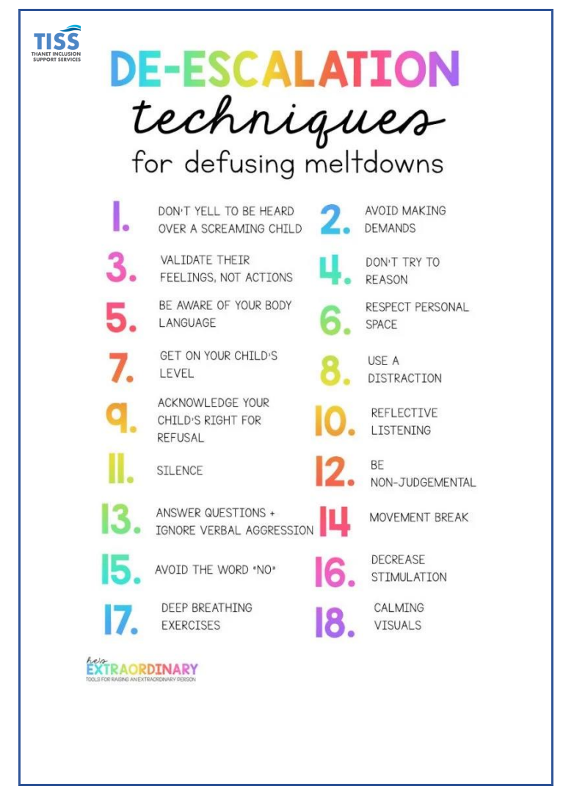

Appendix 2 (classroom non-negotiables)

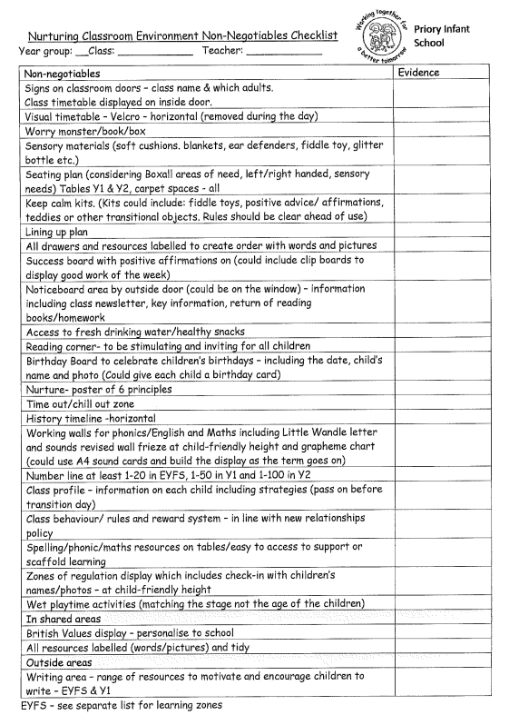

Appendix 3 (behaviour scripts)

|  |  |  |
| --- | --- | --- |
| Behaviour | script | visuals |
| climbing | Feet on floor |  |
| spitting | Stop, kind mouth |  |
| hitting | Stop, kind hands |  |
| snatching | Stop, kind hands, ask |  |
| swearing | Stop, kind mouth |  |
| throwing objects | Stop, kind hands |  |
| showing privates/pants | Pants are private |  |
| escaping school | Stop, in school |  |
| escaping class | Stop, in class |  |
| chasing others | Stop, be safe |  |
| pushing | Stop, kind hands |  |