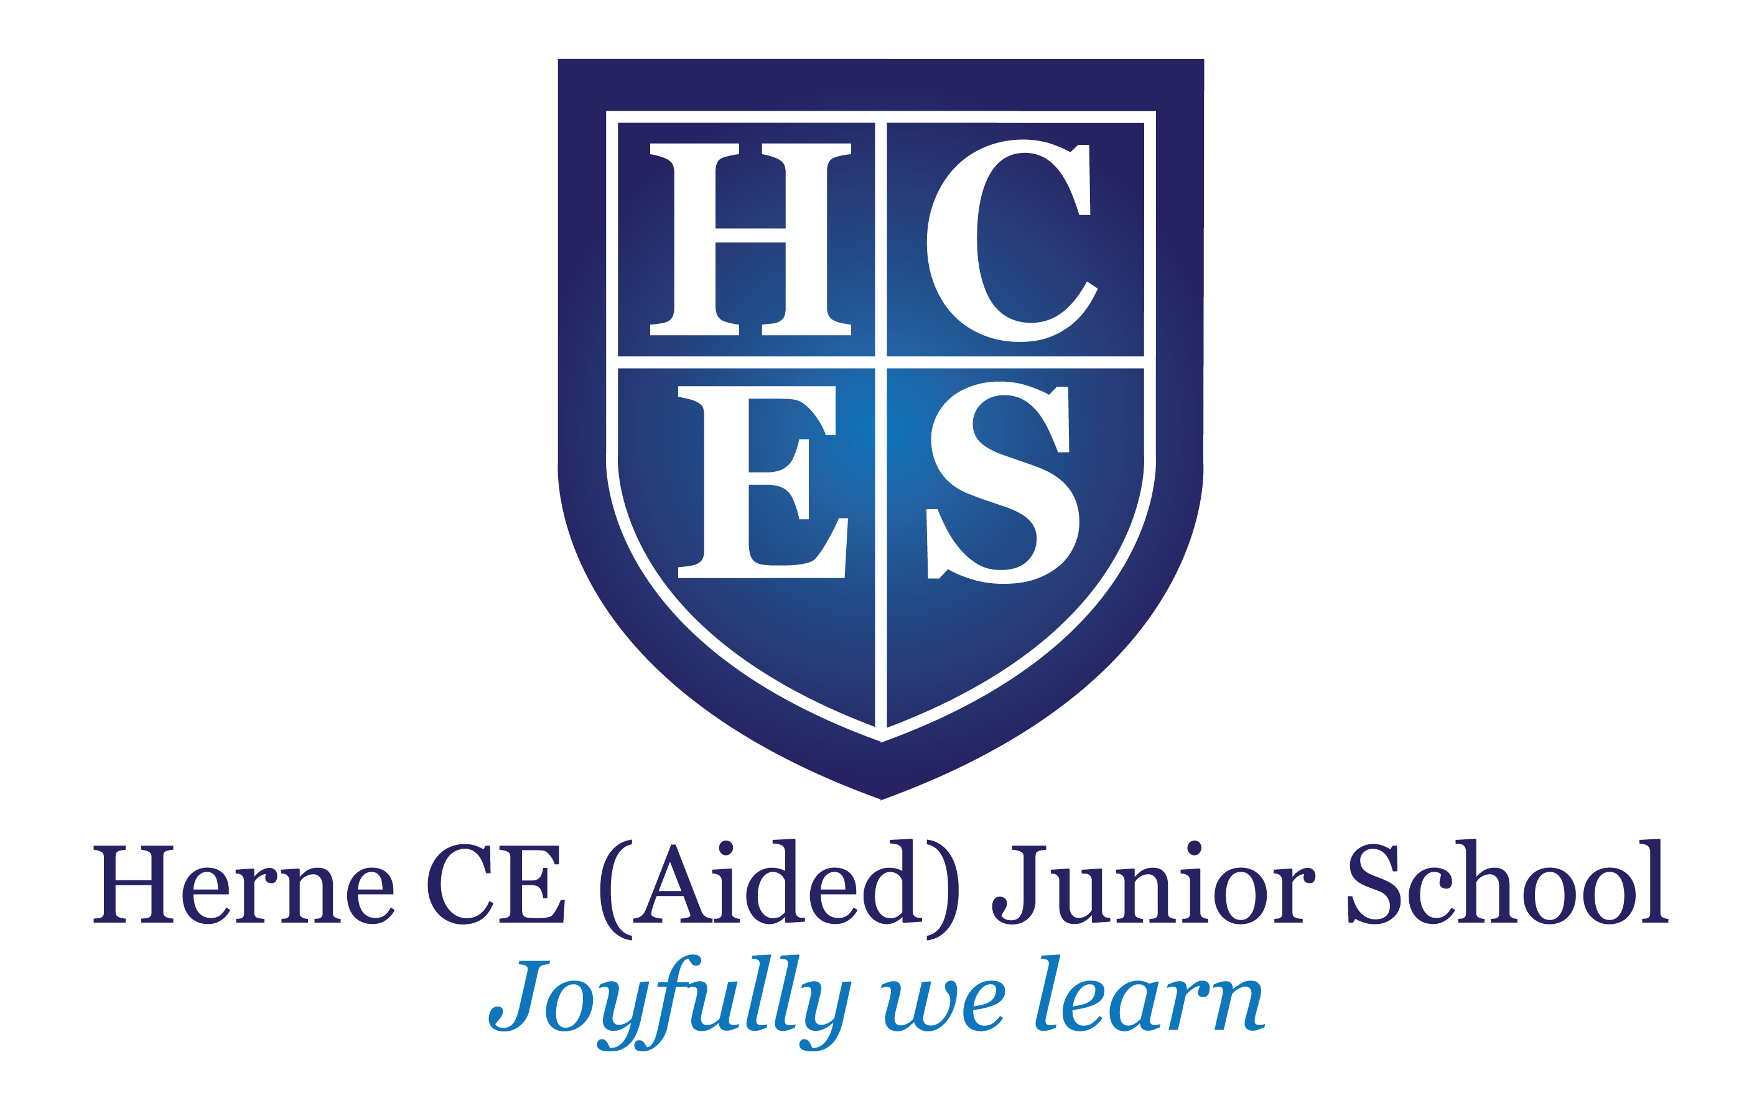
Headteacher
Mr Malcolm Saunders BSc (Hons) NPQH

E-mail: office@herne-junior.kent.sch.uk
Website: www.herne-junior.kent.sch.uk
Twitter: @hernecej

School Lane, Herne, Kent CT6 7AL

Tel: 01227 374069
Fax: 01227 741415

Love your neighbour as you love yourself
Matthew 22:39

PERSON SPECIFICATION
CLASS TEACHER

Requirements | Essential | Desirable
Professional  - A teaching qualification in Education which is recognised by the DfE  - Successful teaching experience within the primary age range and an excellent understanding of current theory and best practice in teaching and learning  - Able to demonstrate the skill required to build strong working relationships with children, parents and colleagues  - Relevant and recent professional development  - A knowledge and understanding of:  - The monitoring, assessment, recording and reporting of pupil progress  - Safeguarding practices and strategies to support pupil well-being  6. Successful completion of the ECF (for ECTs)  7. Evidence of levels of mastery within the ECF (for ECTs)  Personal  - Recognises and supports the distinctive Christian ethos of the school  - Has drive and ambition, with a strong commitment to moving our school forward  - Approachable, relates well to pupils and responsive to their needs  - Ability to listen effectively and be sensitive to the views of others  - Should have enthusiasm, patience, perseverance and a good sense of humour  - The ability to work within a committed team  - A commitment to extra-curricular activities  - Has a thirst for self-development | √  √  √  √  √  √  √  √  √  √  √  √  √  √ | √  √

