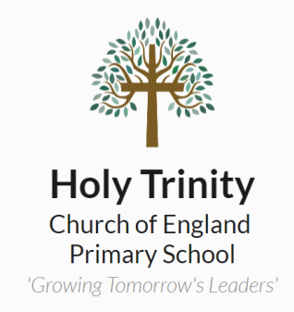
Holy Trinity C E Primary School
Dartford

Job Description

Post Holder:

Effective Date:

Job Title: Caretaker

Grade: KR4

Hours: 16.25

Responsible to: Line Manager

Purpose of the Job:
Be responsible for the security, caretaking, cleaning, general maintenance needs of the premises
(Roles at this level do not deliver “specified work” as defined in the guidance to Section 133 of the Education Act 2002.)

Key Duties and Responsibilities:
- Undertake general repairs and maintenance around the establishment, inside and out, including plastering, decorating, repairs on furnishings and buildings, including woodwork to ensure a safe environment is maintained. Storing and maintaining resources such as cleaning supplies and equipment.
- Maintain security of the site i.e. opening and closing of the premises including those for lettings, fixing or reporting any problems, attend to all contractors visiting or working on site, to ensure a safe environment and liaising with line manager as appropriate.
- Monitor the boiler to ensure it is kept running on a day to day basis to meet the establishments needs.
- Provide a porterage service for deliveries to ensure supplies are correctly handled and appropriately delivered.
- Take meter readings from appropriate sites around the premises to assist in ensuring invoices received are correct and budget monitoring is maintained when needed.
- Ensure that buildings and site are secure, undertaking security checks.
- Keep records relating to maintenance and security
- Perform duties in line with health and safety regulations (COSHH) and take action where hazards are identified, report serious hazards to line manager immediately
- Undertake general portage duties including moving furniture and equipment within school
- Undertake minor repairs (i.e. not requiring qualified craftsperson) and maintenance of the buildings and site
- Operate systems such as heating, cooling, lighting and security (including CCTV and alarms)

Individuals in this role may also undertake some or all of the following:
- Periodic cleaning of designated areas of the school building and grounds according to instructions
- Assist with the maintenance of specialised equipment following training, for example sports/theatrical equipment
- Act as a designated key holder, providing emergency access to the school site
- Act as school contact in relation to premises related contractors
- Organise testing for asbestos and other health and safety procedures.

Carrying out any other duties that may reasonably be required by the Senior Leadership Team.

Signed ___________________________________________ Date ____________________________

Signed ___________________________________________ Date ____________________________
(On Behalf of the Governing Body)

