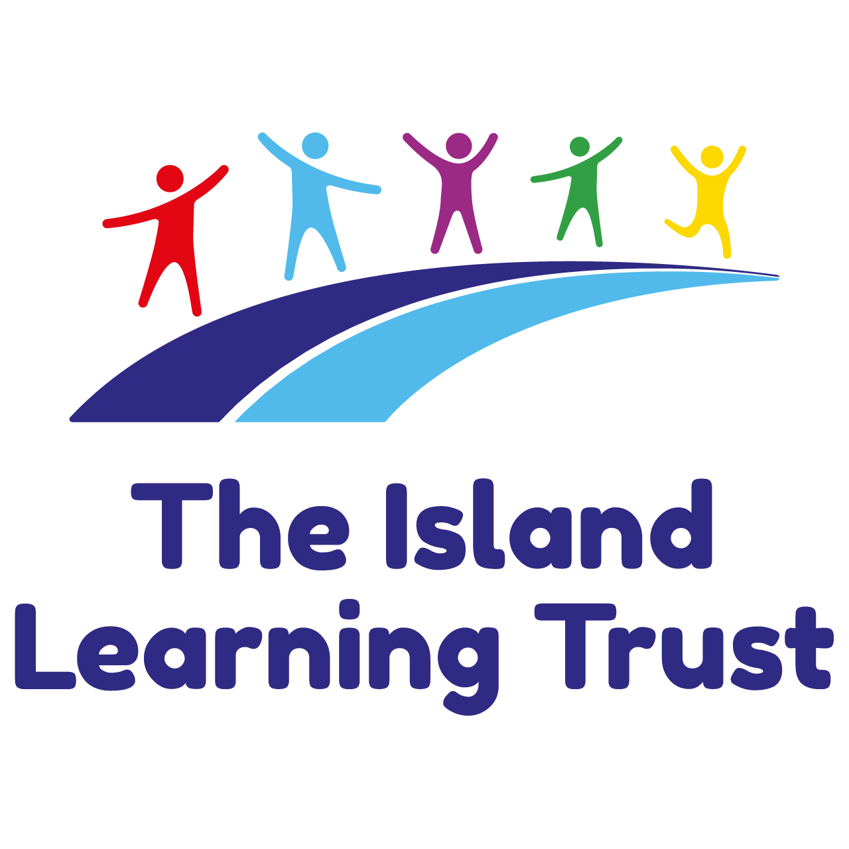
PERSON SPECIFICATION

JOB TITLE: CLASS TEACHER (MAIN SCALE)

CRITERIA OR REQUIREMENTS | Method of Assessment
EDUCATION / EXPERIENCE
1. QUALIFICATION
- First degree and PGCE or B.Ed/B.A. (with QTS) or QTS via employment based route.  - Training in and experience of the age range applying for. | AF  AF
2. EXPERIENCE
- Understanding of what ‘good’ teaching looks like  - Judged as at least ‘good’ during previous lesson observations  - Experience and understanding of organising, promoting and evaluating the curriculum  across a range of subjects at classroom level.  - Understanding of the principles of successful curriculum organisation at classroom level.  - Understanding of good classroom management.  - Understanding of the requirements of the National Curriculum.  - Understanding how pupils with special educational needs may be integrated in the  classroom. | AF/I  AF/I  AF/I  AF/I  AF/I  AF  AF/I
3. KNOWLEDGE
- Awareness of the management of pupils’ behaviour and motivation.  - Evidence of empathy with national and local policies regarding equal opportunities and their implementation.  - Commitment to the importance of parental and local community involvement.  - Awareness of how to implement policies in classroom practice.  - Skills in effective communication, both written and oral, to a range of audiences.  - Ability to effectively incorporate ICT in the curriculum.  - Ability to record and maintain children’s progress and data effectively.  - Ability to work under pressure whilst maintaining a sense of humour. | AF/I  AF/I  AF/I  AF/I  AF  AF/I  AF/I  AF/I

