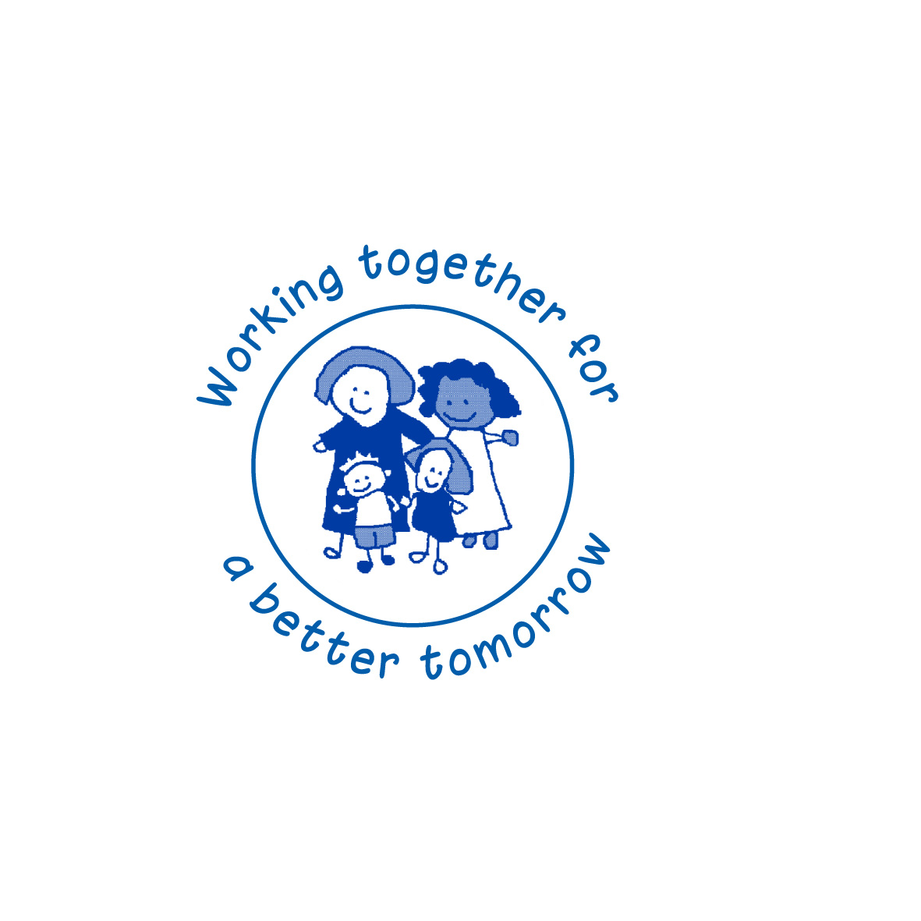

PRIORY INFANT SCHOOL

“Working Together for a Better Tomorrow”

Job Title: Mid Day Meals Supervisor Responsible to: Senior MDMS & Headteacher
Salary: Kent Scheme Band 3 (pro rata, Term time only) 11.45am to 1.15pm ( 7.5 hours per week)

Summary of Job:
- Supervise and play with children during the lunchtime period to ensure children have a happy lunchtime and playtime.
- Monitor and take actions to maintain health and safety of the areas of work – inside and outside.
- Follow school’s safeguarding and behaviour policies and procedures, ensuring children’s safety, well-being and enjoyment at all times. Priory Infants School is committed to safeguarding and promoting the welfare of children, young people and adults, and expects all staff and volunteers to share this commitment.
- Be aware of and take account of children with SEND, AEN and medical needs.
- Adhere to the code of conduct for all staff members and follow the school’s ethos and values, as described in the Staff Handbook.
- Adhere to the schools GDPR policy and complying with Data protection and FOI regulations

Outline of Main Duties:
- Support with the setting up of tables for the lunch period to ensure there are sufficient settings for the number of pupils eating that day.
- Ensure pupils enter the dining hall in a safe and orderly fashion and behave appropriately when sitting down in order to maintain safety and well-being of all pupils.
- Follow school routines to ensure all children receive their dinner promptly
- Assist the pupils, as necessary, during the meal to ensure their well-being. This may include providing them with a drink, helping with spillages, cutting up food, chatting to them about their morning activities, reminding them about lunchtime rules, caring for pupils’ personal needs including toileting.
- Ensure plates etc. are cleared from tables in an appropriate manner to maintain a clean and tidy environment and to free up space for any further sittings where applicable.
- Ensure safety and appropriate behaviour is observed during transition between eating and going out to play.
- Apply basic first aid during the lunchtime to deal with any accidents that occur, so that children are treated quickly and following school first aid guidelines.
- Actively supervise pupils at all times – report back any incidents or relevant information to class teacher or TA at the end of the lunchbreak before children go back into class.
- Take an active role in play activities on playground – encouraging children to join in, share and take turns. Supervising the use of play equipment safely and fairly and helping children to tidy up and put away equipment at the end of each session.
- Take part in fire drills and emergency evaluation procedure practices as necessary.
- Undertake training applicable to post of MDMS.eg. statutory child protection training; first aid training; active playtimes training.
- Meet with Senior MDMS and / or Headteacher to discuss school mealtime arrangements when required

Health & Safety
Staff responsibilities
- Take reasonable care of their own health and safety and that of others who may be affected by what they do or fail to do.
- Co-operate with their employer/employees on health and safety matters.
- Will not interfere with anything provided to safeguard their health and safety or that of others.
- Report all health and safety concerns to the head teacher or their line manager.
- Have due regard to H & S policies and guidelines within the school
- Carry out activities in accordance with training and instructions
- Where necessary, read/complete the relevant risk assessment appropriate to particular jobs e.g. manual handling (lifting), Working at Heights (display work), Design & Technology (working with tools/glue guns etc) to protect yourself and others.
- Awareness of issues such as dealing with: Bodily fluids, Cleaning, Interactive Whiteboard Safety
- Priory Infants is a non-smoking school. Smoking is not allowed anywhere within the school grounds and boundaries.

October 2023

