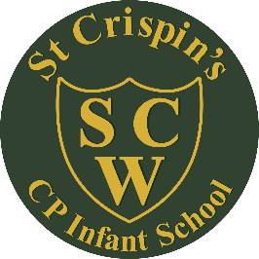

**St Crispin’s CP Infant School**

Position: Cleaner

Location: St Crispin’s CP Infant School

Responsible to: Site Manager / Headteacher

Grade: Kent Range 3

Personal Specification

|  |  |
| --- | --- |
|  | Essential (E) or Desirable (D) |
| **Knowledge and abilities**  Experience of using a range of cleaning equipment.  Able to follow work routines / instructions  Knowledge that is usually acquired based on “on the job training”, but sometimes requiring some attendance of formal courses, e.g. manual handling  Willingness to undergo training as required  Awareness of the need for safeguarding and procedures in a school setting. | D  E  D  E  D |
| **Working with people**  Able to work with others and in teams  Able to form effective working relationships  Able to deal with others courteously and in an acceptable manner  Contributes to day to day smooth running of the school | E  E  E  E |
| **Communication**  Has every day spoken skills, e.g. telephone and face to face conversations  Written and numeric skills appropriate to the job  Ability to listen, observe and report information to supervisor  Able to communicate with others in an acceptable and appropriate manner, e.g. patience, tact, humour, sensitivity, understanding, firmness  Understands and applies confidentiality relevant to the client group, job and workplace | D  D  E  E  E |
| **Health and Safety**  Understands and able to apply Health and Safety procedures relevant to the job such as:   * Safe use of machinery and / or equipment * COSHH * First Aid and Hygiene Practice | E |
| **Equality**  Understands equal opportunities  Deals with all pupils and students and work colleagues fairly regardless of race, colour, sex, disability, age or religious belief. | E  E |