PERSON SPECIFICATION FOR POST OF KS1  CLASS TEACHER AT ST CRISPIN’S CP INFANT SCHOOL | 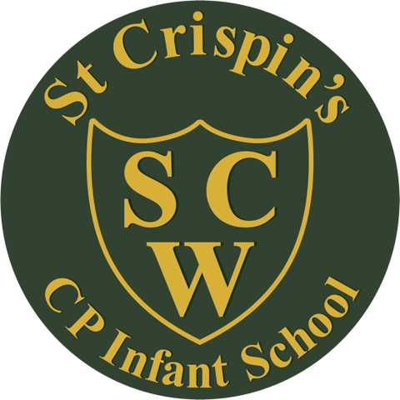

CRITERIA | ESSENTIAL | DESIRABLE
Qualifications and Experience | - Qualified teacher status.  - Successful experience of teaching in KS1.  - Proven track record of achieving rapid pupil progress  - Experience of teaching phonics. | - Experience of teaching in EYFS.  - Experience of end of Key Stage Teacher Assessment.
Knowledge and Understanding | - KS1 National Curriculum.  - Assessment for learning.  - Effective behaviour management strategies.  - An understanding of child development.
Teaching Skills and Abilities | - Ability to plan and deliver effective lessons.  - Ability to meet the differing needs of individuals. | - Experience of leading a curriculum area.
Working with others | - Ability to build positive relationships with children, parents and colleagues.  - Excellent communication and interpersonal skills. | - Experience of working with outside agencies
Personal Qualities | - Enthusiasm and energy.  - Effective organisational skills.  - Flexibility.  - Positivity.  - Willingness to reflect upon and develop own practice.  - Desire to be part of a team.  - Good sense of humour.

