|  |  |
| --- | --- |
| Oaklands School **T**ogether **E**verybody **A**chieves **M**ore  **Prospective Team Member Pack**  ***Apprentice Teaching Assistant 2023-24*** |  |

**Our school is committed to equality and take the safeguarding our children very seriously. Therefore all references will be rigorously taken up, no open references will be accepted and several pre-employment checks.**

**THE OAKLANDS TEAM**

Thank you for taking the time to visit the school and taking an interest in working at Oaklands. We are an exciting school to work with the associated challenges and rewards which come with a school working in a deprived area.

Our vision is simple:

**Together Everybody Achieves More**

We honestly believe in working in a team and we support and encourage each other. Working here, you will be part of many teams, year group, phase and curriculum, so you will be part of the wider school family. Planning is taken in Teams and phases so that you are able to share ideas and suggestions.

As part of our school, you need to understand our values. At Oaklands we have the following values which we demonstrate, model and teach to our children. As a staff member this means:

**A**spire

*We have high expectations and set ambitious challenges for our children in a broad & balanced curriculum.*

**S**elf-confidence

*We praise children’s efforts and achievements in a safe environment. We teach children to have faith themselves as learners.*

**P**erseverance

*Teaching children to keep trying and not give up. We track children’s progress to make sure they are learning to the best of their abilities.*

**I**ndependence

*We insist upon high standards of behaviour to maintain a safe and orderly community. We help children to be independent in their learning.*

**R**espect

*We treat all people kindly. We look after everything and everyone.*

**E**nquiry

*We structure our learning around children’s interests and questions. We constantly reflect to ensure we are giving a high standard of teaching for all children.*

We expect all members of our community to uphold these values and to promote them whenever they are within our local community.

**WELLBEING**

Being part of a team means we look out for each other. We firmly believe in our own and others well being. We take time out of the term for wellbeing and extra time is set aside for certain tasks such as provision mapping and getting planned for the next term.

We value time and ensure that any meetings are productive and time is given out of the school day. Professional Development Meetings are kept to half an hour at the most and all TAs received 1:1 support from a Subject Leader and PPA time. PPA is absolutely protected. We never miss anyone's PPA.

**SCHOOL GROUNDS**

Our school is set in extensive grounds which incorporate woods, meadow land, an orchard and playing fields. We use these grounds whenever possible to extend and enrich the children’s learning.

As well as this, we have our own swimming pool, training kitchen, Art & Design room, Music room, a radio station, library and two IT suites which all allow a wide range of opportunities for our children’s learning.

**CURRICULUM**

We aim for our curriculum to be fun and exciting for the teachers to teach so that the children enjoy it and learn. We review the curriculum each year to ensure that it is effective and current with the children’s needs.  It is based on experiential learning and follows a structure of:

Each term, the children will engage in an **Engage** event such as a special activity day; visit to a specific place or a guest visiting the school.  All the learning builds to an **Innovate** challenge where the children share the outcomes of their studies with other people in an **Engage** event.

As well as year group topics, we enjoy school whole topics based on specific areas of learning or current events such as Arts Week, Book Week or our Healthy Living and Sports Day finale to the year.

**TEACHING & LEARNING**

At Oaklands, we are very focused on consistency for our children. We are not looking for clones or a certain way of teaching but we do have some non-negotiable elements which we all sign up to.

We believe in sharing the best with the rest and so are looking for new ideas and imaginative ideas to share with all our staff so we learn from you as well as you hopefully learning things from us.

Planning is kept to a minimum and based on ensuring that the correct skills are taught to the children. Planning is in teams so that you can work together in creating learning experiences for the children which are exciting while achieving high standards.

TAs work across phases in the school. You will work with a team of trained TAs who focus on a specific Area of Learning, such as English, Maths or Pupil Premium. You will receive training in these areas which will help your children.

**ASSESSMENT OF LEARNING**

We make sure that all assessment has the purpose of knowing what the children know and helping them moving forward in their learning.

We don't believe in wasting time. We know that verbal feedback is the most powerful way of sharing feedback and so encourage all staff to spend time with children and use key word feedback from the verbal feedback you give in the lesson.

Data is collected termly to ensure that we can see any children who may need extra help and time is given for you to meet with other teachers and leaders to help come up with ways of helping your children.

**AMBITION**

We are a learning school and one of our values is ambition. We are looking to support teachers in their careers. We actively help you move forward in that, whether it is to be more effective in the classroom, move into Higher Level Teaching Assistant or into teaching. We work with a range of partners, such as the CCCU and Schools Direct and it is a busy and thriving learning community for all.

**SAFEGUARDING**

Our school is committed to equality and take the safeguarding our children very seriously. We will conduct the following checks with applicants:

|  |  |
| --- | --- |
| **Pre interview** | * Two professional references * Self-disclosed criminal record history |
| **Interview** | * Discussion around your suitability for the role |
| **Pre employment** | * ID and qualification checks * Evidence to work in the UK * DBS and Barred List check |

Safeguarding training will be provided before or when you join the team so you are aware of the school's policies, procedures and practices.

**INDUCTION**

If you are successful in joining the Oaklands team, you will have a thorough induction. Previous team members have said that they have never had such a supportive induction as we offer.

After appointment, you will visit the school to complete paperwork and safeguarding requirements.

You will have a named mentor who will meet with you before you start and on the very first day. They will keep in touch and make sure you have someone who you know to answer any questions and be someone to help settle you in.

**BEHAVIOUR**

Good behaviour for Learning is a key part of being part of the Oaklands team. The school serves a diverse community with a large part of this being from disadvantaged backgrounds. While this is rewarding, it can bring with it challenges which many other schools would not encounter!

We believe in positivity and this is our first and foremost technique for working with children and families. We have a positive pathway which we talk to the children:

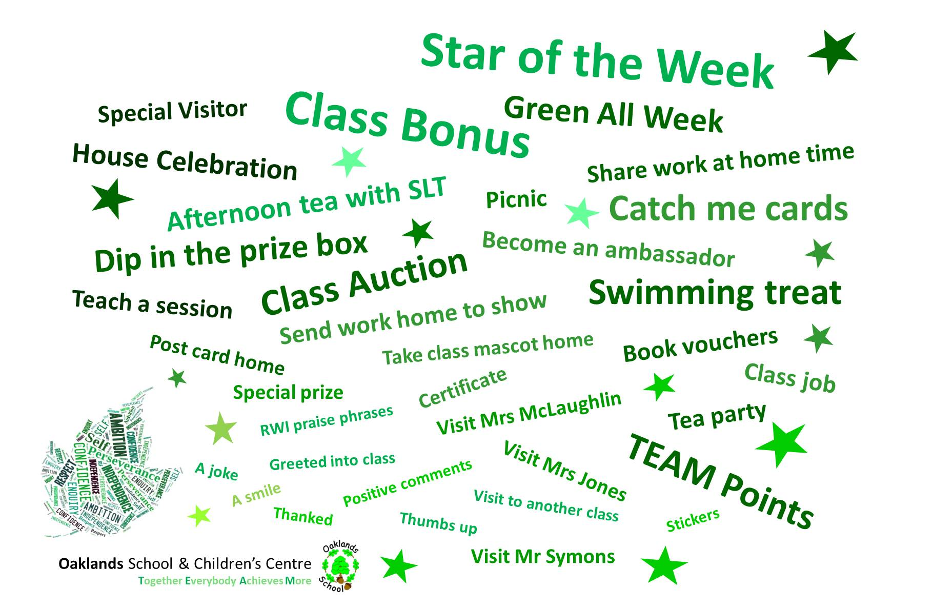

Again, we believe that Together Everybody Achieves More and we work very closely with all families to develop effective working relationships. Working in partnership with parents ensures that they support and trust us.

**RULES**

Oaklands School only has two simple rules for all to follow. We follow a no excuses policy for these two rules. No matter the situation or context, we will not accept anyone breaking these.

**Always follow adults’ instructions.**

**Keep your hands, feet and unkind words to yourself.**

**THE SELECTION PROCESS**

To find the right person, we will use the information you give us in your application to choose a short list of the people we think most meet our criteria.

These people will be invited to an interview and **references** **will be requested, including one from your present employer if applicable**.

The interview is not a test and we know that they can be very nerve-wracking times. We have a range of activities so that we can see all the different sides of you.

The process will usually consist of:

* A short teaching activity of a class or group of children so we can get a flavour of your teaching skills and style.
* An interview with the panel who will ask you some questions to find out more about your experience and skills.

All these activities will be explained to you in advance or on the day and you are always given time to prepare.

**THE DECISION**

The whole process is scored by the panel and the person with the highest score on the day will be offered the role. **Any offer will be conditional upon all safeguarding checks being successful.**

We know that it is hard in any process if you have not been successful. We always phone every single applicant to explain the decision and share feedback on the process. We always follow our own procedure of *'three stars and a wish*' when giving feedback. If you are not successful, it is not because you are not good enough, but we need to find the person who will fit our team the best.

Once again, thank you for taking the time to show an interest in joining the Oaklands team.