

**Occupational Therapist**

**Applicant Pack**





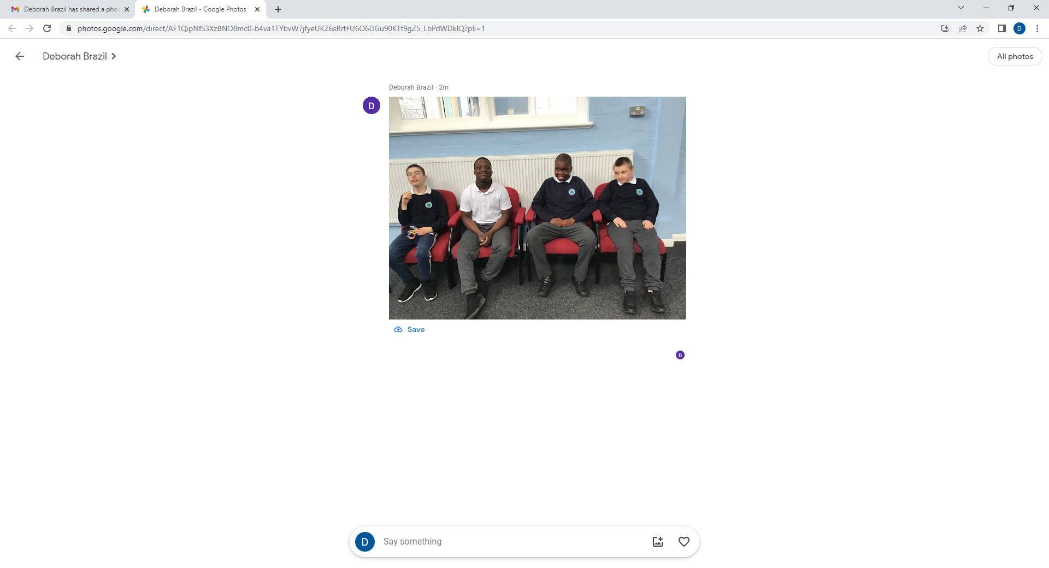



***“Together we engage, thrive and achieve”***

**Executive Head Teacher: Lori Ann Mackey MA (Ed)**

**Head of School: Heather Jolly BA (Ed) Hons**

Primary: Sidcup and Crayford / Secondary: Belvedere

🖰 [**https://www.shenstone-tkat.org/**](https://www.shenstone-tkat.org/)

Dear Applicant

Thank you for showing an interest in the role of Occupational Therapist at Shenstone School.

We have devised this recruitment pack to show you, with pride, what being a member of the Shenstone School community means. Please take time to read through the literature provided, and we would encourage you to explore the school’s website and arrange a time for a school tour, as detailed on the job advert page.

Our website can be found at [www.shenstone-tkat.org](http://www.shenstone-tkat.org) and contains further information about our Vision and Values, Policies and Procedures, Health and Well-being, Curriculum Offer, School Development Plan, Ofsted report and highlights what makes Shenstone a truly remarkable school. The school has an ethos of ***“Together we engage, thrive and achieve”***. This is integrated into, and evident in, all we do at Shenstone.

If, after reading through the recruitment pack, you still feel as though Shenstone is the place for you, we would welcome you to apply. To do so, please use the application to showcase your experience and how it reflects both the job description and person specification for the role. We want to hear why you are choosing Shenstone School and what you can bring to this position.

If you require any further information or have queries, please do not hesitate to contact the school office at 01322 524145 or via e-mail at [hr@shenstone-tkat.org](mailto:hr@shenstone-tkat.org).

Yours faithfully



**Lori Mackey**

**Executive Head Teacher**









**About Shenstone School**

Shenstone School is an all-through specialist school for children and young people with severe and/or profound and multiple learning difficulties. We opened our doors to our secondary provision in September 2022, when we welcomed our first year 7 cohort. As a school community, we are thrilled to have the opportunity to extend our learning offer to year 7-13 by 2029. The Secondary site is situated in Belvedere. Although we currently have a temporary facility for our secondary students, a specially adapted secondary school is currently being built in Halt Robin Road, Belvedere. We hope our permanent site will be up and running next academic year; however, we are expanding to welcome two new Year 7 classes in September 2023.

Our staff are passionate about providing the best opportunities and education to our students. Working in partnership with parents and carers, we successfully foster and develop a positive attitude in our young people and support them to have opportunities that will allow them to achieve beyond their expectations. The support and guidance students receive from staff gives them the confidence to learn independently and strive to achieve their most aspirational outcomes.  The school positions itself as a centre of excellence for its students, parents/carers, staff, local authorities and the wider community.

We aim to ensure that all students have the maximum opportunity to participate fully in society to enhance their life chances.  We pride ourselves on ensuring that learning remains purposeful but is equally fun. We are committed to supporting the emotional health and well-being of all our students, staff and parents/carers, and we stand by our motto of “together we engage, thrive and achieve”.

We are very proud of Shenstone School and our achievements which include: The Autism accreditation through the National Autistic Society, The Wellbeing Award for Schools, Outstandingly Happy School status, Move Centre of Excellence Award, National Online Safety Certified School status, and we are also an accredited Arts Award Centre. We continue to expand with new ideas and initiatives to maintain and improve services for students and staff.

Staff at Shenstone School can access the following benefits: excellent induction and probation processes, comprehensive in-house training, competitive pension scheme, employee counselling services, vaccination programmes, on-site mental health first aid team and various other well-being and social activities.



**About TKAT**

Shenstone School is part of the TKAT academy (The Kemnal Academies Trust). TKAT is one of the largest Multi-Academy Trusts in the South and East of England, with 45 Primary and Secondary Academies in the TKAT Family. Our ultimate aim is to ensure we drive educational standards through the provision of outstanding teaching, leadership and learning for all.

Our leaders focus on student progress and attainment and regularly share knowledge, insight and experience. We believe passionately in the power of collaborative working and actively promote school-to-school support.

Our students are at the heart of everything we do, and we strive to inspire learners and change lives as a result of our exceptional educational provision.

Via our website [www.tkat.org](http://www.tkat.org), you can read our Welcome Brochure, which gives lots of information about:

* Our journey so far
* Our vision and values
* Our governance
* Our Executive Team
* Our primary strategy
* Our secondary strategy
* How we support our Academies

**Working for TKAT:**

In return for working for TKAT, as an employee, you will benefit from

* A wide variety of opportunities for professional development, including the potential to develop your career at more than one TKAT academy,
* Opportunities to work flexibly, where possible.
* Our support for your well-being at work, and
* The rewards of working to improve the life chances of our students.

**What we do well**

The following statements have been obtained from staff via questionnaires or feedback requests.

I have settled in well and look forward to coming in every day to work with the amazing team and children at Shenstone.

Shenstone has provided me with so many opportunities for progression.

The induction I received was thorough and the staff on site have all supported me with my ongoing learning within the job.

Shenstone is one big team

I felt like I achieved so much.

It is a rewarding job with beautiful friendly staff and children.

**I most enjoy working alongside amazing children and being part of a team.**

**I loved working at Shenstone, the staff were friendly and the children were lovely.**



**Job Advert**

**Post Title:** Occupational Therapist

**Post Location:** Shenstone School

You will be required to work with pupils at all of our Shenstone Sites: Crayford, Sidcup and Belvedere.

**Contract Type:** Permanent

**Hours/Weeks:** **36 hours per week/40 weeks per year (term-time + 2 weeks)**

For the right candidate there could be some flexibility in hours or the possibility of some hybrid working. Should this be something of interest, this will be discussed at interview. However, please bear in mind that this is a pupil focused position and we will require the post holder to be on the premises working during pupil core hours (9:30 a.m. – 3:30 p.m.)

**Grade:** Scale 15 (equivalent to NHS Band 7)

**Salary:** **£35,202 - £41,060 approx* term-time only salary**

*This salary is based on 36 hours per week/40 weeks per year.

**£39,375 – £45,927 (full-time equivalent)**

Your salary will be discussed at appointment stage. The point on the scale will be assigned according to your experience and qualifications.

**Post Start Date**: This will be discussed at interview.

**Tour:** If you are interested in applying andwish to view our amazing school, please e-mail [hr@shenstone-tkat.org](mailto:hr@shenstone-tkat.org) with your name and contact number and we will arrange a convenient date and time.

**Closing Date:** Sunday 8th October 2023

**Interview Date:** Monday 16th October 2023

If the successful candidate doesn’t hold a Sensory Integration qualification, then this is something we could look at funding (subject to terms and conditions)





**About the Role**

An exciting opportunity has arisen for an inspirational and passionate Occupational Therapist to join the staff team at Shenstone School.  We are looking for someone who is able to help, support and bring out the best in our pupils who have severe, profound and/or complex needs.

The successful candidate will be a qualified and experienced Occupational Therapist who is confident, enthusiastic and motivated. This is a pro-active role, working with the pupils within the classroom setting. You will be providing personalised, innovative and new ideas in order to obtain the best individual outcomes for our fantastic pupils.

They will be responsible for such duties as: assessing, diagnosing, treating and managing pupils needs, sourcing equipment, liaising with parents/carers and multidisciplinary teams regarding their implementation, producing reports/plans, supporting in meetings etc.

The post holder will ideally work 36 hours per week over 40 weeks per year (term-time + 2 training/administration weeks). However, for the right candidate there could be some flexibility in hours or the possibility of some hybrid working. Should this be something of interest, this will be discussed at interview. However, as this is a pupil focused position, the successful candidate will be required to be on the premises working during pupil core hours which are 9:30 a.m. – 3:30 p.m.

Staff at Shenstone School can access the following benefits: Excellent Induction and probation process, Comprehensive In-house training (Manual handling, Team-Teach and much more), competitive pension scheme, Employees counselling services, vaccination programmes, on-site mental first aid team and various other wellbeing and social activities.

TKAT******

|  |  |  |  |
| --- | --- | --- | --- |
| **JOB DESCRIPTION**  **Occupational Therapist** | | | |
| **Name** |  | | |
| **Accountable to** | The Senior Leadership Team | | |
| **Job Purpose** | To be a key member of the school team offer professional support with regards to Occupational Therapy input at Shenstone School. To work with the wider staff team leading on the assessment and support offering strategies and programmes to improve the functional and developmental opportunities of the pupils with severe and complex learning difficulties. The key focus will be around sensory processing with the emphasis on supporting the pupils to self regulate their emotional and physical needs. To create OT programmes, maintain detailed records, contribute to annual reviews and EHCP outcomes, carry out timely reviews and report outcomes to staff teams and families. To offer training and support to others (parents/carers, staff etc. in appropriate specialist programmes and practices). To work alongside staff and other multi-agency professionals sharing practice and ideas to ensure the most aspirational outcomes for the pupils of Shenstone. To work with the senior leadership team to ensure that the support offered is whole school and child-centred. | | |
| **Key Area** | **Roles and Responsibilities** | | |
|  | * To be accountable for all aspects of your work including the management of pupils and caseloads as directed by the school. * To manage your own time effectively and demonstrate an ability to prioritise tasks. * To write timely reports for families and relevant professionals that reflect knowledge of occupational therapy needs. * To produce reports reflecting specialist knowledge regarding pupil needs and support teachers with the creation of OWL (Shenstone’s version of an Individual Education Plan) plans and specific OT programmes where required. * To attend and provide reports/support for meetings such as annual reviews and any other meetings where your expertise/supporting evidence is required. * After thorough assessment to develop individual and specialised support and intervention programmes to allow maximum outcomes for pupils. * To monitor the progress of implemented programmes and modify as necessary. * To assess, monitor and order any necessary equipment that is required for the pupils. * To be responsible for the security, maintenance and overall care of equipment and to keep records of equipment on loan to pupils. * To work alongside and exchange ideas with other therapists to ensure well-coordinated care plans etc. * To communicate findings relating to evidence provided from assessment about pupils to parents/carers, staff and other relevant members of the multidisciplinary team and other professionals. * To identify training needs within the wider school community to include staff and families. * To participate in the development and delivery of specialist training of school staff. * To refer to and link with other specialist services as appropriate. * To demonstrate the ability to reflect on practice with other multi-agency professionals and the school’s senior leadership team. * To respect the confidentiality for all school and pupil information. * To demonstrate a working knowledge of relevant procedures including: safeguarding children, SEND procedures and other statutory requirements. | | |
| **Review of Job Description** | * This job description is intended to provide guidance on the range of duties associated with the post. It is not intended to provide a full and exclusive definition of the post and the post holder may be required to undertake additional duties as instructed by the Head Teacher, governing body and TKAT. It may be subject to modification and amendment at any time after consultation with the post holder. | | |
|  |  | | |
| Signed member of staff |  | Date |  |
| Signed appraiser |  | Date |  |
| Approved Executive Head Teacher |  | Date |  |

This job description is intended to provide guidance on the range of duties associated with the post. It is not intended to provide a full and exclusive definition of the post and the post holder may be required to undertake additional duties by the Head Teacher. It may be subject to modification and amendment at any time after consultation with the post holder.

|  |  |  |
| --- | --- | --- |
| **PERSON SPECIFICATION**  **Occupational Therapist** | | |
|  | **Essential** | **Desirable** |
| **Qualifications** | * Degree/Diploma in Occupational Therapy | * Recent Manual Handling Training |
| **Knowledge and Experience** | * Experience of working in a paediatric setting. * Experience of working with children with severe and complex learning difficulties. * Moving and handling experience. * Experience in assessment, planning and delivery in the following areas: * Coordination difficulties, * Sensory processing difficulties, * Experience in teaching parents/carers, staff etc. in Occupational Therapy techniques and practice plans. * Knowledge of OT frameworks and models of reference. * Knowledge of up to date clinical practice. * Knowledge of legislation and policies impacting current case management e.g. Safeguarding Children, Education Act, Children’s Act. |  |
| **Professional**  **Skills** | * To motivate and engage children with a wide range of cognitive, perceptual and motor abilities in assessment and treatment sessions. * Ability to work autonomously and be accountable for own professional actions. * Ability to manage own caseload and prioritise cases where necessary. * Able to deliver and lead group intervention and to support other staff in the delivery of programmes for pupils. * Ability to work cooperatively within a team, and to support the team in embedding new initiatives such as outcome measures. * Able to communicate with a range of people: pupils, parents/carers, staff and other professionals. Including any difficult conversations that may arise from time-to-time * Be able to demonstrate the ability to use tact, diplomacy and manage emotional situations and communicate correctly in both written and verbal forms. * Able to write comprehensive/specific care/support plans for pupils. * Working knowledge of children’s development and how conditions may affect them. * Ability to involve yourself in the necessary manual handling needed for such things as: equipment, positioning, manoeuvring and mobilising pupils during the working hours. |  |
| **Personal Qualities** | * Excellent interpersonal skills * Teamwork and commitment * Ability to promote and develop positive relationships within and beyond the school community. * Ability to self-motivate and work to deadlines and under pressure. * Ability to remain positive and solution-focused. * Have empathy and understanding of the needs of children with additional understanding of the support required for their parents/carers. * Drive and ambition for CPD * A sense of humour and fun to support our exceptional school setting |  |

TKAT******

**Safeguarding**

The school is committed to safeguarding and promoting the welfare of children and expect all staff and volunteers to share this commitment. Offers of employment will be subject to the full Safer Recruitment process, including an enhanced DBS check and barring service check. We will also undertake an online search as part of our diligence.

**Equal Opportunities**

We are committed to equality of opportunity. We welcome applications from all suitable candidates, regardless of any protected characteristic for example race, gender, sexual orientation, disability or age. All applications are treated on merit. This includes applications from individuals wishing to work full time, part-time or on a flexible basis.



To apply for this vacancy, please download and fully complete the TKAT application form. Once completed please return to [hr@shenstone-tkat.org](mailto:hr@shenstone-tkat.org)

Please be advised that references will be taken for all shortlisted candidates prior to interview and in accordance with the terms stated on the application form.

Only those shortlisting for interview will be contacted.