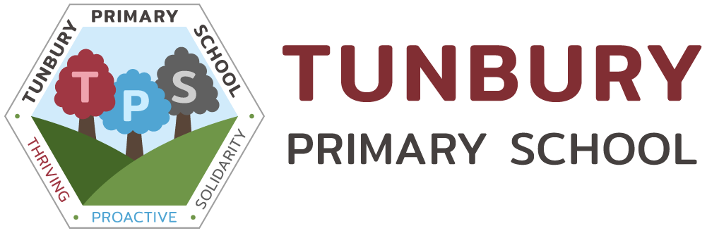
Grade: | KR6
Responsible to: | Line Manager

Purpose of the Job:

To work with teachers to organise and support teaching and learning activities for classes. The primary focus is to undertake specified work with individuals, groups and whole classes under the direction and supervision of a qualified teacher

Key duties and responsibilities:

- Plan, prepare and deliver specified learning activities to individuals, small groups and/or classes modifying and adapting activities as necessary under the direction and supervision of a teacher.
- Assess, record and report on development, progress and attainment.
- Liaise with staff and other relevant professionals and provide information about pupils as appropriate.
- Use teaching and learning objectives to plan, evaluate and adjust lessons/work plans as appropriate within agreed systems of supervision.
- Assess the needs of pupils and use knowledge and specialist skills to support pupils’ learning.
- Support pupils in social and emotional well-being, reporting problems to the teacher as appropriate.
- Teaching Assistants at this level are expected to undertake at least one of the following:
- Provide specialist support to pupils with learning, behavioural, communication, social, sensory or physical difficulties.
- Provide specialist support to pupils where English is not their first language.
- Provide specialist support to gifted and talented pupils.
- Provide specialist support to all pupils in a particular learning area (e.g. ICT, literacy, numeracy, National Curriculum subject).

Note: The options in point 7 above are alternative specialisms and only the specialism actually applicable should be used.

Teaching Assistants in this role may also undertake some or all of the following:

- Develop and implement Individual Development Plans for pupils (such as Individual Educational Plans), including attendance at, and contribution to, reviews.
- Support the role of parents / carers in pupils’ learning and contribute to meetings with parents / carers to provide constructive feedback on pupil progress/achievement etc.
- Contribute to the development of policies and procedures.
- Provide short- term cover supervision of classes.
- Supervise or manage the work and development of other classroom support staff.
- Be responsible for the preparation, maintenance and control of stocks of materials and resources.
- Liaise with external agencies on a regular basis.
- Provide pastoral care to pupils for example as head of year or tutor group.
- Be responsible for pupils who are not working to the normal timetable.
- Assist pupils with eating, dressing and hygiene, as required, whilst encouraging independence.
- Invigilate exams and tests.
- Be responsible for the presentation of displays.

The following outlines the criteria for this post. Applicants who have a disability and who meet the criteria will be shortlisted.

Applicants should describe in their application how they meet these criteria.

 | CRITERIA
QUALIFICATIONS | - Level 2 or 3 Diploma (or equivalent) plus additional knowledge in specialist area; working at or towards professional standards for HLTA
EXPERIENCE | - Successful relevant experience of working with children of relevant age within a learning environment.
SKILLS AND ABILITIES | - Developed skills for communicating with individual, groups and whole classes of pupils to promote learning, including assessing the impact of the communication on recipients and adjusting approach as necessary.
KNOWLEDGE | - Full working knowledge of relevant policies, codes of practice and legislation plus working knowledge and experience of implementing national curriculum and other relevant learning programs.  - Good understanding of child development with the ability to apply behaviour management policies and strategies which contribute to a purposeful learning environment.

